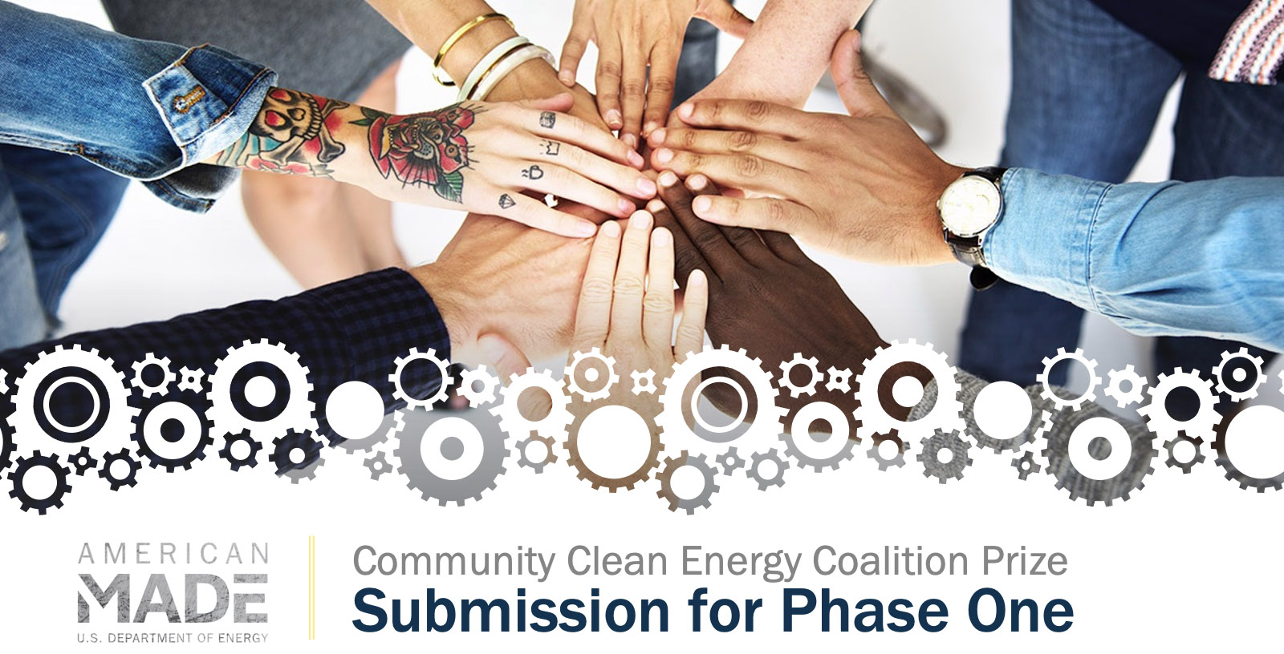
PROJECT NAME
Innovation tagline (e.g., your mission in a few words)
Keyword tags

TEAM
Names, geographic locations, contact info, and LinkedIn profiles

PARTNERS AND AMERICAN-MADE NETWORK
Key project partners and organizations
The Connectors (up to three) that significantly helped you advance your solution and the major items they helped with (if applicable)

Link to your video

Online Public Video (Will Be Made Public)

0BOnline Public Video

Tell us about your coalition and Justice40 Initiative priorities in 90 seconds.
It is suggested the competitor provides:  - Information about the coalition, team members, and committed partners  - Identification of the community to be served  - The defined energy challenge(s) to be addressed and the DOE Justice40 Initiative priority (or priorities) to which the coalition mission is aligned  - General approach for building and maintaining the coalition  - Initial outline of the action plan and the next steps that will be taken if the coalition wins the prize in Phase One. | A single score on a scale of 1–6 is provided, taking the following statements into consideration:  The video depicts:  - A strong overall summary of the coalition partners  - The community to be served  - The energy challenge(s) to be addressed  - Alignment with the DOE Justice40 Initiative policy priorities  - A thoughtful and realistic consideration of next steps.

Narrative Content
The Coalition Commitment Narrative must not exceed 2,000 words. Submissions can also include up to five supporting visuals or graphics, and unlimited letters of support (optional).

Topics
There are three topic areas that need to be addressed in the Commitment Narrative:
- Topic 1: Coalition Description and Commitment, including committed/developing partners and stakeholders
- Topic 2: Community Energy Challenge Alignment with Justice40 Initiative Priorities including potential impact and planned activities meet the challenge
- Topic 3: Coalition Narrative outlining continuing development and proposed activities.

Topic 1: Coalition Description and Commitment
Describe the committed partners, the community to be served, the specific community need being addressed, and alignment of need with one or more DOE Justice40 Initiative policy or priorities.
It is suggested the competitor provides:  - Identify the committed partners, and describe their relevant experience, resources, capacity, and connection to the community to be served.  - Identify the community to be served and describe stakeholders outside the coalition members who are being engaged.  - Define the community-focused energy challenge to be addressed by the coalition.  - Describe the level of commitment of the coalition and its partners, and the consideration of future action that will impact the long-term success of the coalition. | A single 1–6 score is provided, taking the following statements into consideration:  - The committed partners have the experience, resources, and capacity necessary to successfully address the defined energy challenge(s).  - The coalition has a strong connection to the community to be served and demonstrates a strong understanding of the community and the community’s clean energy needs.  - The identified community has a history of being underrepresented when addressing the defined energy challenge.  - The identified community includes disadvantaged communities.  - The coalition has the capability and capacity to serve the identified community.  - The defined energy challenge reflects the priorities and/or needs of the identified community.  - The coalition makes a compelling case for how it will be maintained and developed, and how it will have a positive impact on the community.

Response to Topic 1:

Topic 2: Community Energy Challenge Alignment With DOE Justice40 Initiative Policy Priorities
Describe the defined energy challenge(s) and connections to DOE Justice40 Initiative policy priorities and articulate how addressing the defined energy challenge(s) will advance the DOE Justice40 Initiative policy priorities and further the development and deployment of clean energy.
It is suggested the competitor provides:  - Identify the key DOE Justice40 Initiative policy priority(ies) being addressed.  - Describe how the defined energy challenge relates to the identified DOE Justice40 Initiative policy priority(ies) and how the mission of the coalition advances the relevant priority(ies).  - Describe how the relevant coalition partners will help the coalition meet or exceed the goals of the coalition and the relevant priorities. | Each statement scored on a 1–6 scale:  - The competitor demonstrates coordination between the defined energy challenge(s), the coalition mission, and one or more of the DOE Justice40 Initiative policy priorities.  - The coalition mission establishes a well-defined role in addressing the defined energy challenge.  - The proposed partner actions are likely to successfully address the challenge.

Response to Topic 2:

Topic 3: Coalition Narrative Outlining Continuing Development and Proposed Activities
Describe the coalition and how the initial arrangements will allow for continued development and for providing measurable impacts.
It is suggested the competitor provides:  - Describe the structure of the coalition, how it will be organized, and how the structure and organization will support continuation of the coalition.  - Describe the steps you will take to formalize the coalition and its mission.  - Describe initial arrangements for addressing the defined energy challenge and outline expected steps.  - Identify the methods and metrics that will be used to evaluate the progress of activities through specific, measurable, achievable, relevant, and time-bound (SMART) goals.  - Provide a budget for the proposed activities.  - Describe the existing resources (funding, personal, and expertise), current funding needs, and expected sources of future funding. | Each statement scored on a 1–6 scale:  - The structure and organization of the coalition is set up to be successful in delivering value to the underserved community.  - The coalition’s high-level proposed activities are aimed at meeting one or more of the goals of the prize and are well-reasoned and likely to achieve the stated goal(s).  - The coalition’s proposed activities are likely to address the defined energy challenge in a manner advancing the DOE Justice40 Initiative policy priorities and clean energy.  - The coalition’s outlined activities are likely to build trust and strengthen relationships and partnerships with disadvantaged communities.  - The competitor’s metrics to evaluate success and the relevant SMART goals are well-suited to provide an accurate indication of success in meeting one or more of the goals of this prize.  - The description of outlined activities and the associated budget are of adequate detail and indicate that the activities are achievable.  - The competitor has demonstrated that they will have access to the necessary resources and capabilities to execute their proposed plan or have a plan to secure necessary funding.

Response to Topic 3:

SUPPLEMENTARY INFORMATION

THREE TOPIC NARRATIVE WORD COUNT: ____________ total words

Submission Summary Slide (Will Be Made Public)
Make a public-facing, one-slide submission summary that introduces the coalition and general plan highlights. There is no template, so competitors are free to present the information in any format. Any text must be readable on a standard printed page and a conference room projection and should be in at least 14-point font.

Letters of Commitment or Support
In a single file, combine and upload one-page letters from relevant entities (e.g., coalition members, relevant stakeholders) to provide context for your coalition and outlined activities. Any letters of commitment or support must be written on letterhead or a template with the organization’s name on it, uploaded as a single file, and limited to a single page.

