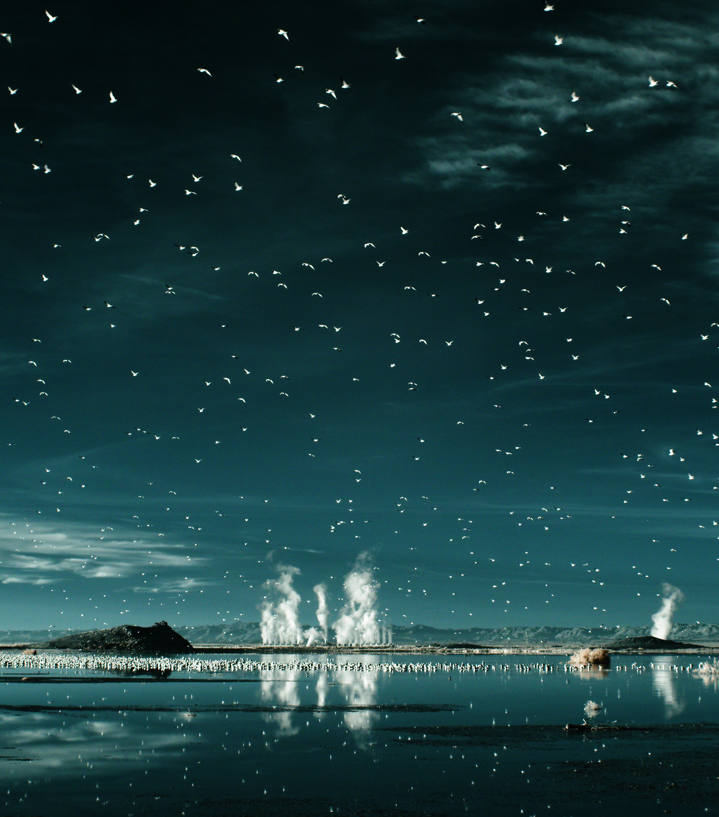
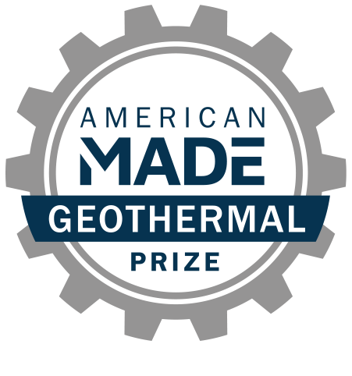
AMERICAN-MADE GEOTHERMAL LITHIUM EXTRACTION PRIZE
Phase 2 Submission
Team Name + Project Name

PROJECT NAME

Innovation tagline (e.g., your mission in a few words)
Keyword tags

TEAM
Names, geographic locations, contact info, and LinkedIn profiles

PARTNER SUPPORT
Key project partners and organizations (if any)

PHASE 2 TECHNICAL NARRATIVE

Your technical narrative should answer each of the following questions:
- Addressing the Problem—How has your team advanced a solution to the identified problem?
- Advancing Innovation—What progress have you made?
- Plan—How do you plan to fabricate and test your solution?

For convenience, these questions are provided in the headings of the tables starting on page 4, along with suggested content (and corresponding judging statements) to help guide your responses. You decide where to focus your answers.
The individual answers to the three questions do not have a word limit; however, the aggregate response to these questions must not exceed 15 pages when printed using standard 8.5 x 11 paper with 1” margins (top, bottom, left, and right) and 12-point or larger font size.
Images, figures, graphs, footnotes, and cited references must be included in the 15-page limit of your Technical Narrative. Expert reviewers will score the questions based on the content you have provided that conforms to the previously described limits.
Save the Technical Narrative in a single PDF file using the following convention for the title: “TeamName_TechnicalNarrative”.
Responses should not be entered into the existing table format for each question (Question tables may be deleted prior to submission).

Question 1: Addressing the Problem
How has your team advanced a solution to the identified problem?
Suggested content:  - Describe the barrier within the lithium extraction process that your solution addresses.  - Describe your solution and its unique value proposition.  - Quantify how your solution will ultimately improve the economics and/or environmental impacts of DLE from geothermal brines. | Each statement will be scored on a 1–6 scale according to the following criteria:  - The competitor has advanced a solution to their Phase 1 problem.  - The competitor has demonstrated a clear path to lowering overall DLE costs.  - The competitor has demonstrated the improved economics of their DLE as compared to the current state of the art.  - The competitor has demonstrated the improved environmental impact of their DLE as compared to the current state of the art.

Response to Question 1:

Question 2: Advancing Innovation
What progress have you made?
Suggested content you provide:  - Describe your progress on your DLE innovation, including documentation of proof-of-concept design (see special instructions).  - Describe how you worked with your IAP member to advance your design, how their mentorship was important, and how the feedback changed your design process.  - Describe your efforts to undertake rigorous design processes, highlighting key engagements, relationships, and milestones (see special instructions).  - Describe your design process. How did you settle on the final design? What other designs did you consider? Why is your final design the best? How did different members of your team or outside support influence the design process? How did you select materials  (if applicable)?  - How does your design incorporate a diverse perspective, and how did you seek out those perspectives? | Each statement will be scored on a 1–6 scale according to the following criteria:  - The solution represents an innovative approach, built on reasonable assumptions, valid technical foundations, and lessons learned from other notable efforts in this space. Competitors provided necessary figures, models, tables, and assumptions used in their approach.  - The planned innovation is reasonably ambitious and validates critical assumptions needed to advance the proposed solution.  - A considerable amount of high-quality effort was put into defining and advancing the proposed concept.

Special Instructions for Question 2
Although design documentation will be application-specific, documentation should clearly show the functionality and performance benefits of the proposed innovation over conventional technology. This documentation should include the design engineering steps taken that support the submitted design basis. Example design engineering content includes computer-aided design (CAD) model renderings, engineering calculations, and finite element analysis along with a description of the calculation basis, and other approaches that credibly quantify potential impacts. All design documentation must be included in the 15-page limit, and in the same readable PDF format. CAD drawings or other modeling content that requires specific software licensing will not be judged.

Response to Question 2:

Question 3: Plan
How do you plan to fabricate and test your solution?
Suggested content you provide  - Describe where you stand in your development cycle and define goals and SMART metrics for Phase 3.  - Describe your team’s readiness to meet your goals. What resources provided by the contest will help meet your goals, and what resources will need to be externally solicited? How and when will that occur?  - Describe details of where/how you plan to test your innovation. Include performance metrics and details of where you will get brines and tools for next phase. Provide a letter of commitment if applicable.  - Provide a high-level budget and project management plan to meet your goals during Phase 3, including how you will leverage program resources, including IAP member mentorship, or other entities (include references to letters of support/commitment if applicable). | Each statement will be scored on a 1–6 scale according to the following criteria:  - The team has met intended goals for Phase 2.  - The stated Phase 3 goals are ambitious, reduce risks, and show a commitment to an accelerated development cycle.  - The proposed plan is appropriate and logical in order to achieve the stated goals.  - Meeting the stated goals demonstrates critical progress toward building, testing, and validating the functionality of the innovation.  - The proposed plan effectively uses resources available in-house, attainable within the prize period, or through this program to advance the innovation.  - The teams states a plan for testing and demonstrating their innovation using real geothermal brine.

Response to Question 3:

