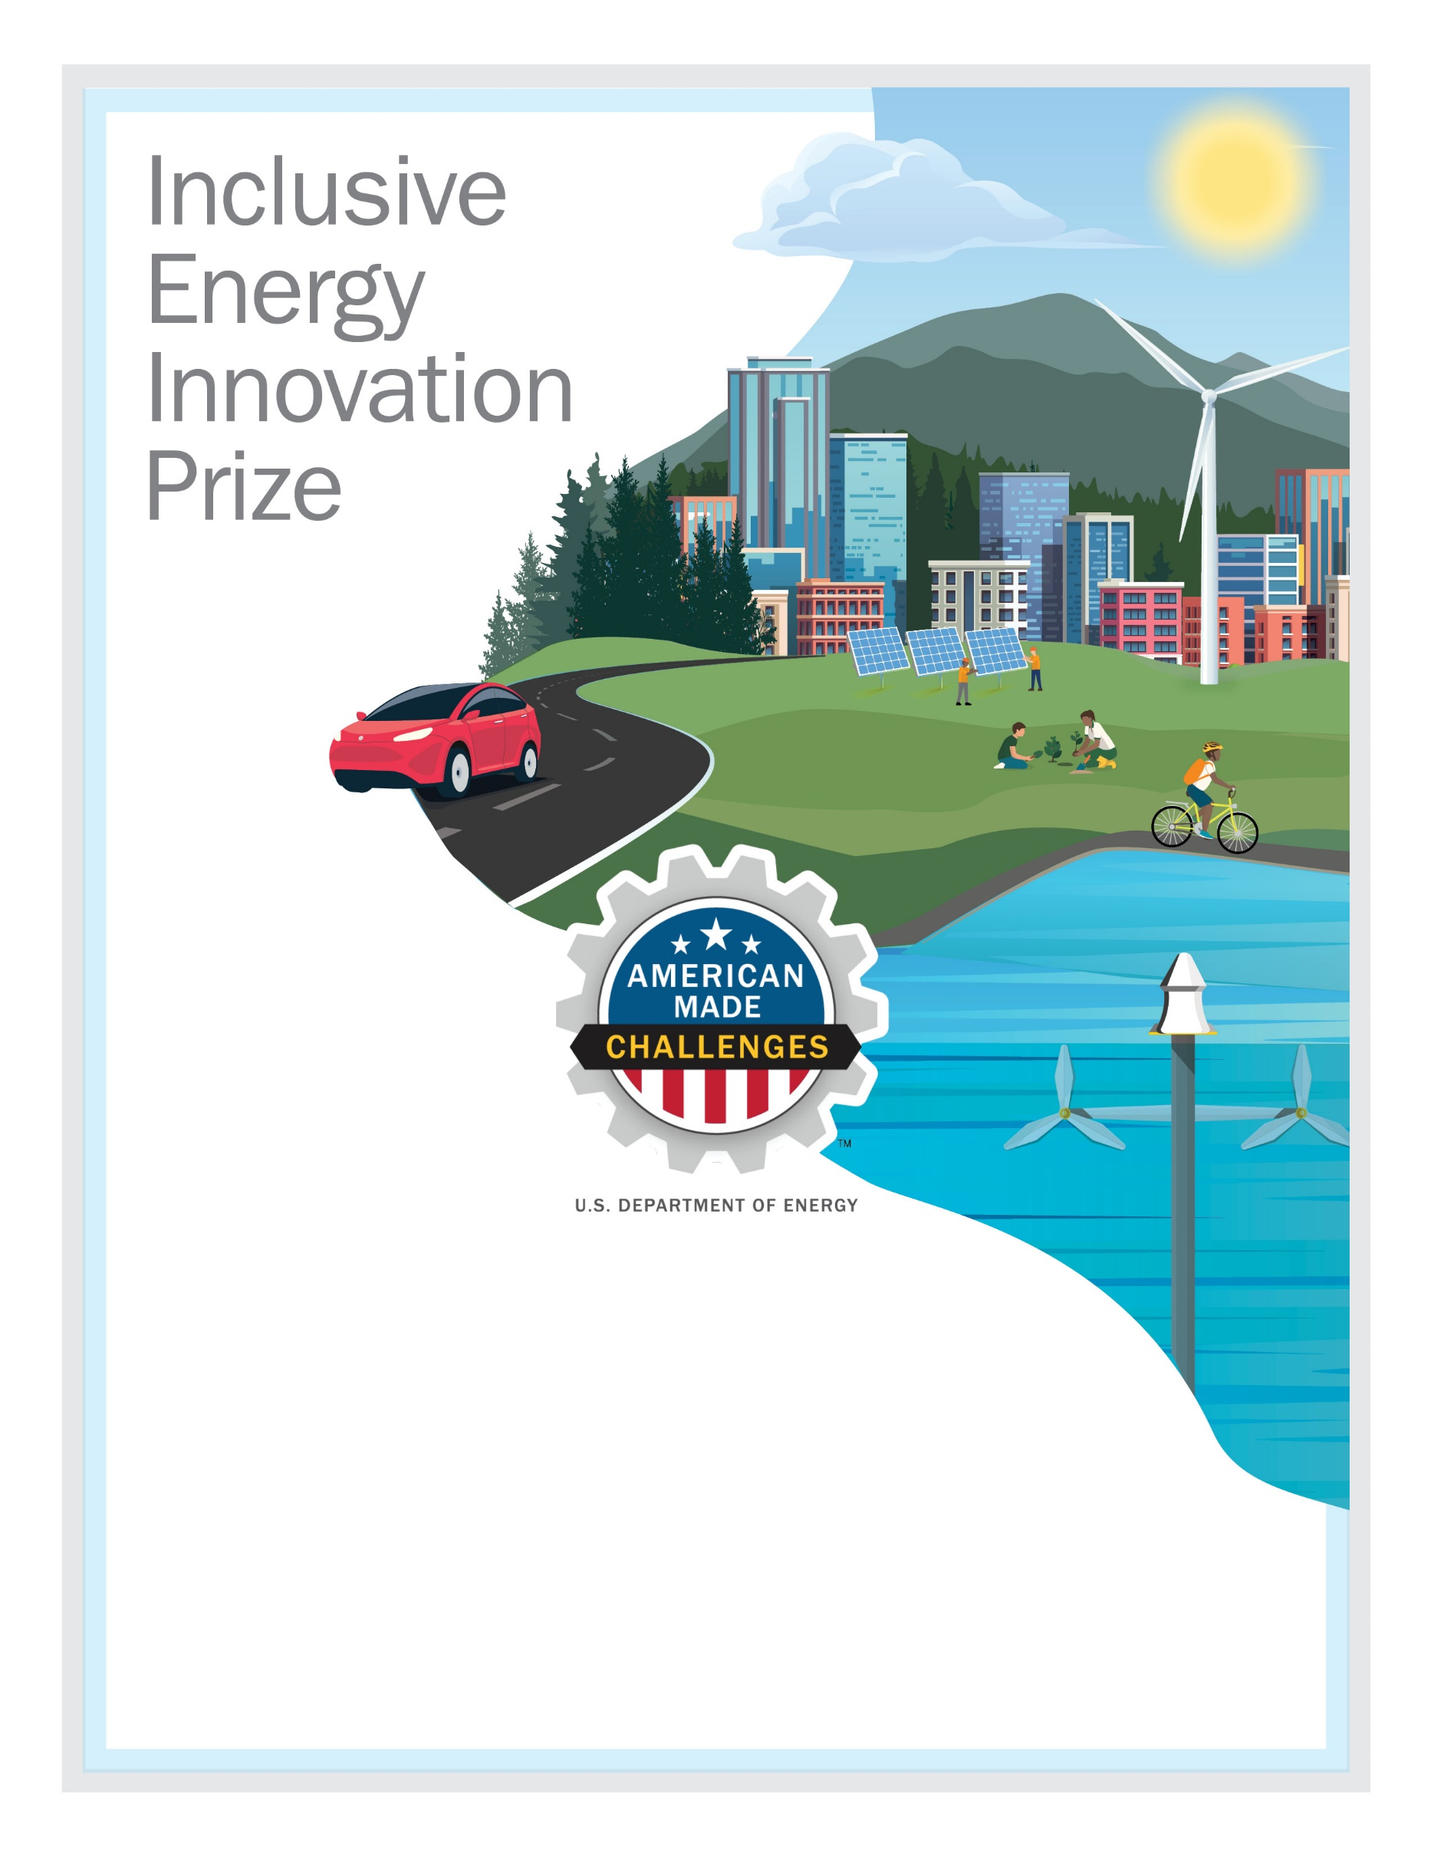
[TEAM NAME HERE]
Impact Plan
September 2021

Write a detailed impact plan in a narrative format describing your team/organization, planned activities, resources and capabilities, and anticipated impacts. The impact plan should be guided by the Anticipated Prize Impacts stated in Section 2.3 of the Official Rules Document.
The total length of this impact plan cannot exceed 5,000 words. You may include up to five supporting visualizations or graphics. The impact plan must be submitted as a PDF, via the HeroX platform, along with the other submission documents. Information contained in hyperlinks to external sources will not be reviewed or considered by the reviewers or the judge.
Collectively, the video pitch and impact plan should address all four scoring criteria (see Section 2.5 of the Official Rules Document to see suggested content to provide for these criteria):
- Criterion 1: Experience in Engaging and Supporting Disadvantaged Communities
- Criterion 2: Proposed Activities During Phase One of the Prize
- Criterion 3: Resources and Capabilities to Execute Prize Goals
- Criterion 4: Vision and Anticipated Long-Term Impacts
**** PLEASE DELETE THIS TEXTBOX FROM YOUR FINAL IMPACT PLAN SUBMISSION ****

[Please delete bracketed guidance text prior to submission]

Team Information:
[Fill in the information below for each team member. The first team member listed should be the Team Lead]
Team Lead Name: [first, last]
Team Member 2: [first, last]
Team Member 3: [first, last]
Team Member n: [first, last]

Short Description:
[A clear and concise description of your team/organization and mission. Recommended length: 50-200 words, does not count towards 5000-word limit.]

Table of Contents
Contents
Team Information: 2
Short Description: 2
Table of Contents 3
Impact Plan: 3
Experience in Engaging and Supporting Disadvantaged Communities 3
Proposed Activities 4
Resources and Capabilities 4
Vision and Anticipated Impacts 5
Concluding Remarks 5

Impact Plan:
[Description of planned activities, resources and capabilities, budget, and anticipated impacts. Total length must not exceed 5000 words, exclusive of team information, description, table of contents, and headings. Submissions may include up to five graphics/supporting visuals. Please note that the following structure and recommended section lengths are suggestions only. Applicants may structure their impact plan narratives as they see fit.]

Experience in Engaging and Supporting Disadvantaged Communities
[Describe the competitor’s experience and capabilities in working with and engaging disadvantaged communities, experience and capabilities promoting climate and energy justice, and how the competitor assesses success or failure in these endeavors, as outlined in criterion 1 of the prize rules.
Suggested content:
- A description of the mission of the competitor and how it aligns with one or more goals of the prize
- A description of experience/expertise of the competitor in working with disadvantaged communities
- A description of types of activities the competitor has carried out in providing entrepreneurship and innovation support
- A description of types of activities the competitor has carried out in securing funding from federal, state, or local government or private (for-profit or nonprofit) funding
- A description of strategies the competitor has used to effectively engage with disadvantaged communities
- A description of experience the competitor has in working successfully on promoting renewable energy development, addressing climate change and energy justice issues
- A description of experiences, insights, or lessons learned by the competitor from strategies that have been ineffective or unsuccessful in promoting renewable energy development, and addressing climate change and energy justice issues
- A description of established practices the competitor has used to evaluate the success or failure of previous efforts and incorporate lessons learned into subsequent efforts.
Recommended length: 500-1200 words

Proposed Activities
[Describe proposed activities and how these will address one or more goals of the prize, as outlined in criterion 2 of the prize rules.
Suggested content:
- A description of proposed activities the competitor aims to carry out that will meet one or more of the goals of the prize
- A description of strategies and methods the competitor can use to build trust and strengthen relationships and partnerships with disadvantaged communities to understand and assist such communities in overcoming barriers to entry into DOE funding in furtherance of the government’s Justice40 goals
- A description of activities and methods that can help identify and foster grassroots innovation related to just and equitable clean energy deployment
- A description of credible methods and metrics to evaluate the competitor’s progress of activities through specific, measurable, achievable, relevant, and timebound (SMART) goals
- A description of ambitious yet achievable deliverables that the competitor will accomplish during the 12 months after receiving funding from this prize
- A description of planned outreach and engagement activities and strategies that the competitor will use to engage disadvantaged communities.
Recommended length: approximately 1500-2200 words.]

Resources and Capabilities
[Describe the resources and capabilities, either currently present within the team/organization or which the competitor will acquire, that will enable the competitor to successfully implement the proposed activities and have meaningful impact toward achieving the goals of the prize, as outlined in criterion 3 of the prize rules. Provide a budget describing how prize funds will be used to help you achieve these goals. You may also describe staff and materials that will help you implement proposed activities..
Suggested content:
- A budget for the proposed activities
- A description of staff resources the competitor can use to execute the proposed plan, including but not limited to staff experienced in promoting justice, diversity, equity, inclusion, entrepreneurship, and other activities
- A description of outreach and engagement strategies and platforms that the competitor will use to work with disadvantaged communities to execute the proposed plan
- A description of other resources and strategies the competitor plans to utilize to execute the proposed plan, which may include technical resources.
Recommended length: approximately 500-1200 words.]

Vision and Anticipated Impacts
[Describe the impact of planned activities, as outlined in criterion 4 of the prize rules. This includes the impact of the activities in 2-5 years, contribution to enabling a just and equitable transition to a clean energy economy in the served community/region, strategies for making proposed activities sustainable, further impact that could be achieved with ongoing funding beyond initial award.
Suggested content:
- A description of the competitor’s role in enabling a just and equitable transition to a clean energy economy in the relevant community and region
- A description of anticipated impact of the proposed activities after 2–5 years
- A description of strategies the competitor will employ to secure ongoing funding to build upon the proposed activities to ensure sustainability of the proposed activities
- A description of progress toward a clean energy transition that the competitor could achieve with ongoing funding beyond the initial award from this prize.
Recommended length: 500-1200 words.]

Concluding Remarks
[Briefly highlight any key points if desired and any other pertinent information for reviewers and administrators.
Recommended length: less than 300 words]

