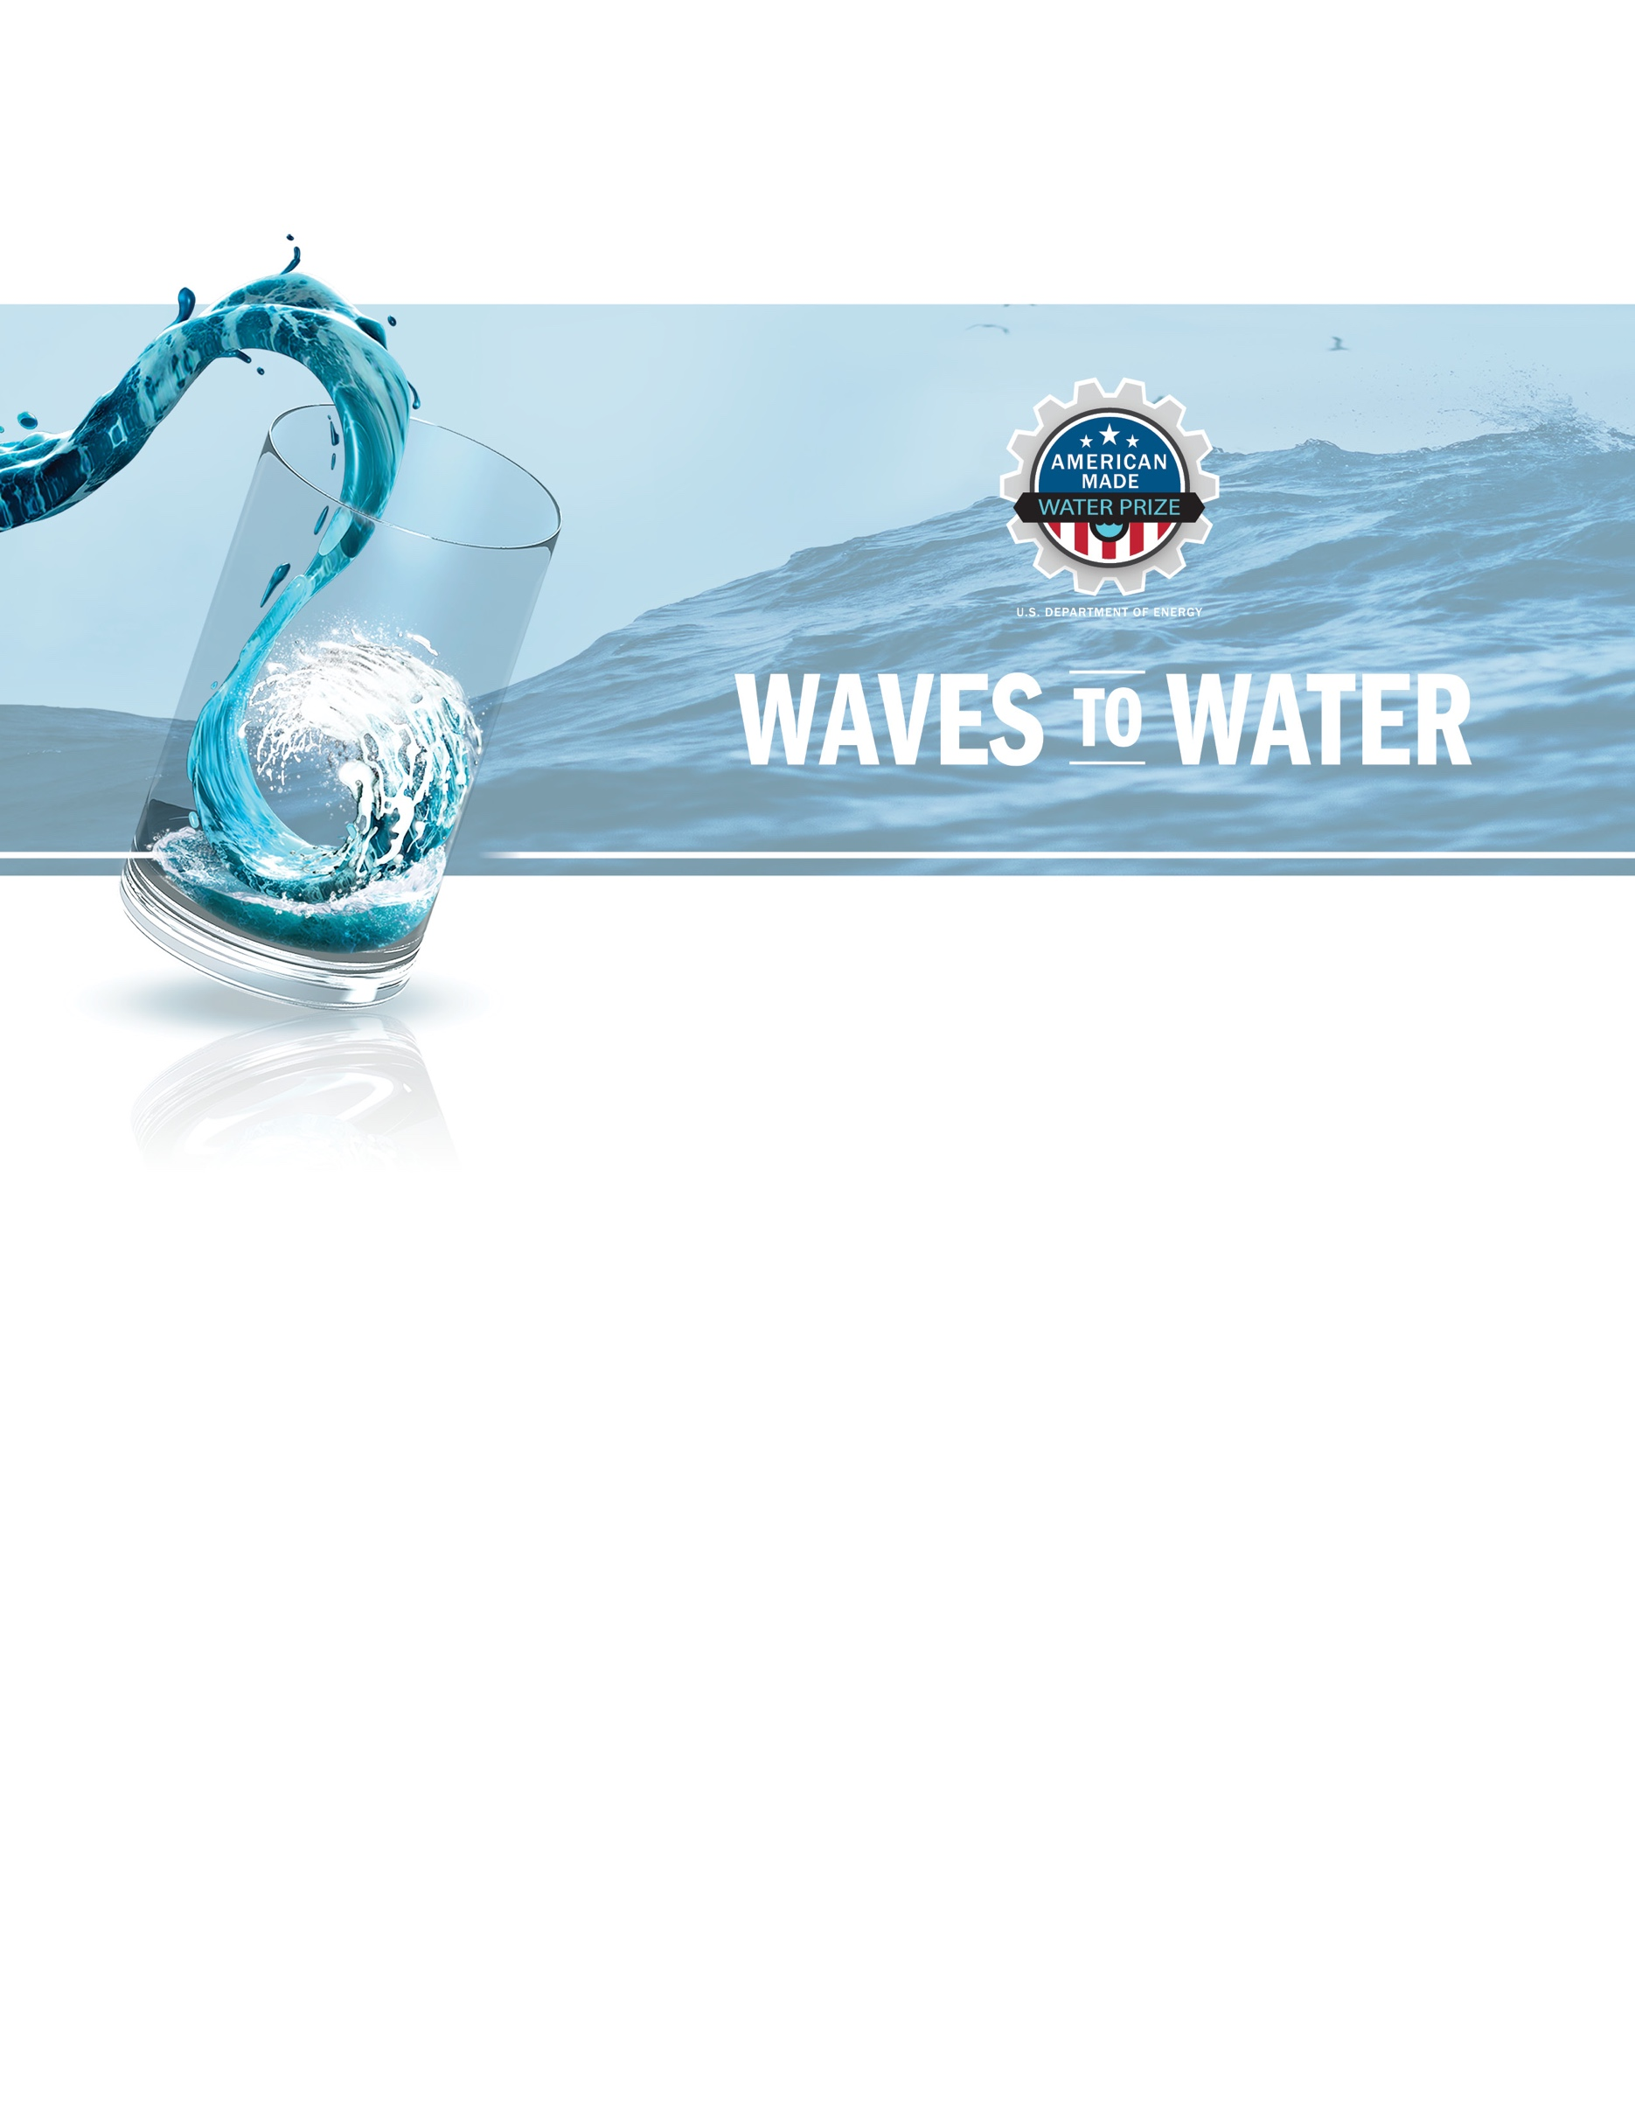

DRINK STAGE
Deployment and Commissioning Plan

DRINK STAGE
Deployment and Commissioning Plan

DRINK STAGE
Deployment and Commissioning Plan

DRINK STAGE
Deployment and Commissioning Plan

Project Title [Your team’s title]
Tagline: [Your mission or idea as a single catchy sentence]

Team Name [Your team’s name]
Names and contact information (list those planning to travel to North Carolina and include their cell phone numbers)

Project Title [Your team’s title]
Tagline: [Your mission or idea as a single catchy sentence]

Team Name [Your team’s name]
Names and contact information (list those planning to travel to North Carolina and include their cell phone numbers)

DRINK STAGE
Deployment and Commissioning Plan

DRINK STAGE
Deployment and Commissioning PlanProject Title [Your team’s title]
Tagline: [Your mission or idea as a single catchy sentence]

Team Name [Your team’s name]
Names and contact information (list those planning to travel to North Carolina and include their cell phone numbers)

Project Title [Your team’s title]
Tagline: [Your mission or idea as a single catchy sentence]

Team Name [Your team’s name]DRINK STAGE
Deployment and Commissioning Plan

DRINK STAGE
Deployment and Commissioning Plan

DRINK STAGE
Deployment and Commissioning Plan

DRINK STAGE
Deployment and Commissioning Plan

[Your team’s project title]
Tagline: [Your mission or idea as a single catchy sentence]

[Your team’s name]

Project Title [Your team’s title]
Tagline: [Your mission or idea as a single catchy sentence]

Team Name [Your team’s name]
Names and contact information (list those planning to travel to North Carolina and include their cell phone numbers)

DRINK STAGE
Deployment and Commissioning Plan

DRINK STAGE
Deployment and Commissioning PlanProject Title [Your team’s title]
Tagline: [Your mission or idea as a single catchy sentence]

Team Name [Your team’s name]
Names and contact information (list those planning to travel to North Carolina and include their cell phone numbers)

Project Title [Your team’s title]
Tagline: [Your mission or idea as a single catchy sentence]

Team Name [Your team’s name]
Names and contact information (list those planning to travel to North Carolina and include their cell phone numbers)

Project Title [Your team’s title]
Tagline: [Your mission or idea as a single catchy sentence]

Team Name [Your team’s name]
Names and contact information (list those planning to travel to North Carolina and include their cell phone numbers)

Project Title [Your team’s title]
Tagline: [Your mission or idea as a single catchy sentence]

Team Name [Your team’s name]
Names and contact information (list those planning to travel to North Carolina and include their cell phone numbers)

DRINK STAGE
Deployment and Commissioning Plan

DRINK STAGE
Deployment and Commissioning PlanProject Title [Your team’s title]
Tagline: [Your mission or idea as a single catchy sentence]

Team Name [Your team’s name]
Names and contact information (list those planning to travel to North Carolina and include their cell phone numbers)

Project Title [Your team’s title]
Tagline: [Your mission or idea as a single catchy sentence]

Team Name [Your team’s name]
Names and contact information (list those planning to travel to North Carolina and include their cell phone numbers)

DRINK Stage Deployment, Installation, Commissioning, Decommissioning, and Retrieval Plan
Competitors are expected to work with the Waves to Water Prize technical team members at NREL, DOE, and CSI to identify the best plan.
A final version of this document must be submitted on or before January 12, 2022. Late submissions may lead to disqualification.
This document is not to be made public.

Deployment
This table has been completed by all teams in the CREATE stage, however we would like to capture this information for the DRINK stage in case there are any revisions:

For teams that are sending water, either drinking water or raw seawater to the pier, please answer the following:
Will you be sending seawater or drinking water to the pier? | ☐ Seawater | ☐ Drinking water
What is the design and/or maximum flowrate (in liter/min) you anticipate delivering water?
What are the working pressures your system will operate at?
If applicable, what safety reliefs have you designed for in the event of over-pressure? What is the relief pressure?
For teams that are sending electricity to the pier to power a pier mounted desalination system:
Are you intending to send AC or DC power to the pier? | ☐ AC | ☐ DC
If AC, single phase, or 3-phase? | ☐ Single phase | ☐ 3-phase
For all systems, what is the maximum voltage you will be delivering? | Volts
For all systems, what is maximum current you will be delivering? | Amps
In the event of an over-current condition, have you accounted for any circuit breakers, safety switches, or dump loads? | Will have a circuit breakers and switch on the pier. Do not anticipate needing a dump load.
If AC, is a ground fault circuit interrupter (GFCI) or ground fault equipment protection (GFEP) device included to reduce stray current entering the water?
For all teams:
What is your anticipated watch circle? | < 10 meters
Do you anticipate needing a secondary Danforth anchor to prevent spinning or maintain a desired watch? | ☐ Yes | ☐ No
What is needed to transport your device from the parking lot to the end of the pier? | ☐ Hand carry, ☐ Cart, or ☐ Forklift  Select the option or identify alternative equipment:

Lift Plan:
Teams must provide responses to the following questions to help develop a lift plan for the device:
- Weight of the device dry?
- Anticipated weight of the device wet upon retrieval? Please include calculations of voids, pumps, hoses, wet filters, and other relevant equipment.
- Schematic of lifting points, tow points, and tag line locations.
- Device dimensions.
- Height from the lowest point of the device to the top of the bridle.
- Bridle SWLL?
- Any sharp edges?
- Any special precautions required for lifting, dropping in the water, or setting down on the pier?
- Will the bridle remain on the device during the competition, or will it need to be removed?
  - If it remains on the device, how will the lifting point be accessible for retrieval from the water? Will the device need to be boarded or will the bridle be reachable by the dive team?
- Will you need access to the device while it is suspended from the crane before it is deployed?

Responses to these questions will help to detail your hoisting and rigging lift plans with the NREL and CSI team for both deployment and retrieval. NREL Form F1262 is available as a reference for how this information will be used.
Additional Reference Material can be found here: https://training.bnl.gov/demo/BasicRiggingWorkbook.pdf

Installation
This section covers steps taken BEFORE the device is energized. To help guide the development of this section, content does not need to exceed 1,000 words.

Installation Plan:
Detail how your device will be attached to the provided anchor here.

[Think about what needs to be done before versus after being attached to the anchor and what needs to be completed once the device is energized in the commissioning, for example: Does a spring need to be discharged or disengaged? Does the pump need a valve to bypass water prior to connections? Does the electrical system have a switch at the device to ensure power is not flowing the lines? Does inflatable need to be partially inflated on sure and fully inflated on water?].

Include tables/images as necessary.

Identify any additional steps that may be required once the device has been towed to its final location.

Commissioning
This section covers steps taken to energize your device. To help guide the development of this section, content does not need to exceed 1,000 words.

Commissioning Plan:
Detailed instructions must explain how to commission once it has been attached to the supplied anchor and installed.

[Questions your plan should answer, but are not limited to: How does your device ensure no power is going through the cable while divers are in the water? Does your device utilize an electric system or hydraulic system? Is this step completed on the deployment vessel or from the pier? What is needed to engage or energize the power takeoff (PTO)?]

This will include any operations to initiate power (energizing) or water production (pressurizing) once the device has been safely connected to the anchor and any power cables and/or hoses have been attached to the desalination unit on the pier. [e.g., opening valves, releasing safety switches, and so on]

Identify any points of operation that could pose a hazard to workers or support personnel when the equipment is undergoing commissioning/decommissioning or running. The point of operation is where work is performed on a material.

Guard all parts of an electrical or mechanical system that transmit energy (i.e., kinetic, pneumatic, hydraulic, electrical, tension etc.) to the point of operation of machines whose operation exposes a person to injury.

Identify any energized parts that will be on the pier and include a plan for energizing and pressurizing the elements on the pier as well.

Include tables/images as necessary.

Decommissioning
This section covers steps taken to deenergize your device. To help guide the development of this section, content does not need to exceed 1,000 words.

Decommissioning Plan:
Detailed instructions must explain how to decommission and deenergize once it has been attached to the supplied anchor and installed.

Develop an equipment specific lockout/tagout procedure to achieve effective isolation and zero energy to protect personnel interacting with your equipment during the competition.
The unexpected energization or startup of the machines or equipment, or a release of stored energy, could harm personnel.

An example of a Lockout Tagout procedure can be found here:
https://www.osha.gov/sites/default/files/2018-12/fy15_sh-27664-sh5_Toolbox_LOTO_Procedures_Example.pdf

Lockout Tagout Reference Materials:
https://www.osha.gov/sites/default/files/publications/osha3120.pdf

[Questions your plan should answer, but are not limited to: How does your device ensure no power is going through the cable while divers are in the water? Does your device utilize an electric system or hydraulic system? Is this step completed on the deployment vessel or from the pier? What is needed to decouple the PTO?]

This will include any operations to shut off power (deenergizing) or water production (depressurizing). [e.g., opening valves, releasing safety switches, and so on]

Identify any energized parts that will be on the pier and include a plan for deenergizing and depressurizing the elements on the pier as well.

Include tables/images as necessary.

Retrieval
This section covers steps taken AFTER the device is deenergized. To help guide the development of this section, content does not need to exceed 1,000 words.

Retrieval Plan:
Detail how your device will be removed from the provided anchor here.

[Think about what needs to be done before versus after being detached from the anchor and what needs to be completed once the device is deenergized in the decommissioning, for example: Does a spring need to be discharged or disengaged? Should the pump bypass valve need to be open? Does water need to be drained or removed from a ballast tank?].

Identify any additional steps that may be required to prepare the device for retrieval and towing back to shore.

Complete a hoisting and rigging lift plan utilizing NREL Form F1262 for retrieval of equipment from the water.

Include tables/images as necessary.

Emergency Retrieval Plan:
In the event of a rapid retrieval due to an emergency what steps can be taken to rapidly decommission and retrieve the device?

[Think about: What can be cut? What should absolutely NOT be done – e.g. releasing a pressurized spring?]

Removal Plan:
Each competing team will also be required to provide a removal strategy in their lift
plan to get the device back onto the pier and back to the staging area. In the staging area, competing teams will be required to disassemble and remove the device from the test location. The device does not need to fit back into the required container, but it must be removed from the contest location by each competing team. Any abandoned equipment will be disposed of at the discretion of CSI and teams will be charged an exorbitant fee for disposal.

