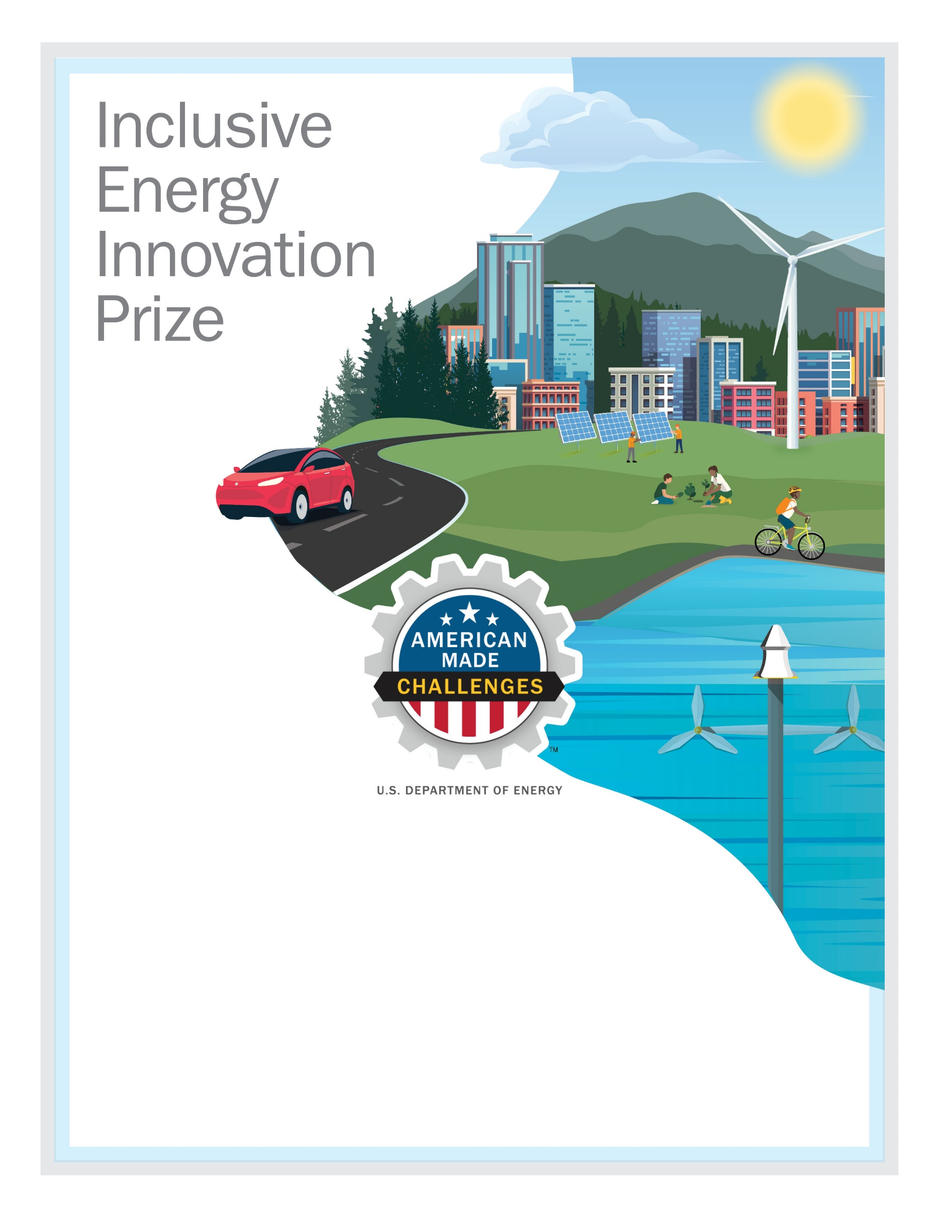
[TEAM NAME HERE]
Impact Plan
September 2021

Write a detailed impact plan in a narrative format describing your team/organization, planned activities, resources and capabilities, and anticipated impacts. The impact plan should be guided by the Anticipated Prize Impacts stated in Section 2.3 of the Official Rules Document.
The total length of this impact plan cannot exceed 5,000 words. You may include up to five supporting visualizations or graphics. The impact plan must be submitted as a PDF, via the HeroX platform, along with the other submission documents. Information contained in hyperlinks to external sources will not be reviewed or considered by the reviewers or the judge.
Collectively, the video pitch and impact plan should address all four scoring criteria (see Section 2.5 of the Official Rules Document to see suggested content to provide for these criteria):
- Criterion 1: Experience in Engaging and Supporting Disadvantaged Communities
- Criterion 2: Proposed Activities During Phase One of the Prize
- Criterion 3: Resources and Capabilities to Execute Prize Goals
- Criterion 4: Vision and Anticipated Long-Term Impacts
**** PLEASE DELETE THIS TEXTBOX FROM YOUR FINAL IMPACT PLAN SUBMISSION ****

Team Information:
[Fill in the information below for each team member. The first team member listed should be the Team Lead]
Team Lead Name: [first, last]
Team Member 2: [first, last]
Team Member 3: [first, last]
Team Member n: [first, last]

Short Description:
[A clear and concise description of your team/organization]

Table of Contents
Contents
Team Information: 2
Short Description: 2
Table of Contents 3
Impact Plan: 3
Planned Activities 3
Resources and Capabilities 3
Budget 3
Anticipated Impacts 3
Concluding Remarks 3

Impact Plan:
[Description of planned activities, resources and capabilities, budget, and anticipated impacts.]

Planned Activities
[text]

Resources and Capabilities
[text]

Budget
[text]

Anticipated Impacts
[text]

Concluding Remarks
[text]

