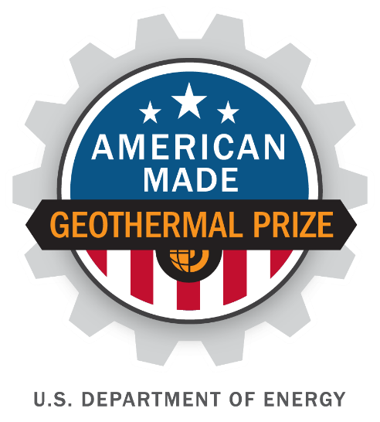

American-Made Geothermal Lithium Extraction Prize
PHASE 1 SUBMISSION
Industry Advisory Panel (IAP) Request
PROJECT NAME
Innovation tagline (e.g., your mission in a few words)
Keyword tags

TEAM
Names, geographic locations, contact info, and LinkedIn profiles

1

|

American
-
Made Solar Prize Official
Rules

Please rank the top four (4) IAP members that you would like to work with during Phase 2 of this competition, with 1 being your first choice.
IAP Member | Rank | IAP Member | Rank
Derek Benson  EnergySource Minerals, LLC |  | Stephen Harrison  All America Lithium
Kevin Brown  GEOKEM |  | Dan Hoyer  Veizades & Associates
Jason Czapla  Controlled Thermal Resources |  | Mike O’Sullivan  Geo40
Darrell Gallup  Thermochem |  | Andy Robinson  Standard Lithium Ltd.
Katharina Gerber  Vulcan Energy Resources |  | Jonathan Weisgall  Berkshire Hathaway Energy Co.

Industry Advisory Panel Assistance Request (2 pages, including images, not including cover page, not public)
Provide a two-page description of where your unique solution would be most aided by the input from an IAP member. Outline open science or engineering questions, facilities/supply needs, and other requests for expertise. The Prize Administrator will make this request broadly available to the members of the IAP.

