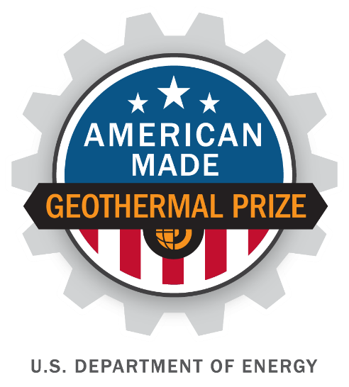

American-Made Geothermal Lithium Extraction Prize
PHASE 1 SUBMISSION
PROJECT NAME
Innovation tagline (e.g., your mission in a few words)
Keyword tags

TEAM
Names, geographic locations, contact info, and LinkedIn profiles

PARTNER SUPPORT
Key project partners and organizations (if any)

Link to your 90-second video

1

|

American
-
Made Solar Prize Official
Rules

Video Pitch: showcase your idea in 90 seconds
Post your publicly accessible video online (e.g., YouTube, Vimeo). Be creative and produce a video that conveys the required information in exciting and interesting ways but do not focus on time consuming activities that only improve production values (i.e., technical elements such as décor, lighting, and cinematic techniques).
Online Public Video (up to 90 seconds, will be made public) — What is your innovation?
Suggested content you provide  - The Problem: Why the technical challenge you wish to tackle is worthwhile  - Your Solution: A high-level vision of your proposed solution  - Your Team: Who you are and why you have a competitive edge  - Creative Input: Creative content that conveys your submission in exciting and interesting ways. | Required submission format  - Ensure that your video is posted publicly online (e.g., YouTube, Vimeo)  - The video should not exceed 90 seconds.

Four Question Written Narrative

Answer each of the following four questions:
- Problem - What is the problem and why is solving it important?
- Innovation - What is your solution and why will it be successful?
- Team - What have you done to date and what qualities give you a competitive edge?
- Plan – What is your plan to achieve your goals?

For convenience, these questions are provided in the headings of the tables on pages 3-6 along with suggested content (and corresponding judging statements) to help guide your responses. You decide where to focus your answers.

The individual answers to the four questions do not have a word limit, however, the aggregate response to these four questions must not exceed 2,500 words. You may also include up to five supporting images, figures, or graphs. The judges will score the questions based on the content you have provided. Responses should not be entered into the existing table format for each question (Question tables may be deleted prior to submission).

Question 1: Problem—What is the problem and why is solving it important?
Suggested content you provide  - Describe the barrier within the geothermal lithium extraction supply chain that your innovation will overcome. Use evidence-based validation (e.g., interview with users, case studies, literature) and metrics to support the argument that this barrier is worth addressing.  - Explain how overcoming this barrier will ultimately lower the cost of DLE from geothermal brines. | Each statement scored on a 1–6 scale  - The competitor identifies a critical problem using compelling analysis.  - There is clear linkage and relevance between overcoming the barrier and lowering overall DLE costs.  - The competitor’s assessment shows a strong understanding of the broad lithium extraction industry’s current state-of-the-art.

Response to Question 1:

Question 2: Innovation—What is your solution? How will you define if your solution has achieved success?
Suggested content you provide  - Propose a new design concept that improves our ability to extract lithium from geothermal brines.  - Describe how your innovation will improve the economics of DLE.  - Describe your innovation’s unique value proposition and how it will improve upon the current state-of-the-art of current geothermal lithium extraction technology.  - Specify expected performance goals and specific, measurable, achievable, relevant, and timely (SMART) metrics relevant to your innovation for designing and testing (see special instructions below). Identify what area(s) of improvement you intend to be judged on. Note that these metrics should be similar to those identified in Question 1. | Each statement scored on a 1–6 scale  - The competitor shows a strong understanding of how their solution addresses the problem identified in Question 1.  - The solution represents an innovative approach, built on reasonable assumptions, valid technical foundations, and lessons learned from other notable efforts in this space.  - The planned innovation is reasonably ambitious and validates critical assumptions needed to advance the proposed solution.  - Performance improvement goals and metrics are verifiable and aggressive, but attainable.

Response to Question 2:

Question 3: Team—Why is this the right team to solve this problem? What expertise is lacking and how will it be addressed?
Suggested content you provide  - Introduce your team, explain how it came together, and highlight the knowledge and skills that make it uniquely capable of achieving success.  - Describe how your team’s expertise is applicable to the geothermal lithium extraction industry.  - Describe how your team’s expertise is applied to your specific proposed innovation.  - Describe any potential gaps in expertise that your team currently has, and how you intend to fill those gaps (e.g., with IAP guidance, other American-Made support, external support).  - Describe your efforts to advance your solution concept since the announcement of the prize contest or prior and highlight key milestones achieved. | Each statement scored on a 1–6 scale  - The team’s track record demonstrates notable entrepreneurial qualities such as adaptability, creativity, decisiveness, and resourcefulness.  - The team’s expertise is appropriately relevant to geothermal lithium extraction.  - The team’s drive, knowledge, and complementary skill sets provide a strong competitive edge toward realizing this solution in the near future.  - A considerable amount of high-quality effort was put into defining and advancing the proposed concept.  - The team has identified realistic gaps in expertise that can be rectified in a short time frame.

Response to Question 3:

Question 4: Plan—How do you plan to realize success?
Suggested content you provide  - Describe where you stand in your development cycle and define goals and SMART metrics for both Phase 2 and Phase 3 (based on the schedule listed in Section I.9 (see special instructions below).  - Describe your team’s readiness to meet your goals. What resources provided by the contest will help meet your goals, and what resources will need to be externally solicited? How and when will that occur?  - Provide a high-level budget and project management plan to meet your goals between the conclusions of Phase 1 and Phase 2, including how you will leverage program resources or other entities (include references to letters of support/commitment if applicable). | Each statement scored on a 1–6 scale  - The stated goals are ambitious, reduce risks, and show a commitment to an accelerated development cycle.  - Meeting the stated goals demonstrates critical progress toward designing, testing, and validating the functionality of this innovation.  - The proposed plan is appropriate and logical in order to achieve the stated goals.  - The proposed plan effectively uses resources available in-house, attainable within the prize period, or through this program to advance the innovation.

Response to Question 4:

Special Instructions for Question 2 and 4
- Use only SMART outcome-based goals—not activity-based—so that a neutral third party can validate them (if possible).
  - For example: Demonstrate a definitive achievement of progress (e.g., achieve X% efficiency or X letters of interest signed); do not describe how time was spent (e.g., provide a report, talk to customers, or perform experiments).
- Performance criteria should discuss how the advancement affects DLE cost drivers, which include but are not limited to yield, reagent type, achievable product purity, energy and water consumption, plant operation time, waste disposal cost, and environmental risk.
- Performance criteria should compare such metrics to the current state-of-the-art. All criteria cited should reflect input from international standards (e.g., the International Organization for Standardization), peer-reviewed literature, or other verifiable benchmarking methods.
- In defining your SMART goals, include quantified, risk-reducing, meaningful, practical, and testable interim milestones.
- SMART goals submitted for each phase application package should not be static. Teams should plan to assess, and update goals based on their own efforts and through relevant stakeholder feedback (e.g., possible investors, customers, and experts in the solution space).

supplementary Information

four question narrative word count: _______ total words
Letters of Commitment or Support (Optional)
Attach one-page letters (of support, intent, or commitment) from other relevant entities (e.g., potential users of the proposed innovation) to provide context. Letters of support from partners or others that are critical to the success of your proposed solution will likely increase your score. General letters of support from parties that are not critical to the execution of your solution likely do not factor into your score. Please limit letters of support to one page each.

Submission Summary Slide (1 slide, will be made public)
Create and attach a public-facing one-slide submission summary that contains technically specific details but can be understood by most people. There is no template, so feel free to present the information as you see fit. Please make any text readable in a standard printout and conference room projection.

Industry Advisory Panel Assistance Request (2 pages, including images, not public)
Provide a two-page description of where your unique solution would be most aided by the input from an IAP member. Outline open science or engineering questions, facilities/supply needs, and other requests for expertise. The Prize Administrator will make this request broadly available to the members of the IAP.

