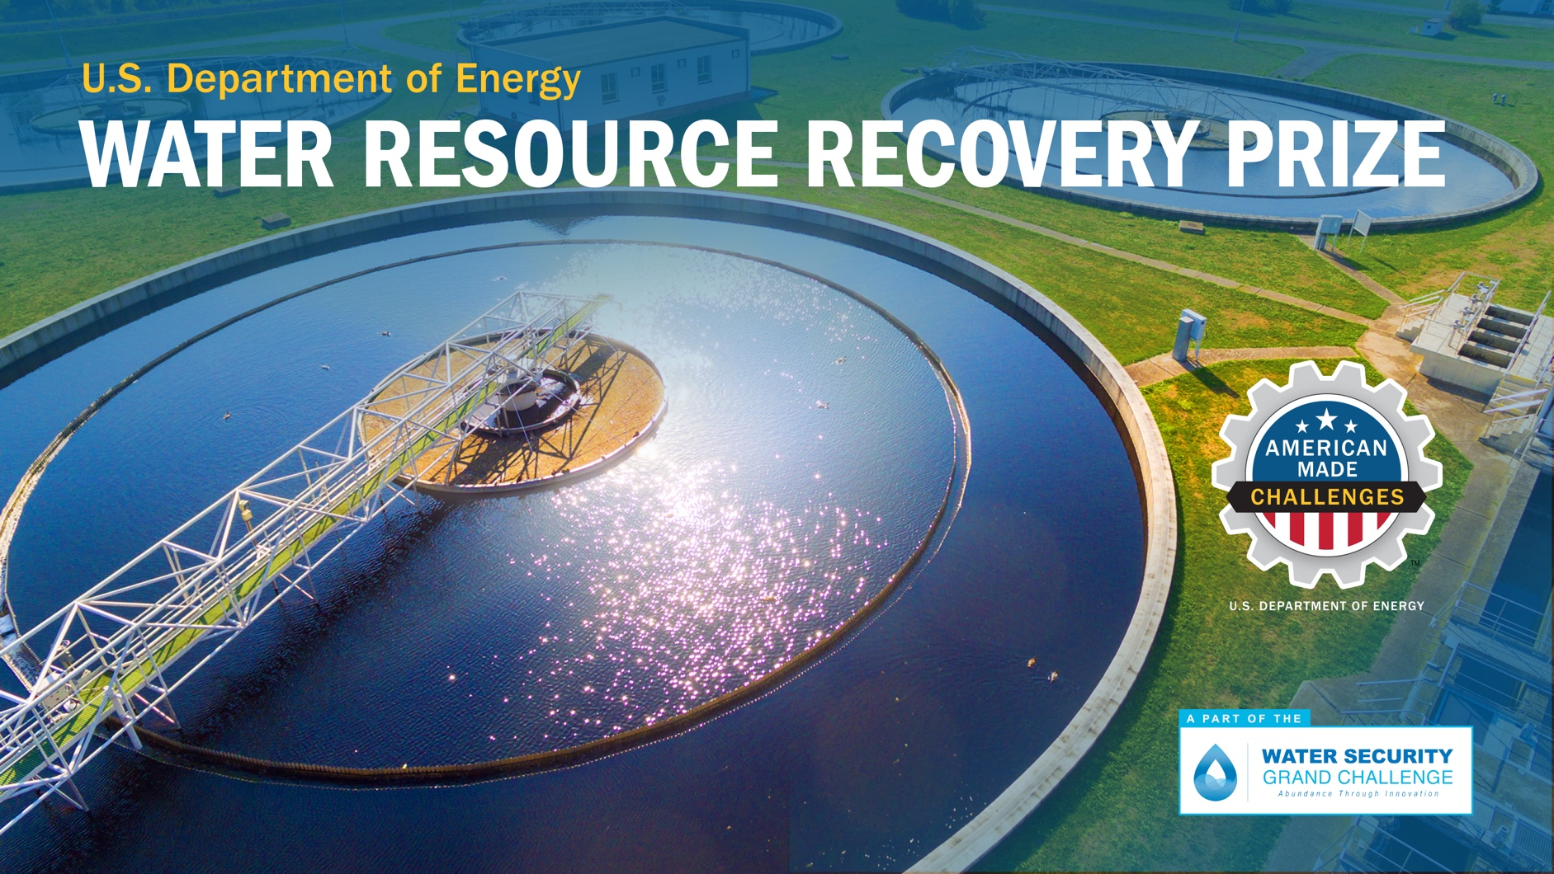

# TECHNICAL NARRATIVE TEMPLATE PHASE II

# Plans & Detailed Analysis

## Project Name [Your team’s name]

Tagline: *[Your mission or idea as a single catchy sentence]*

## Technical Narrative Template

Please refer to the official Rules Document for each criteria question and its associated suggested content. Your response to these questions can be structured however you choose, just be sure to address each question in your answer. You should address each of the following four elements:

1. Technical Performance and Impact
2. Technical Risk Assessment and Mitigation
3. Business and Marketing Plan
4. Finance and Engineering

The Technical Narrative should include a description of the modeling and/or experimental measurement approach used to demonstrate proof of concept for the solution on its own and as part of the water resource recovery facility. Variations in performance across the range of operating conditions for the facility (e.g., average daily composition, daily and seasonal variations, and source(s) of wastewater entering the WWTF/WRRF) should be presented, along with any anticipated changes in the quantity or quality of wastewater inflow. Performance of the facility including the innovative solution should be compared to the resource recovery metrics given in Phase 1, including a discussion of the quality of the resources recovered. A discussion of the potential for transferability of the solution to other facilities should also be discussed. A technical risk assessment should be presented that considers the potential technical failure modes for the solution on its own and within the facility. A marketing and business plan should be included that identifies customers and addresses the current market conditions, future market considerations, logistical costs, other overhead costs, and local policy considerations. The marketing and business plan should also discuss seasonal and other variabilities, where appropriate. A financing and engineering plan should be presented that presents a financial analysis and engineering and construction steps to build the solution at scale as part of the facility. This aligns with the application requirements of public financing programs (e.g., from the U.S. Environmental Protection Agency’s Water Infrastructure Finance and Innovation Act program and Clean Water State Revolving Fund, among others), enabling participants to be well-positioned to apply for these and other funding sources.

Submissions should answer each of the questions in the following section. The content bullets are only suggestions to guide the competitor’s responses. Beyond the guidance mentioned earlier, competitors should exercise their own judgment on where to focus their answers. The individual answers to the questions do not have a word limit; however, the aggregate response must not exceed 25,000 words. Up to five supporting images, figures, graphs, or another graphic may also be included. Footnotes, endnotes, cover page, and captions on graphics do not count toward the word limit.

#### ****Technical performance and impact****



## Your Response:

[Enter your response here]

#### ****Technical Risk assessment and mitigation****



## Your Response:

[Enter your response here]

#### ****Business and Marketing plan****



## Your Response:

[Enter your response here]

#### ****Finance and engineering****



## Your Response:

[Enter your response here]