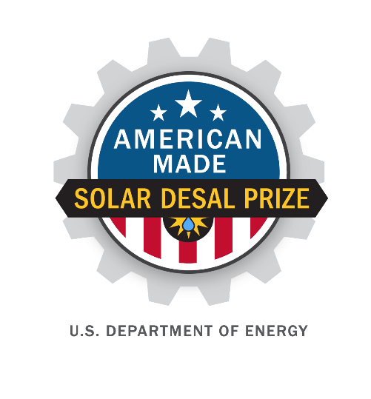
American-Made Solar Desalination Prize
SUBMISSION FOR DESIGN

PROJECT NAME
Innovation tagline (e.g., your mission in a few words)
Keyword tags

TEAM
Names, geographic locations, contact info, and LinkedIn profiles

PARTNERS AND AMERICAN-MADE NETWORK
Key project partners and organizations

The test site selected to do your output water quality testing

The Connectors (up to 3) that significantly helped you advance your solution and the major items they helped with (if applicable)

Link to your 90-second video

1

|

American
-
Made Solar Prize Official
Rules

Video Pitch: showcase your idea in 90 seconds

Post your publicly accessible video online (e.g. YouTube, Vimeo, etc.). Be creative and produce a video that conveys the required information in exciting and interesting ways but do not focus on time consuming activities that only improve production values (i.e. technical elements such as décor, lighting, and cinematic techniques). The American-Made Network may be able to help you with creating your video.
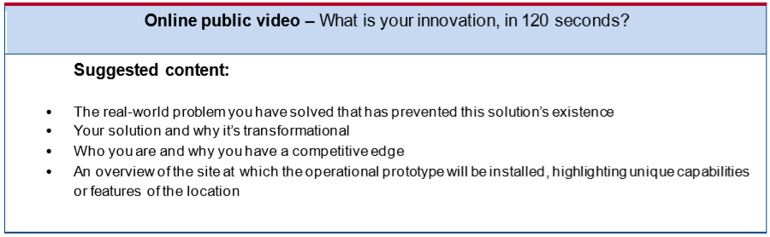
Cover Page: Include the following basic information
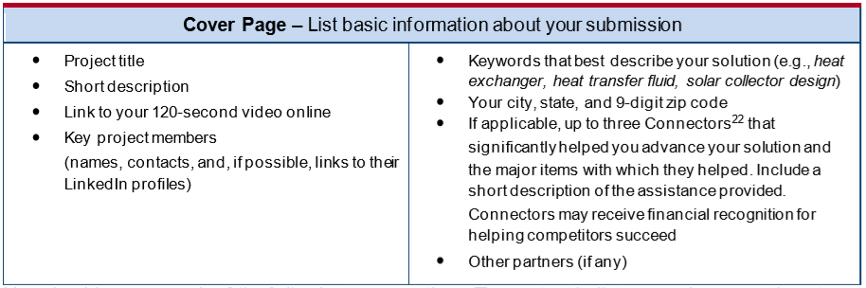

TWO Question Written Narrative

You will answer the following two questions. The content bullets are only suggestions to guide your responses; you decide where to focus your answers. Responses to these questions must not exceed 7,500 words in total. You may also include supporting images, figures, or graphs in the narrative. The reviewers will score the questions based on the content you have provided. Content that is over the word limit and time limit will not be reviewed.
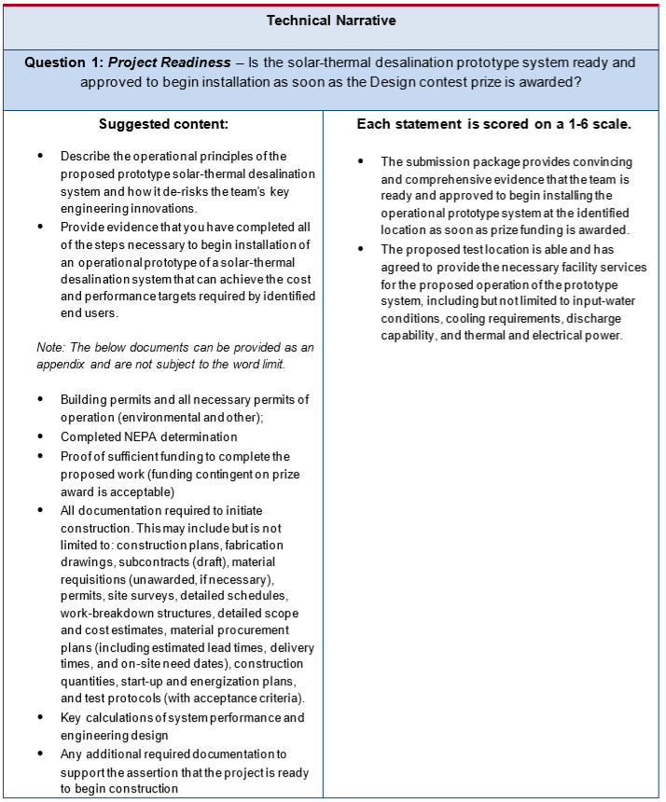
Response to Question 1:

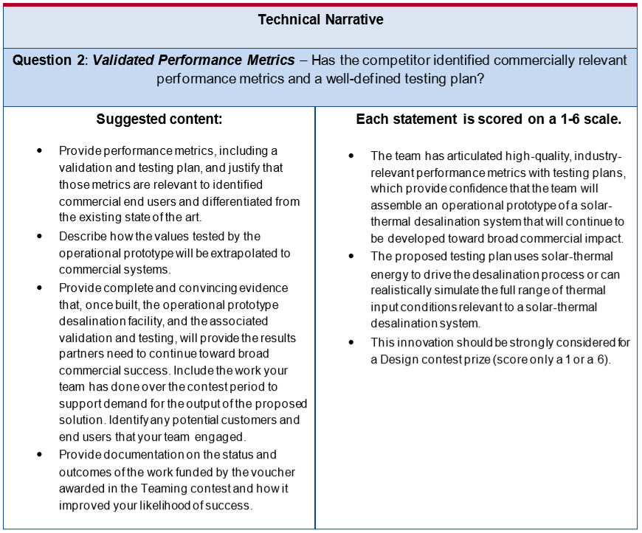
Response to Question 2:

supplementary Information

TWO question narrative word count: _______ total words

