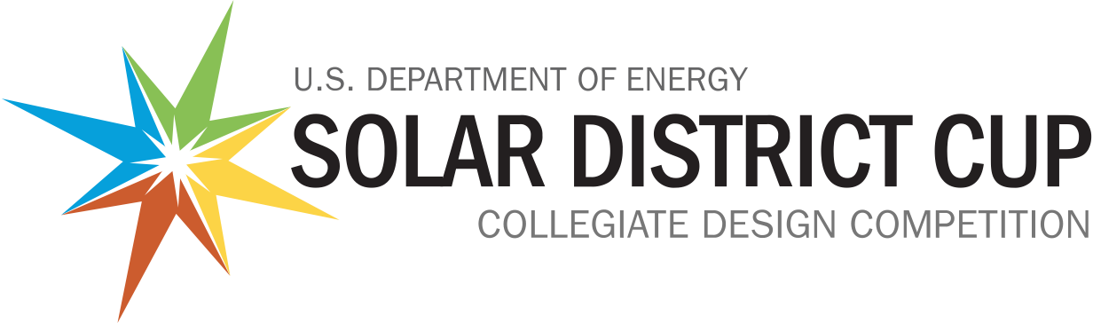
Solar District Cup Communications and Media Outreach Tips

Hello, Solar District Cup Class of 2021-2022!
As you are continuing to work toward submitting your Final Deliverable Package and present your projects at the final event, it’s important to start thinking about where and how you are presenting your team. We highly encourage you to promote your team’s involvement in the Solar District Cup and what you’ve learned so far.

Why Share Your Team’s Progress?
Self-promotion and media outreach can increase your exposure to potential employers, raise the profile of your school, and help you find additional team members. As you prepare for a career in the solar energy workforce, any examples of your experience can elevate your portfolio and help you stand out. Sharing your team’s status as a finalist in the Solar District Cup allows you to:
- Spread awareness of your involvement in a program tied to the U.S. Department of Energy and the National Renewable Energy Laboratory
- Gain interest from potential employers, including alumni and industry
- Create an opportunity to network with industry members
- Showcase your experience with a creative narrative
- Add to your portfolio of work--media coverage can add credibility to your resume.

Where Should You Promote?
Where you promote depends on where you want to be recognized. The best place to start is promoting your involvement on your own personal social media platforms, such as:
- LinkedIn
- Twitter
- Facebook
- Instagram
- TikTok
- YouTube
Remember to also tag with #SolarDistricCup and @ENERGY for more mileage of your efforts.
You can also leverage student-focused media outlets, including:
- School newspapers, magazines, online publications
- Student/school social media (contact your school PR Office)
- Podcasts, etc.

Media Outreach Tips
Here are a few tips to keep in mind when reaching out to media sources to promote your involvement with the Solar District Cup:
- Local Press is Your Friend – Local media outlets love to cover stories about local people and issues. Examples include your college/neighborhood or local newspaper, podcasts, radio, TV, or public access station. Did you leave your hometown for college? Pitch to both your college and hometown press!
- DIY Your Pitch – The smaller the media outlet, the fewer resources they have to cover stories. Drafting a short “pitch” with the details of your project and team, as well as any unique aspects you want to share, goes a long way in getting covered. If it’s well written with high-quality photos, smaller outlets will often use it verbatim (and give you photo credit).
- Use the Communications Standards – Use this guide in talking about the Solar District Cup program--it contains talking points about the program.
In the Solar District Cup Communications Standards document on HeroX, you’ll find resources to help with outreach and promotion. If you have any questions, please reach out to the Solar District Cup organizers, who are happy to help.
Good luck!
The Solar District Cup organizers

