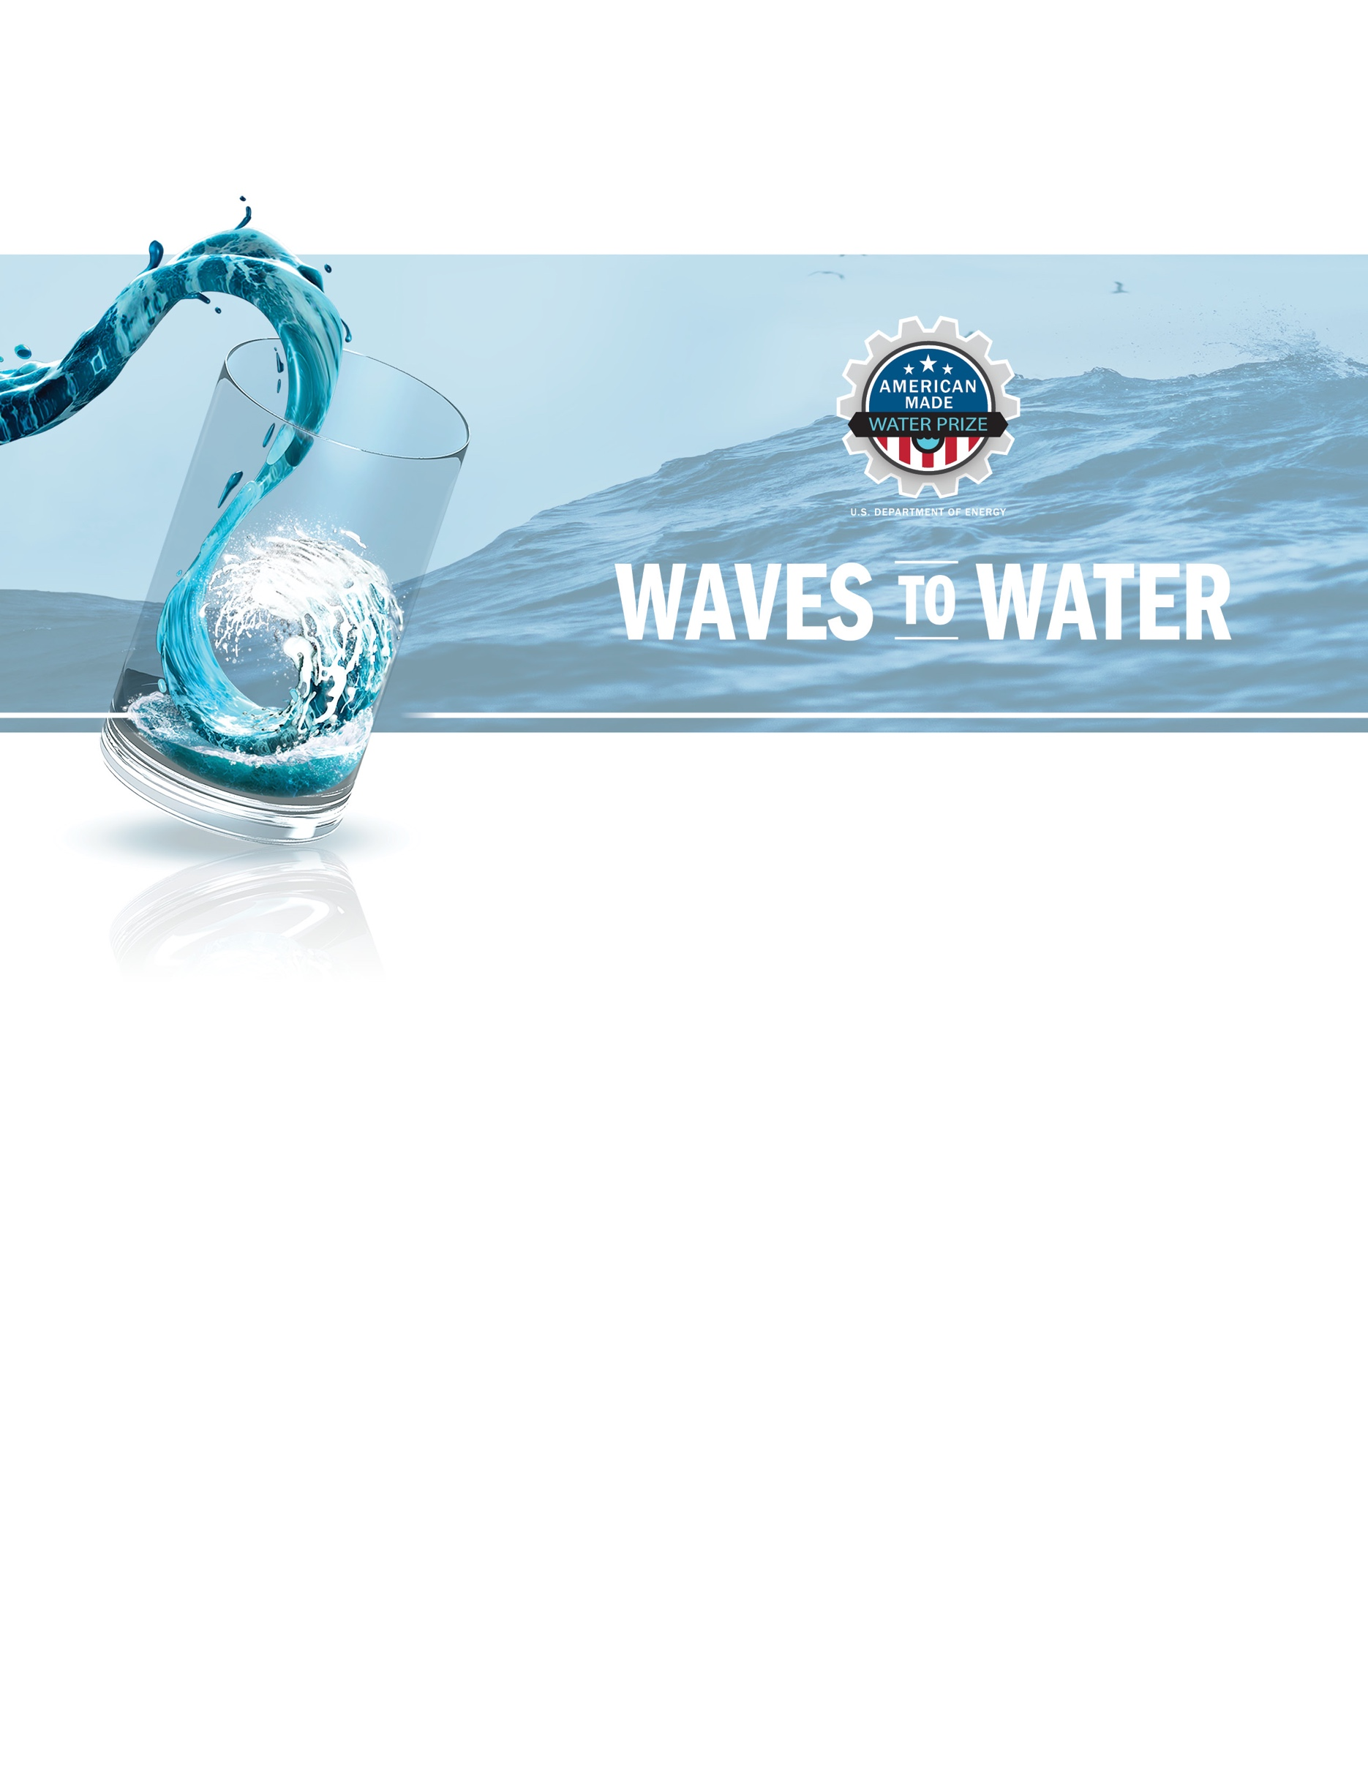

TECHNICAL NARRATIVE TEMPLATE
CREATE STAGE

Project Name [Your team’s name]
Tagline: [Your mission or idea as a single catchy sentence]

Team
Names, geographic locations, contact info, and LinkedIn profiles

Technical Narrative

There are four criteria you will be evaluated against for your Technical Narrative. You can use up to 7,500 words and up to 15 supporting images, figures, or graphs to populate the template provided on HeroX.
- Criteria 1: Validated Design and Analysis - Are your modeled assumptions and designs feasible and validated? Is there robust evidence the prototype development and system design are guided by modeling and simulations?
- Criteria 2: System Build and Deployment Feasibility - Do you demonstrate that off-the-shelf components of your system have been identified and/or purchased, and for novel system components have you demonstrated adequate design and detail of your system?
- Criteria 3: Functional Demonstration - Can you provide testing results or other documentation that you have de-risked your system through lab builds and prototypes of critical components and subsystems?
- Criteria 4: Plan – What are your goals for the DRINK Stage, and what is your plan to achieve your goals?
The table below suggests content for you to provide and the statements used to evaluate your Technical Narrative. The content bullets are only suggestions to guide your responses; you decide where to focus your response.

Criteria 1: Validated Design and Analysis
Suggested Content You Provide:  - Updated modeling documentation tables that show any major design changes made to the system since the ADAPT Stage submission  - Demonstration that the system as designed can meet the minimum system requirements  - Calculations required to show how the design functions  - Mechanical design analysis such as stress calculations or FEA  - Demonstration that adequate safety factors or load factors have been applied to critical components  - Design strategies relevant to survivability and a wide range of wave resource conditions  - The wave energy principles, desalination system, and any integration systems necessary  - Outline of major risks and failure modes and proposed or planned mitigations.  - Description of how the system will perform in conditions such as changing tides, winds, ocean currents, and imperfectly aligned waves  - Wave energy systems must include mooring and/or foundation assumptions that are required. Standard single-point mooring systems (per Appendix 2 and in the Test Site Detail Requirements Table) will be provided at the test. Should a competitor choose not to use a standard connection, detail is needed on the mooring and/or foundation assumptions. | Each Statement Scored on 1–6 Scale:  - There is sufficient evidence that the proposed system design is guided by the modeling and simulations.  - The proposed system is free of major design flaws.  - Notable or high-risk failure modes have been adequately documented and mitigation plans are in place.  - The proposed system can be expected to operate as intended at Jennette’s Pier.
Criteria 2: System Build and Deployment Feasibility
Suggested Content You Provide:  - Design drawings and bill of materials (including piping and instrumentation diagram)  - Design drawings of the following:  - Overall system including dimensions  - Power takeoff, including mechanisms and assembly  - Frame and structure.  - Specifications of off-the-shelf parts (e.g., suppliers, part serial numbers, interfaces, performance, etc.)  - Describe any specific fabrication methods required, including identification of outsourcing or external partnerships/contracts necessary for fabrication or build  - Describe how the system and any additional tooling and/or equipment will be packaged within the specified shipping container  - Deployment and installation plan, including major assumptions for time to deploy the system at a test site and description of realistic device standby modes for limited or shutdown operations  - Describe specific installation strategies including any special equipment that is needed for installation, in a narrative of how the device will be installed in a near-shore location (less than 500 meters from shore)  - Strategy/Design for installing system with common mooring  - Describe how the device will survive at Jennette’s, given the sandy bottom conditions and anticipated sediment movement during the five-day test period.  - How the desalinated water will be delivered at Jennette’s Pier considering site specific conditions outlined in Appendix 2. This should include any retrieval methods, and/or water delivery methods.  - Describe system standby mode(s) for limited or shut-down operations in the water.  - Describe any systematic perspectives on the replacement, modification, or flexible repair of COTS components or sub-systems. | Each Statement Scored on 1–6 Scale:  - The submission demonstrates that all necessary equipment and materials can be obtained before the test at the DRINK Stage.  - Through design drawings, the proposed system is thoroughly described and documented.  - The fabrication plan and methods are well described and align with the team capabilities.  - The submission provides evidence that the entire system, including all necessary equipment needed to assemble and operate the system, fits in the shipping container.  - The submission demonstrates a feasible delivery, deployment, and installation approach, and can be practically unpacked, assembled, and deployed in less than 48 hours given the constraints of deploying at Jennette’s Pier, including consideration of low visibility and crane deployment.  - The seawater intake, discharge (brine, seawater, etc.), and desalinated water delivery system is adequately described and able to meet the required metrics.

Criteria 3: Functional Demonstration—Can you provide testing results or other documentation you have of lab builds or prototypes of critical components and subsystems?
Suggested Content You Provide:  - Description of prototypes and physical testing of components and subsystems that are high-risk (e.g., novel PTO or deployment techniques)  - Any physical demonstration of the PTO system  - Any testing results that demonstrate the system will be able to meet the minimum requirements  - Any experimental or laboratory validation  - Any testing results that validate your modeled claims, including water production or energy generated  - Has the build demonstrated the device will produce water over a 5-day test period with minimal intervention?  - Any data on reliability, system performance data, or other useful measurements of something  - Any physical demonstration of strategy for installing system with common mooring. | Each Statement Scored on 1–6 Scale:  - The prototypes and physical tests are well documented.  - Tests and prototype builds demonstrate that the most high-risk elements of the system have been addressed.  - Tests provide validation that the system is capable of meeting the prize requirements.  - The demonstration or testing adequately de-risks the final DRINK Stage prototype.

Criteria 4: Plan—What is your plan to compete in the DRINK Stage?
Suggested Content You Provide:  - Describe your SMART goals for the DRINK Stage, which should include the delivery of your prototype for the open-water test.  - In defining your SMART goals, include quantified, risk-reducing, meaningful, practical, and testable interim milestones.  - Describe your strategy to develop your technology in the DRINK Stage; providing fabrication plan, diagrams, or other materials is encouraged but not required.  - Provide a high-level budget and plan to meet your goals between the conclusion of the CREATE Stage and the DRINK Stage, including how you will leverage program resources or other entities (include references to letters of support/commitment if applicable) and a schedule.  - Describe your team’s readiness to meet your goals and if additional talent and resources are needed.  - Commitment to travel for duration of competition and any alternative plan/personnel. | Each Statement Scored on 1–6 Scale:  - The team adequately describes how they reach the CREATE stage goals and did they mitigate any risks/issues.  - The stated goals are ambitious, systematic, reduce risks and show a commitment to demonstrating their system at the conclusion of the DRINK Stage.  - The team’s drive, knowledge, and complementary skill sets provide a strong competitive edge and assurance that the team will be able to deploy a system for ocean testing at the end of the prize.

Your Response:
[Enter your response here]

Supplementary Information

TECHNICAL NARRATIVE WORD COUNT: _______ TOTAL WORDS

