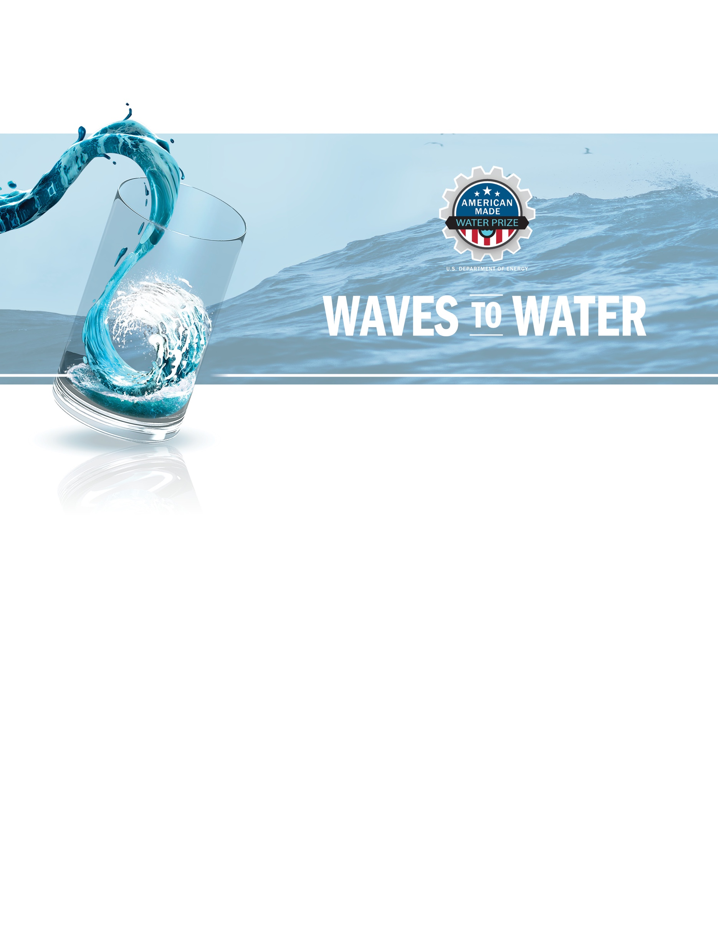

MONTHLY MILESTONE REPORT TEMPLATE
CREATE STAGE

Project Title [Title of your team’s project]

Team
[Team member names]
Milestone Title: [Title of the individual milestone being addressed in the report. The title should be pulled directly from the CREATE Stage Plan.]

Monthly Milestone Report
Milestone Progress
Please provide a short description on how your team has met or exceeded its targeted milestone. This should not exceed 500 words.

Your Response:
[Enter your response here]

CREATE Stage Prototype Risk Assessment Table

As part of your monthly milestone requirements, competitors need to complete a CREATE Stage Prototype Risk Assessment Table detailing key components of your systems, the risks associated, and a test plan - if necessary - to reduce risks of these components. To support WPTO in selecting the final competitors for the DRINK Stage, the table should be updated with every Monthly Milestone Report, so WPTO can evaluate the risks reduced through prototyping. The final submission will include details on major components of the system, outstanding and associated risks, and any modifications needed in the DRINK Stage in order to deliver a final device at the open-water test. The example table and template can be found under the Resources tab on HeroX. For further details, please refer to the official Waves to Water CREATE Stage Rules document.
Example Risk Assessment Table:

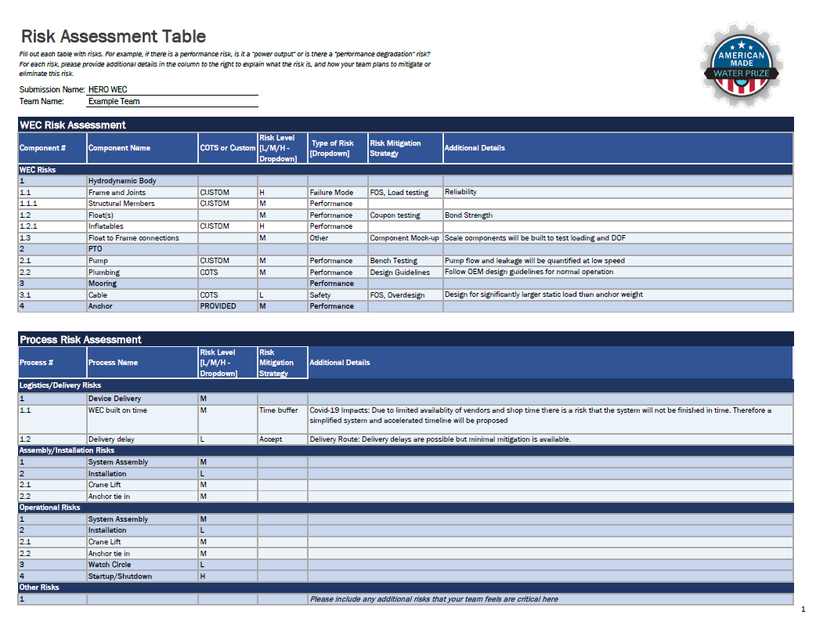

Monthly National Environmental Protection Act (NEPA) Report
Teams should submit answers to the following questions for every monthly check in. Information that is the same as the previous submission should be included in black text. Information that is changed or added from the previous submission should be included in strikethrough red text to indicate deletions and red text to indicate additions.

Comments/questions requesting clarification or additional conversation should be included in blue text.

Drawing

Please include a drawing of how you envision your device in the water. The drawing should include enough information to convey how the device and associated mooring components may interact with fish, marine mammals, sea turtles (e.g., to identify entanglement or pinch-point risks), and the seabed. Also include a drawing of the pier-based system for RO and/or water collection to provide a sense of your entire RO/WEC system.

The following questions are from the Environmental Questionnaire that must be completed by the Prize coordinators as part of the NEPA process. Questions not included here (e.g., 1, 2a, 2b) will be completed for the Waves to Water Stage V: DRINK project in general; competitors do not need to address the omitted questions.

2c. Please identify and describe: (1) any known or potential health and safety hazards (physical or chemical) the public or project workers that may result from or are associated with your proposed project; and (2) any efforts that will be taken to mitigate these hazards. Please describe them individually for the staging area (parking lot), pier, and in-water locations.

Response to Question 2c:
[Enter your response here]

2f. Please list the estimated quantities of materials used and produced by the project. Please describe them individually for the staging area (parking lot), pier, and in-water locations.

Response to Question 2f:
[Enter your response here]

3. Would the proposed project use, result in, or require the management, storage, transport, or disposal of radioactive, toxic, or hazardous chemicals, waste, or other materials that require special handling? Hazardous chemicals and materials include those that, because of their quantity, concentration, or physical, chemical, or infectious characteristics, may increase the risk of mortality or pose a substantial threat to human health or the environment when improperly stored, transported, disposed of, or otherwise managed. If yes, provide detailed description of the (1) materials; (2) approximate quantity; (3) their role in the project; and (4) storage, transport, and disposal procedures for each material.

Response to Question 3:
[Enter your response here]

4. Please describe: (1) all nonhazardous wastes that would be generated by the proposed project; and (2) the method of their disposal. Nonhazardous waste is any garbage, refuse or trash, including solid, liquid, semi-solid, or contained gaseous material. It is presumed every project will generate solid wastes, so applicants answering “none” must explain why no waste will be generated.

Response to Question 4:
[Enter your response here]

6. Does the project involve the use of any nanoscale materials or nanotechnology? If yes, please describe: (1) the nanoscale materials used; (2) potential risks those materials may pose; and (3) how they will be disposed of. Nanotechnology is defined as research and technology development at the atomic, molecular, or macromolecular levels using a length scale of approximately one to one hundred nanometers in any dimension; the creation and use of structures, devices and systems that have novel properties and functions because of their small size; and the ability to control or manipulate matter on an atomic scale.

Response to Question 6:
[Enter your response here]

7. Describe how the project activities may affect Sensitive Resources.

Sensitive Resources for Waves to Water Stage V: DRINK at Jennette’s Pier include:
- Cultural/historic resources (Jennette’s Pier)
- Threatened or endangered species (whether proposed or listed by state or federal governments), including their habitat
- Marine mammals or essential fish habitat
- Coastal zones
- Migratory birds, Golden or Bald Eagles.

Response to Question 7:
[Enter your response here]

8. Does the proposed project involve any of the following activities or areas of concern?

Dredge and/or Fill
Any shore activity with the potential for runoff to waters of the United States. Waters of the United States are all interstate waters, and intrastate lakes, rivers, streams, mudflats, wetlands, sloughs, plays, or natural ponds.

Polychlorinated Biphenyls (PCBs)
PCBs are a family of manmade organic chemicals that were domestically manufactured from 1929 until banned in 1979 due to their toxicity and persistence in the environment. Given their non-flammability, chemical stability, high boiling point, and electrical insulating properties, PCBs were largely used as dielectric and coolant fluids in transformers, capacitors, electric motors, etc. Manufacture, processing, transport, use, marking, storage, and disposal of PCBs are regulated in accordance with the Toxic Substances Control Act (TSCA). Some states also regulate PCBs as hazardous waste. The presence or absence of PCBs should be ascertained.

If the proposed project involves replacement or removal of:
- Capacitors  - Transformers  - Voltage regulators  - Circuit breakers | - Switches  - Cables  - Electromagnets  - Other electrical equipment.

If yes, please indicate (1) the anticipated concentration and quantity of PCB oil, and (2) intended method and location of disposal.

Response to Question 8:
[Enter your response here]

10. Please quantify, to the extent possible, all emissions into the ambient air resulting from project activities. Please describe them individually for the staging area (parking lot), pier, and in-water locations.

Potential emissions include:
- Greenhouse gas emissions
- Particulate matter
- Airborne pollutants (hazardous pollutants?).

Sources of emissions can include:
- Stationary sources:
  - Boilers
  - Process heaters
  - Generators
  - Solvent usage
  - Fume hoods.

- Mobile sources:
  - Vehicles.

Response to Question 10:
[Enter your response here]

12. Would the proposed project result in a discharge of any type of wastewater, pollutant, or contaminant to a sewer system, stormwater system, soils, retention ponds, or any water resources (e.g., surface water, including lakes, rivers, creeks, and wetlands, and ground water)?

If yes, please quantify and characterize the wastewater or pollutants, including thermal discharges. Provide a detailed description of the:
• Wastewater, pollutants, or contaminants to be released
• Water resources that may be affected.

Under federal law:
A pollutant is any of the following items in the table below, discharged into water:
- Sewage sludge  - Munitions  - Chemical wastes  - Biological materials  - Radioactive materials  - Heat  - Wrecked or discarded equipment | - Rock  - Sand  - Cellar dirt  - Industrial waste  - Municipal waste  - Agricultural waste.

A contaminant is any physical, chemical, biological, or radiological substance or matter in water.

For Waves to Water, please include: expected brine concentration, rate of brine production, and location of brine discharge (at the WEC or pier).

Response to Question 12:
[Enter your response here]

13. Would the proposed project have the potential to generate noise impacts to sensitive receptors (such as hospitals, schools, daycare facilities, and elderly housing), adjacent communities, employees working at the project site, and/or wildlife?

If yes, please provide a description of:
- Receptors that may be impacted and their estimated distance from the project activities
- The level of noise generated in A-weighted decibels (dbA) to each receptor
- Anticipated duration.

Example: On-site emergency notification system

Response to Question 13:
[Enter your response here]

15. Please provide a detailed description of how the project will be decommissioned, including the disposition of equipment and materials.

Response to Question 15:
[Enter your response here]

