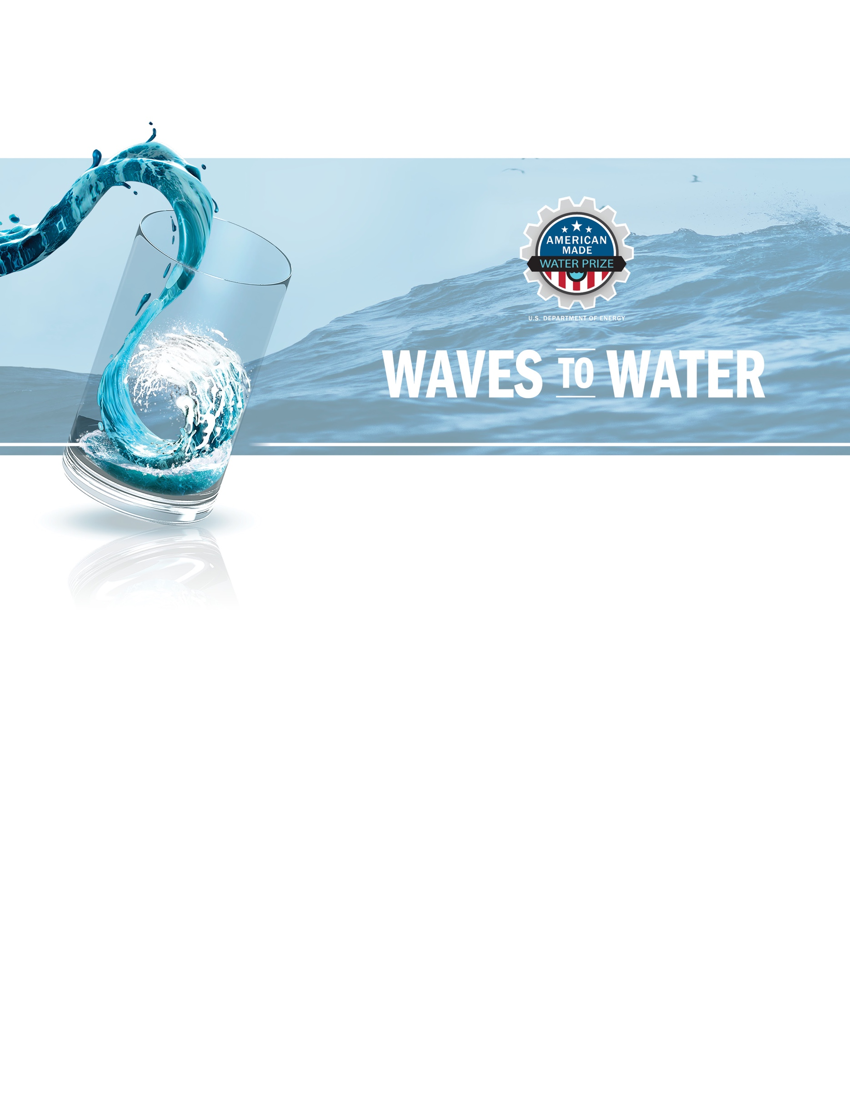

Project Title [Your team’s title]
Tagline: [Your mission or idea as a single catchy sentence]

Team Name [Your team’s name]
Names, geographic locations, contact info, and LinkedIn profiles

CREATE STAGE PLAN TEMPLATE

CREATE Stage Plan

Competitors are required to submit a CREATE Stage Plan by March 5, 2021. Please provide the required information under each of the following categories.

System Detail

Please provide a short description of your system (less than 1,000 words).

Your Response:
[Enter your response here]

System Detail Word Count: _______ TOTAL WORDS

CREATE Stage Goal and Milestones

A specific, measurable, achievable, relevant, and timely Goal to be achieved by the end of the CREATE Stage, and four interim Milestones for the CREATE Stage. Use only outcome-based goals, not activity-based, so that a neutral third party can validate them (if possible). The four Milestones developed by competitors and articulated in this CREATE Stage Plan serve as the key milestones to be reported to WPTO and the Prize Administrator for the four Monthly Milestone Reports and calls. The Milestone Reports will demonstrate progress towards de-risking your technology and demonstrating system feasibility.

Your Response:
[Enter your response here]

CREATE Stage Prototype Risk Assessment Table

Competitors will need to complete a Risk Assessment Table detailing key components of their systems, the risks associated, and a test plan—if necessary—to reduce risks of these components. The example table and template can be found under the Resources tab on HeroX. For further details, please refer to the official Waves to Water CREATE Stage Rules document.
Example Risk Assessment Table:

