Step-by-Step
EQ-1 Submission Guide for DOE Award Recipients

The purpose of completing the Environmental Questionnaire (EQ-1) is to gather detailed information about the proposed project from the award recipient. The information in the EQ-1 is required for the DOE National Environmental Policy Act (NEPA) review. NEPA is a federal law requiring ALL federally-funded projects to undergo an environmental impact review. The following step-by-step instructions will guide you through the EQ-1 submission process. If you have any questions, please contact the Project Officer or Project Monitor assigned to your award, or you can send questions by email to gonepa@ee.doe.gov.
Note- after 15 minutes of inactivity, (which means 15 minutes between saving data-i.e. hitting “Next” to save data) users may receive a warning notice, but will automatically be logged out of the PMC. Users may want to consider completing the EQ-1 Microsoft Word document, in order to cut and paste information into the online EQ-1. The online version of the EQ-1 must still be completed. The EQ-1 Microsoft Word document is located on the PMC Recipients login page.
- Access the Project Management Center (PMC) at https://www.eere-pmc.energy.gov/.
  - The PMC is the database used to manage the NEPA process.
- Click on the “Recipient Resources” tab, as depicted below.
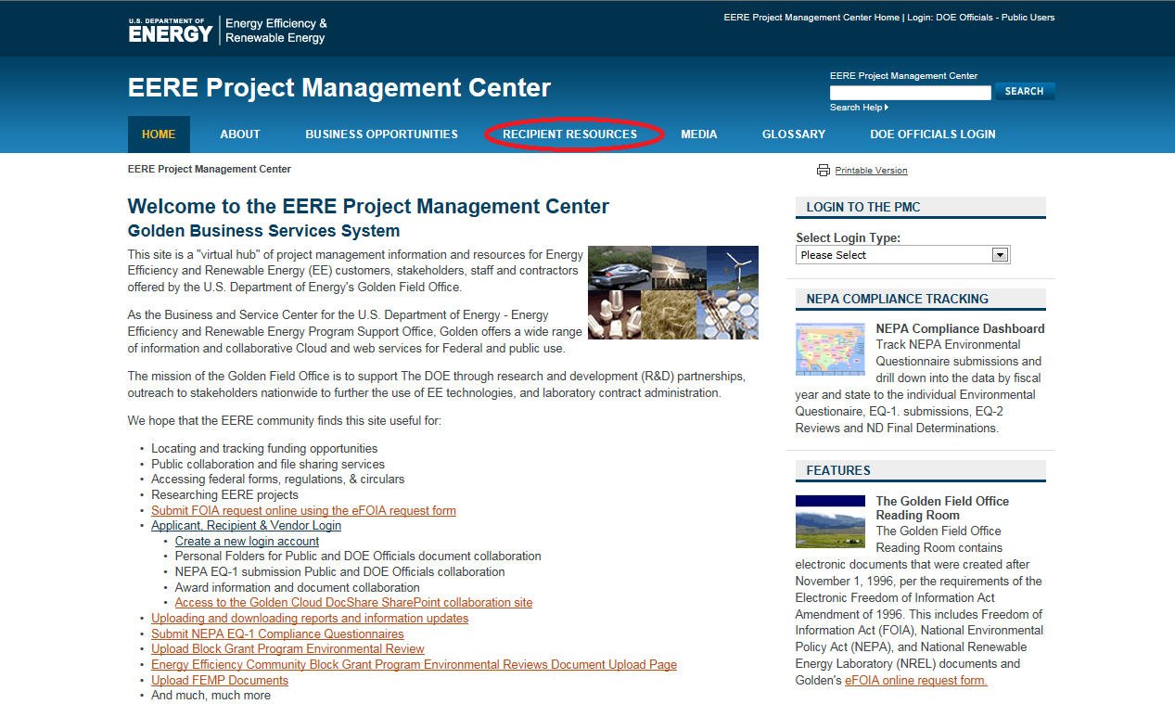

- As illustrated below, click on the “Create Recipient/Applicant Account (for Applicants, Recipients and Vendors)” link at the second bullet, as shown below.
  - If you already have a login, and completed the Multifactor Authentication, click on the first bullet of the column on the left, “Recipient/Applicant Login,” and then move to Step 18 of these instructions. If you have not completed the Multifactor Authentication, even with a login, you will be required to complete this process, and it is explained starting at Step 11.
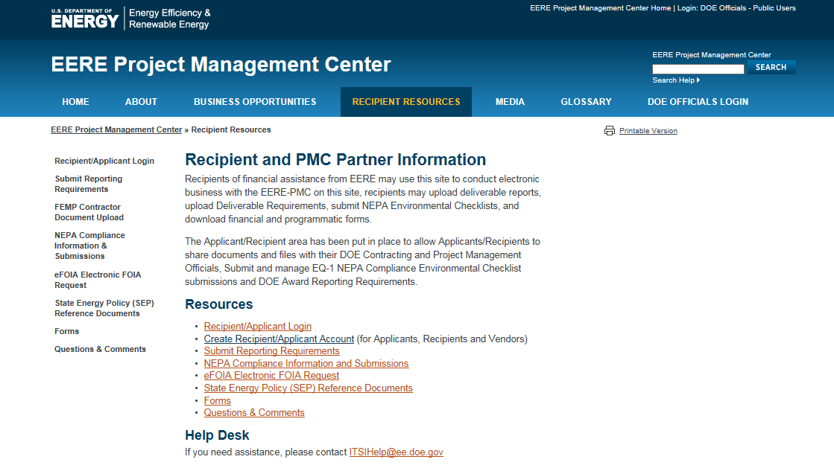

- Continue by clicking on, “Create New Account” as noted below:
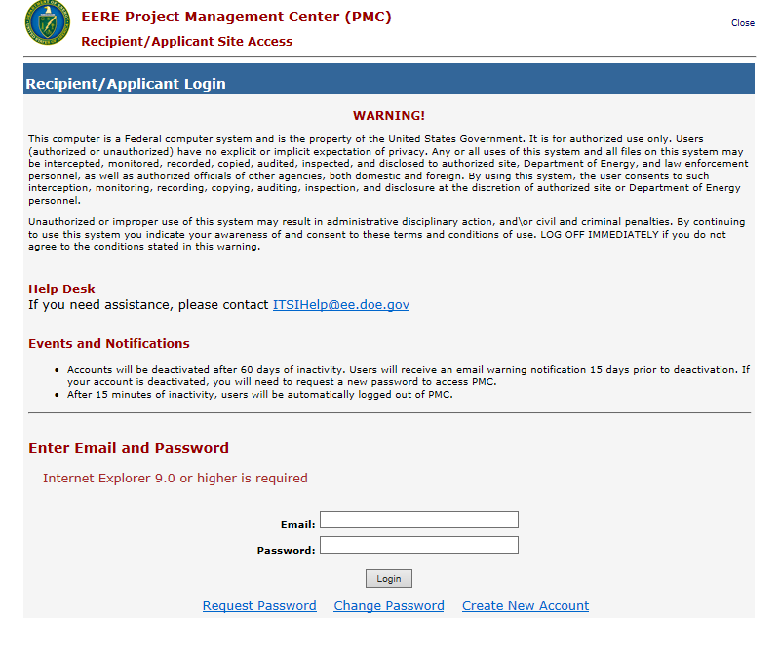

- Read the System Rules of Behavior and click on “Accept” as shown below, to continue:

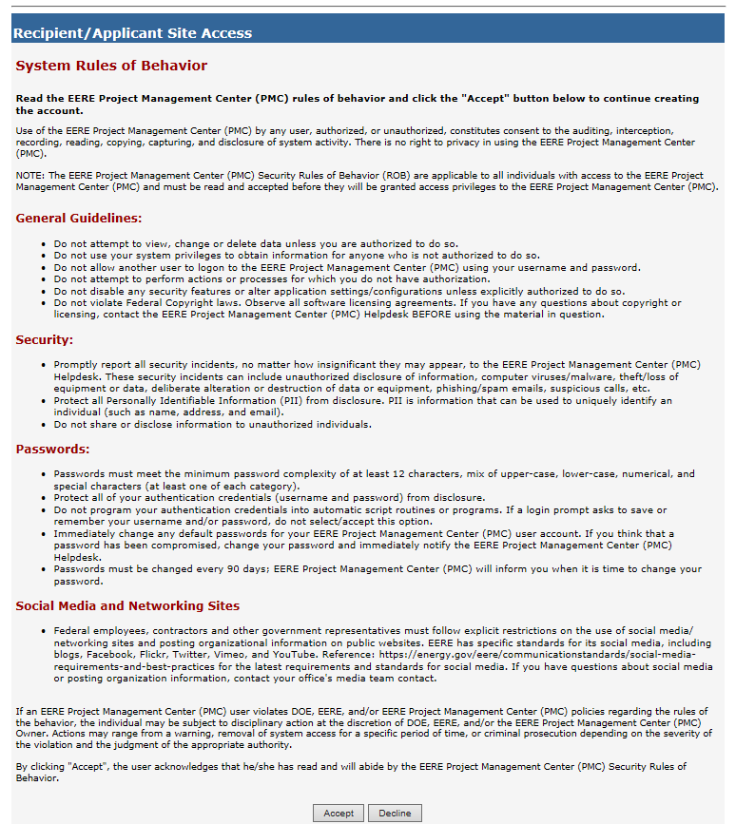

- Once you have entered the required information, click “Create” as demonstrated below:

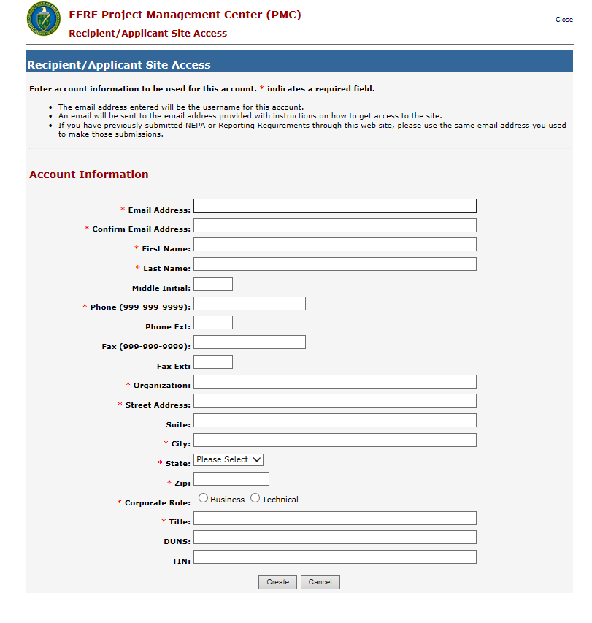

- You will then receive an email with a temporary password, like the one below :
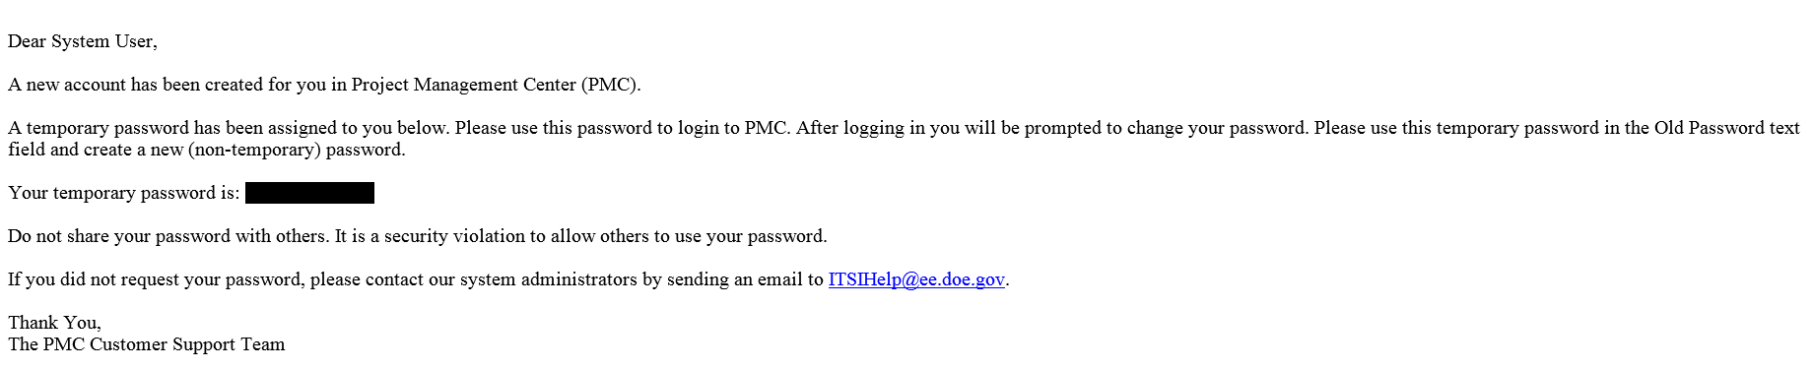
- Click on https://www.eere-pmc.energy.gov/PMCRecipient/, and enter your temporary password, in the password box, along with your email address:
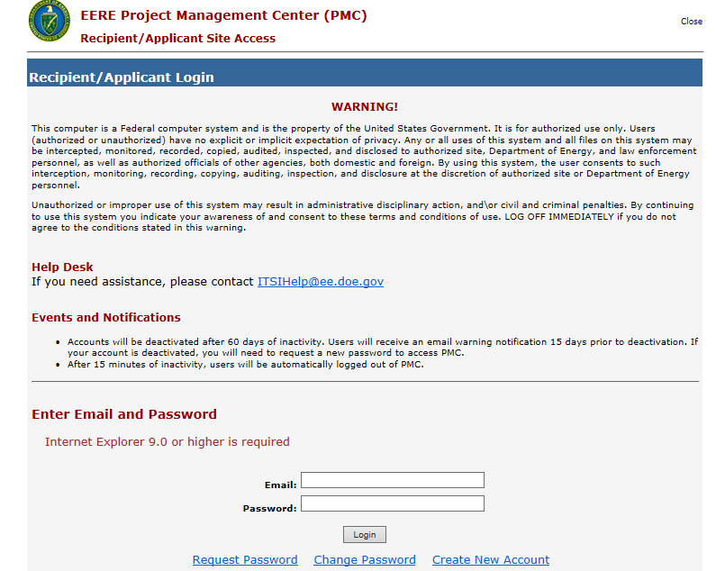

- Once you enter you temporary password, you will be prompted to change your password, in the screen below:
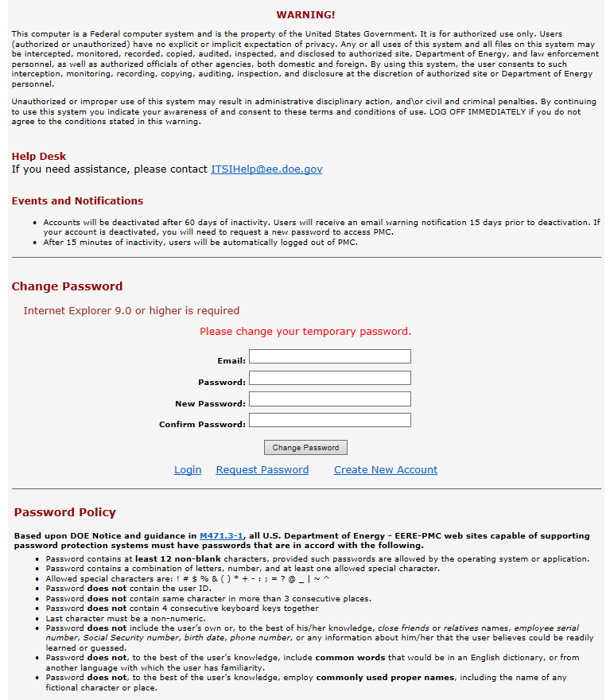

- Once your password is accepted, the system will take you back to the Recipient/Applicant login to login with your new password, as demonstrated below:

- You will need to set up Multifactor Authentication (MFA) if this is your first time using the system. If you’ve used the system in the past, you may also be prompted to set up Multifactor Authentication if you haven’t yet done so. If MFA needs to be set up, you will see the prompt illustrated below. Click on “Continue” to proceed to the next screen.

- If you’ve already set up MFA, please skip to Step 15.

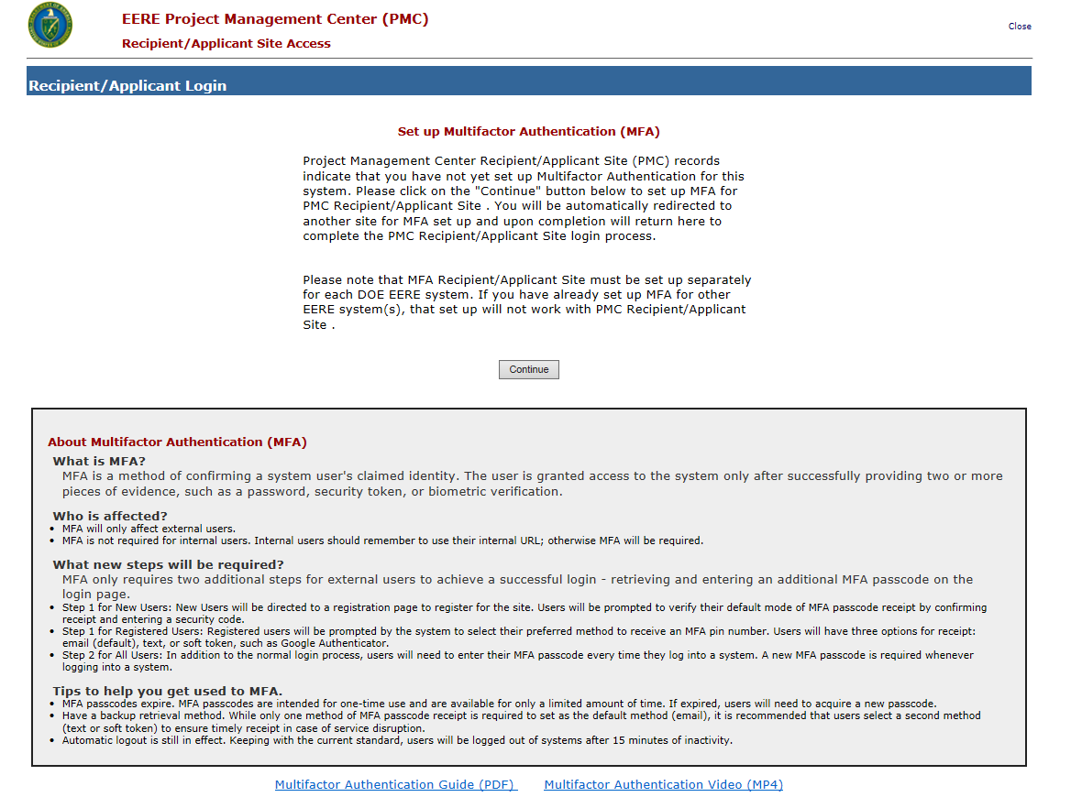

- An email will be sent to the address you provided previously with a verification code required for MFA setup. Review your inbox for the verification code and enter into the field highlighted below. Click on “Continue” to proceed to the next screen.

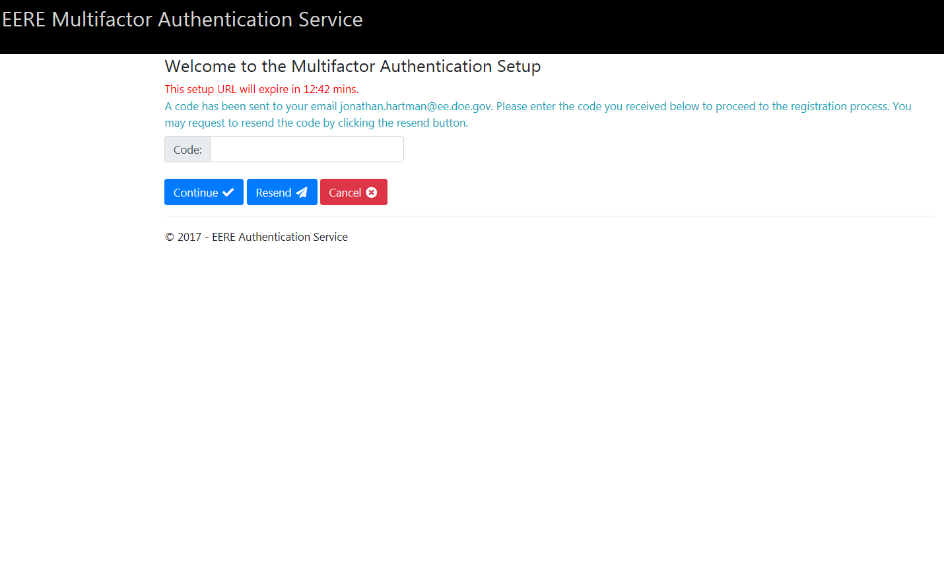

- Select the delivery method you would like to use to complete MFA when logging in. The selected delivery method will be used to receive a temporary password that will be required for login to the PMC. Click on “Finish” to proceed to the next screen.

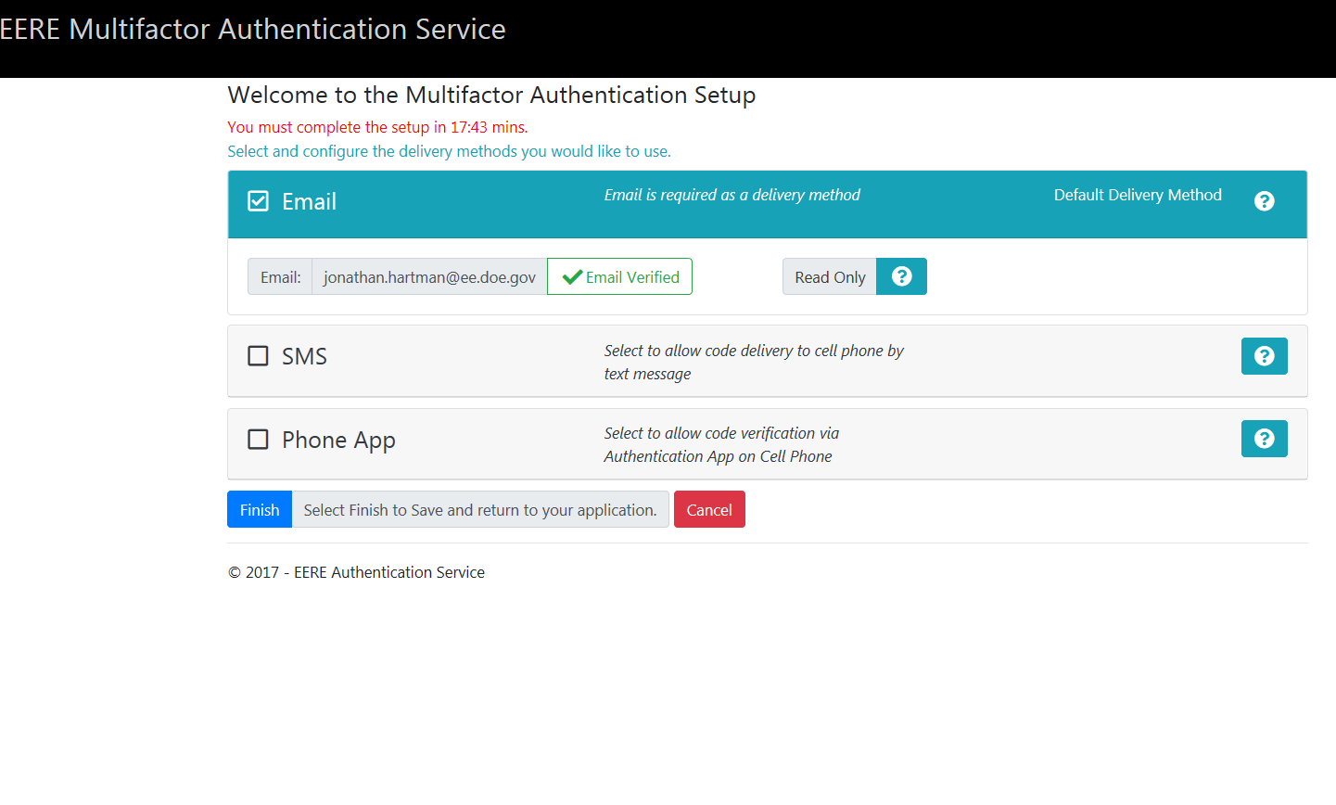
- Upon completion, you will see the confirmation screen presented below. Click on “Return to the Application” to proceed to the login screen.

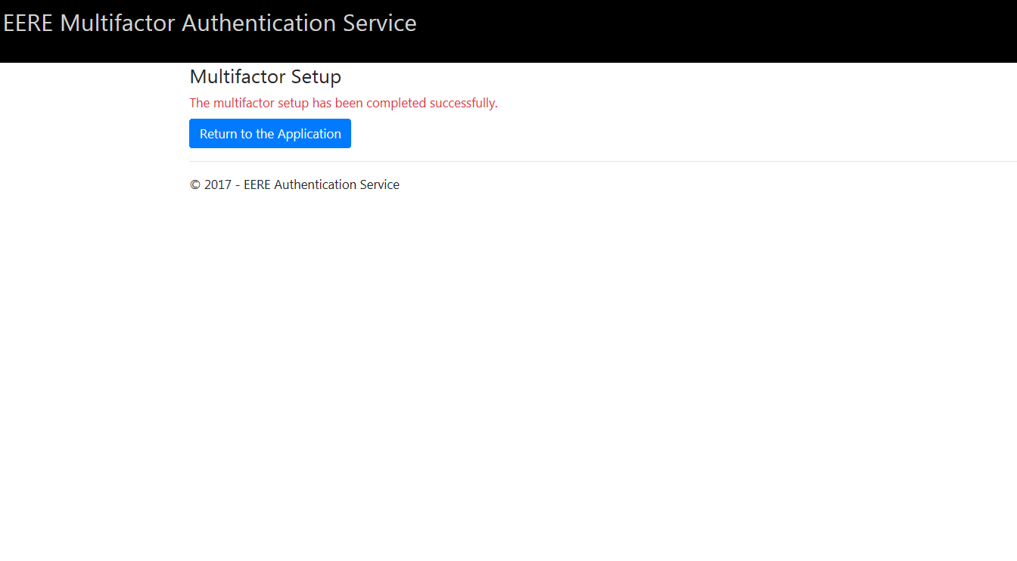

- At the login screen you will be prompted to select your method for receiving an MFA code. Select the appropriate delivery method. Click on “Continue” to proceed to the next screen.

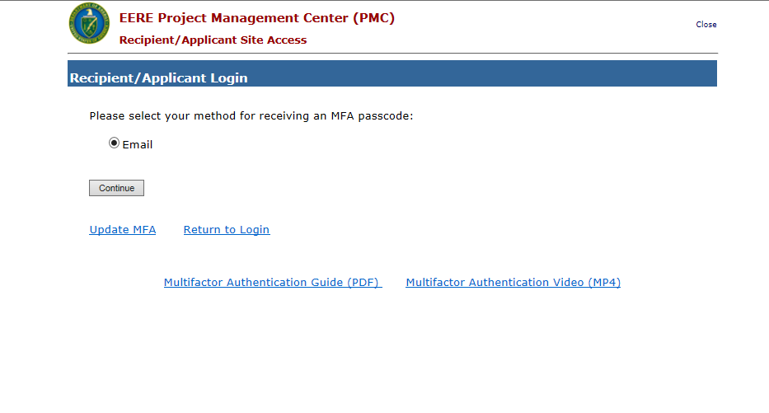

- Review your email (or other delivery method if selected) for a confirmation email with a temporary MFA passcode. Enter the passcode into the screen below. Click on “Continue” to proceed to the next screen.

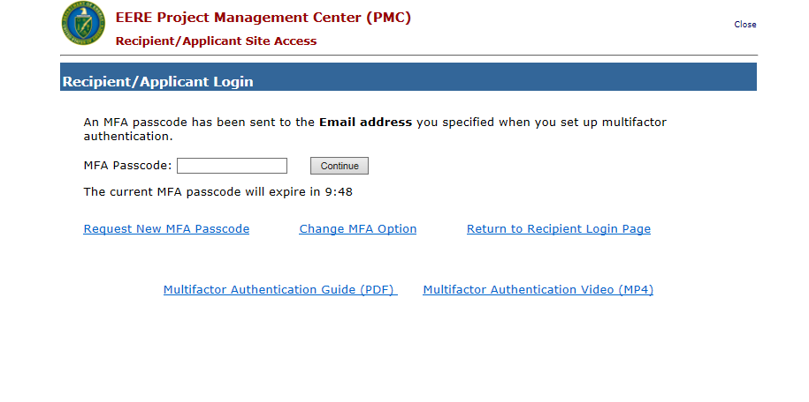

- Read Security Notice and click on “Accept” as noted below to continue:

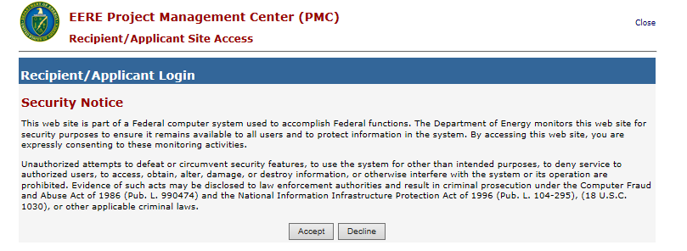

- After login, click on the “NEPA EQ Submissions” tab.
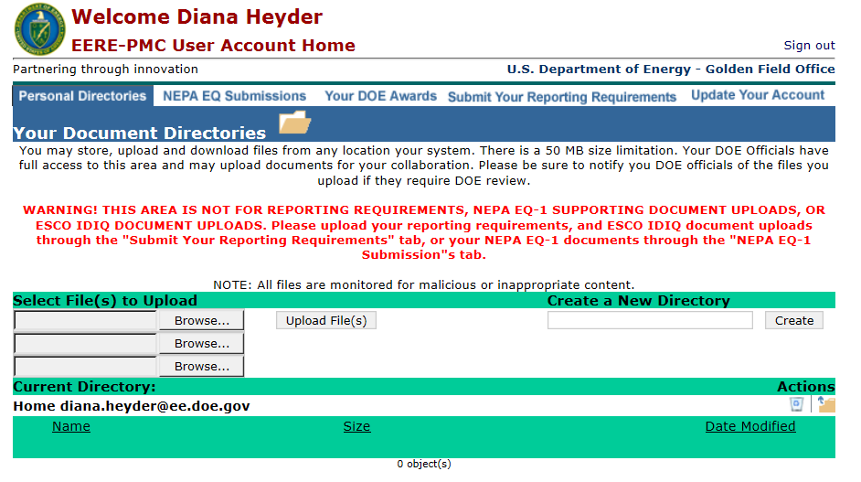
- Click on the “Submit a new NEPA Environmental Questionnaire (EQ-1) Form” link highlighted below.
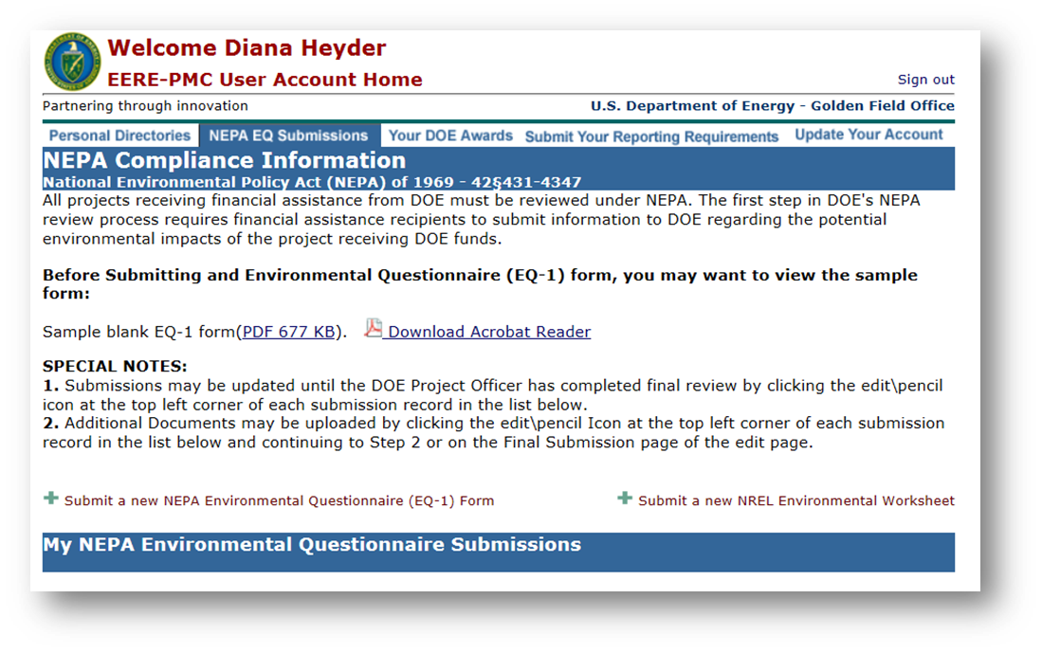

- Complete the required fields as indicated by the red asterisks. If you have the Financial Opportunity Announcement (FOA) Number or DOE Award Number (CID), enter those in the appropriate fields, and click on “NEXT” as indicated below. The “Not Listed” box (es) may need to be checked to allow new Award or Funding Opportunity Numbers to be added.
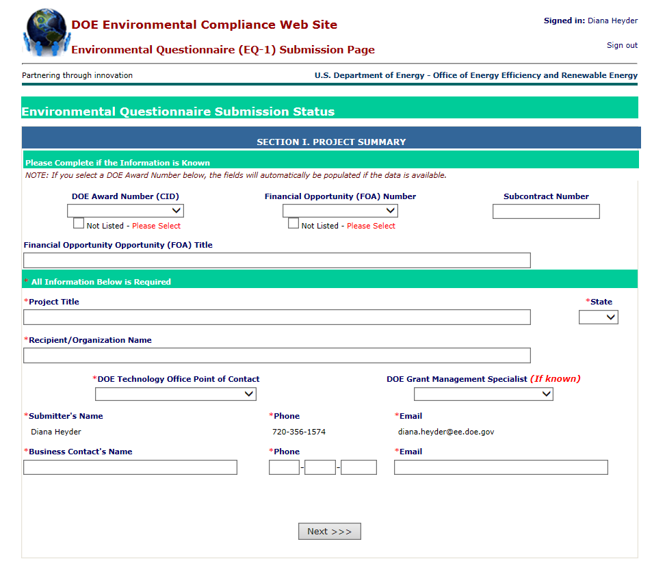

- Upload the Statement of Project Objectives (SOPO) for the proposed project, and click “Next”.
- You are required to upload a document to move to the next step. If your SOPO isn’t final, upload a draft SOPO, indicating the draft status by naming the file “DRAFT SOPO.”
- Later in the process you will have the opportunity to upload additional documentation, if necessary.

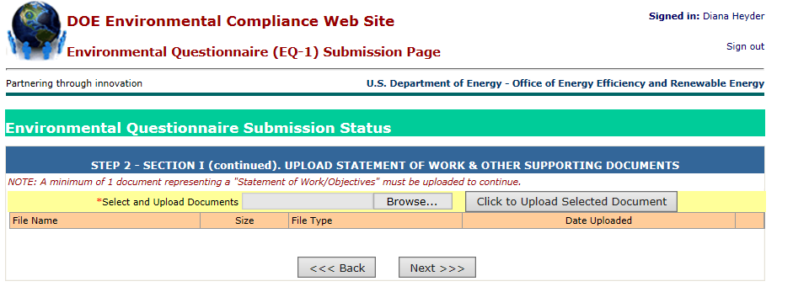

- You will see the instructions for filling out the EQ-1. Please read carefully. Click “Next” to begin filling out the EQ-1.
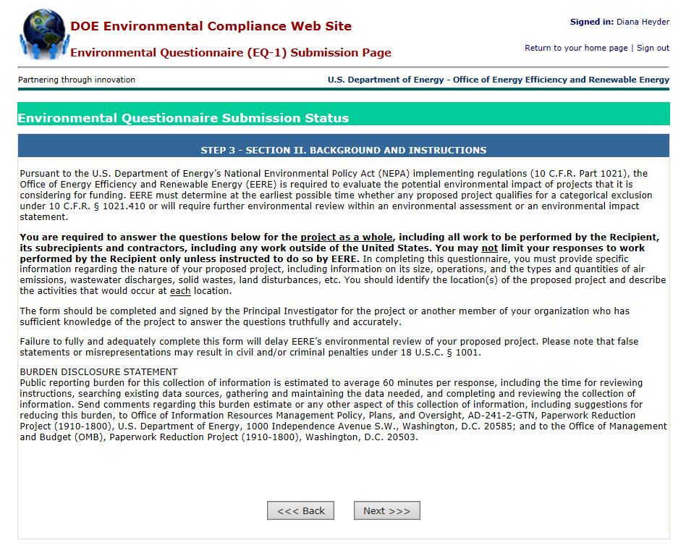

- You should now see the first page of the questionnaire starting with question 1a. Each question will have an example of the type of information you should be entering into the field.
  - The EQ-1 has 13 total questions with question 1 having three parts (a, b, and c) and question 2 having eight parts (a, b, c, d, e, f, g and h).
  - Please pay close attention to question 1c. Only answer “Yes” to question 1c if your project will not include any activities beyond Intellectual, academic, and analytical activities. If your project has activities composed of laboratory work or field work, you must answer “No” to question 1c.
  - Answering “Yes” to question 1c means that you have completed the EQ-1. If your project requires a “No” answer to question 1c, you must complete all 13 questions in the EQ-1.
  - Continue to click on “Next” to continue to advance to the next screen.

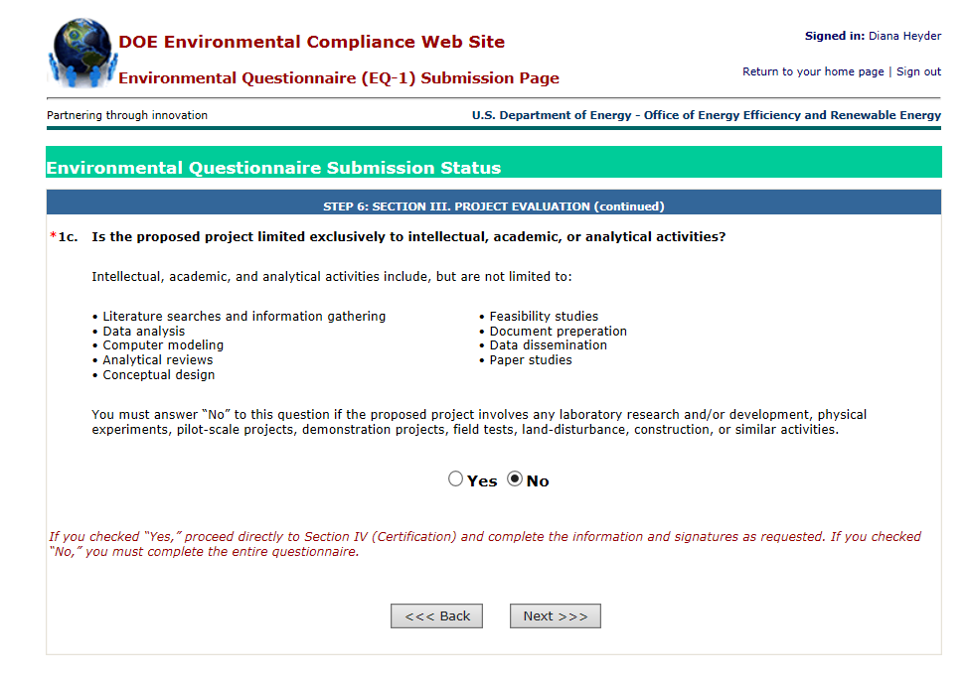

- Question 2b asks you to describe the locations where proposed project activities would occur. It is helpful to include the associated Task/Subtask number(s) if the SOPO is finalized for each activity described.
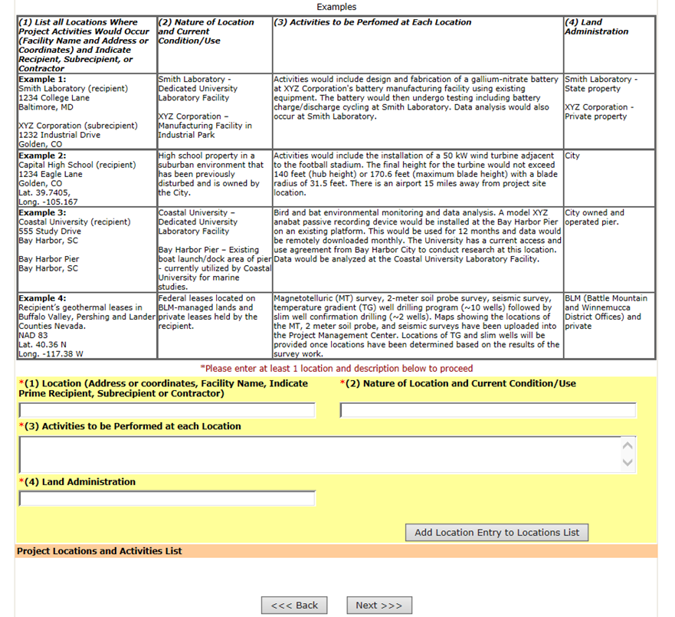

19. The person completing the EQ-1 should certify and submit, as shown below. Once the EQ-1 is submitted, the Project Officer selected at the beginning of the NEPA submission process will be notified automatically.

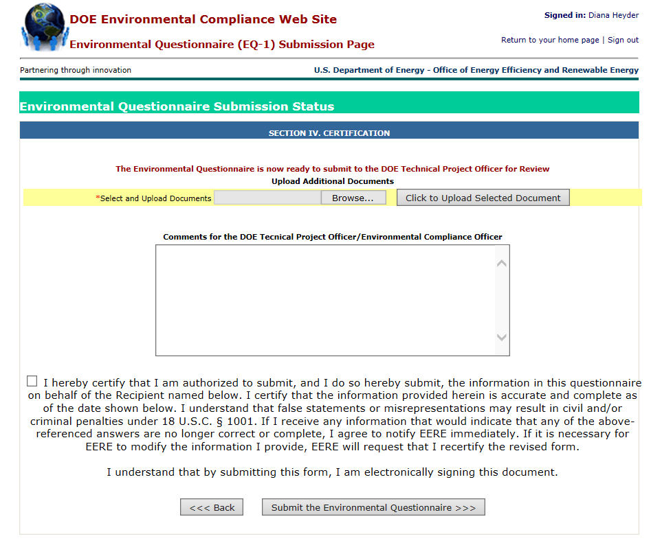

20. It is important to note that if you wish to return to edit your EQ-1 or upload additional documentation, you will not create a new EQ-1. When you login, click on the “NEPA EQ Submissions” tab as shown in Step 12. A list of current projects you have created will be displayed. Click on the “Update the DOE EQ-1” link for the project you wish to edit.

