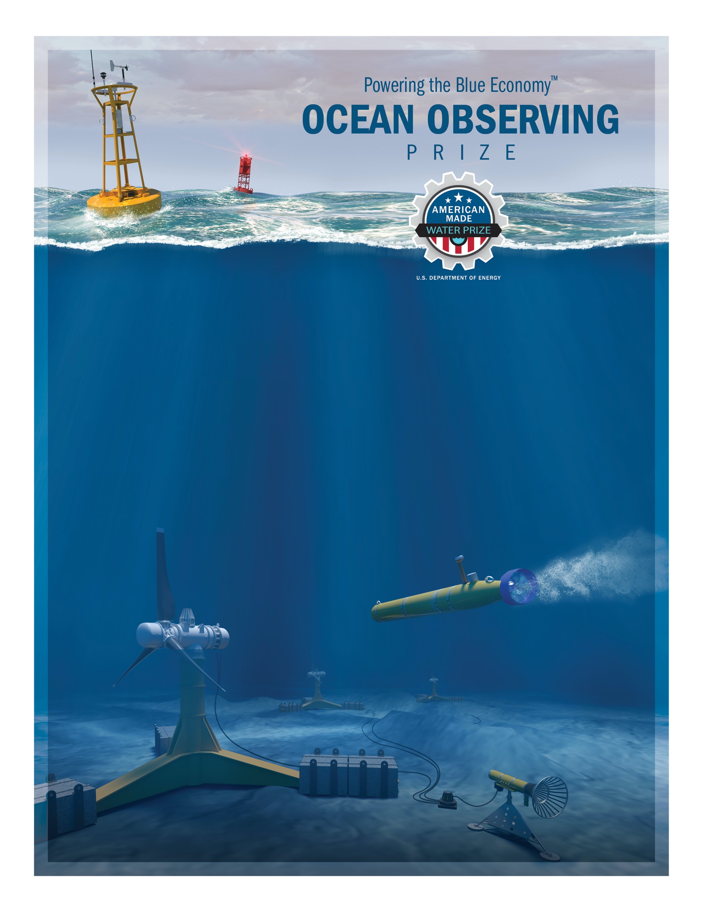
DEVELOP COMPETITION

Eligibility Waiver

Overview
Any entity seeking a waiver for the Domestic Ownership and Control Requirement must fill in this form. This requirement applies only to the authorized account holder, who should also be listed as the primary applicant on the HeroX submission. Partners beyond the authorized account holder are beyond DOE’s concern.

The U.S. Department of Energy Water Power Technologies Office (WPTO) encourages any competitor that believes it needs a waiver to submit it prior to the close of the submission period to receive direction from WPTO on whether a waiver will be provided; however, WPTO does not promise to respond prior to the submission closing with a determination. WPTO may require additional information before making a determination on the waiver request. Submit all completed waivers to wptoprizes@ee.doe.gov.

Lead Entity Information
Fill in the information below for the lead entity, including place of incorporation.
Lead Entity Name and Place of Incorporation:
[Enter lead entity name and place of incorporation]

Location of the Entity’s Primary Place of Business:

[Enter location of entity’s primary place of business]

Written Statement
A statement describing the extent the entity is owned or controlled by a foreign government, agency, firm, corporation, or person who is not a citizen or permanent resident of the United States, including the applicable percentage of ownership/control.

Your Response:
[Enter your response here]

Justification
A compelling justification that addresses the waiver criteria stated above.

Your Response:
[Enter your response here]

United States Economic Contribution
A description of the project’s anticipated contributions to the U.S. economy.

Your Response:
[Enter your response here]

Benefit to United States
A description of how the entity has benefitted U.S. research, development, and manufacturing, including contributions to employment in the United States and growth in new U.S. markets and jobs.

Your Response:
[Enter your response here]

Promotion of United States Manufacturing
A description of how the entity has promoted domestic manufacturing of products and/or services.

Your Response:
[Enter your response here]

