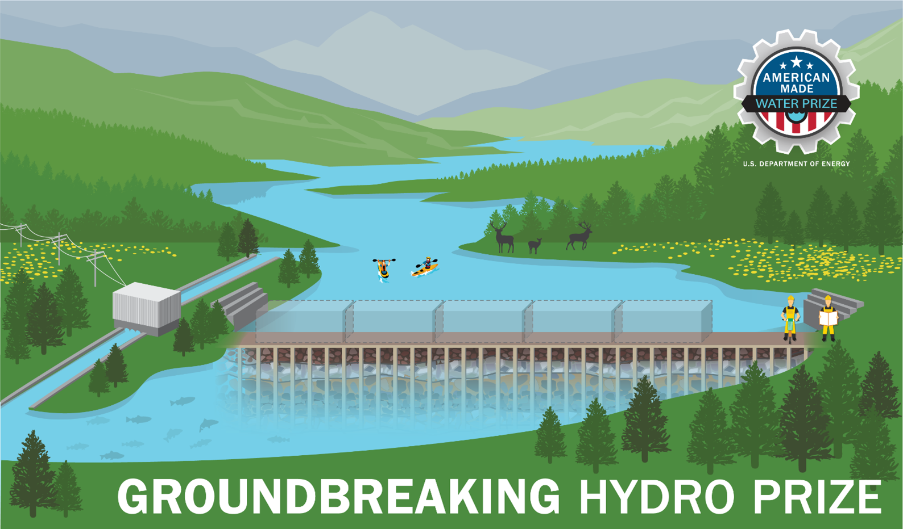

TECHNICAL NARRATIVE TEMPLATE
Groundbreaking Hydro Prize

Project Name [Your team’s name]
Targeted Development Phase: [Enter one or more of the three categories]
Geotechnical Site Assessment
Foundation Design
Foundation Construction

Short Description:
[A clear and concise description of your idea that anyone can understand in 80 words or less]

Video Pitch: Showcase Your Idea in 90 Seconds
Produce a 90-second video that will help the judges and general public understand your concept. Be creative and convey your information in a fun and engaging way, but do not expend time on labor-intensive activities that only improve production quality (i.e., technical elements such as décor, lighting, and cinematic techniques). Judges will focus on content, not the quality of video production. Upload your video online to a publicly accessible platform (e.g., YouTube, Vimeo, etc.). Include your link below:
Link to Your 90-Second Video

Key Project Members:
[Fill in the information below for each team member. The first team member listed should be the Team Lead]
Team Lead Name: [first, last]
Team Member 2: [first, last]
Team Member 3: [first, last]
Team Member n: [first, last]

Written Technical Narrative
Please refer to the official Rules Document for each criteria question and its associated suggested content. Your response to these questions can be structured however you choose, just be sure to address each question in your answer. The aggregate response for the narrative must not exceed 2,500 words. You may also include up to five supporting images, figures, or graphs. You are highly encouraged to include a graphic illustration of your concept as one of your five allowed illustrations. Do not include any hyperlinks other than your video pitch in your submission—they will not be viewed.

Your Response:
[Enter your response here]

Supplementary Information

NARRATIVE WORD COUNT: _______ TOTAL WORDS
Please use the HeroX Platform to submit your Summary Slide and the optional Resources Needed documents for the complete submission package.

