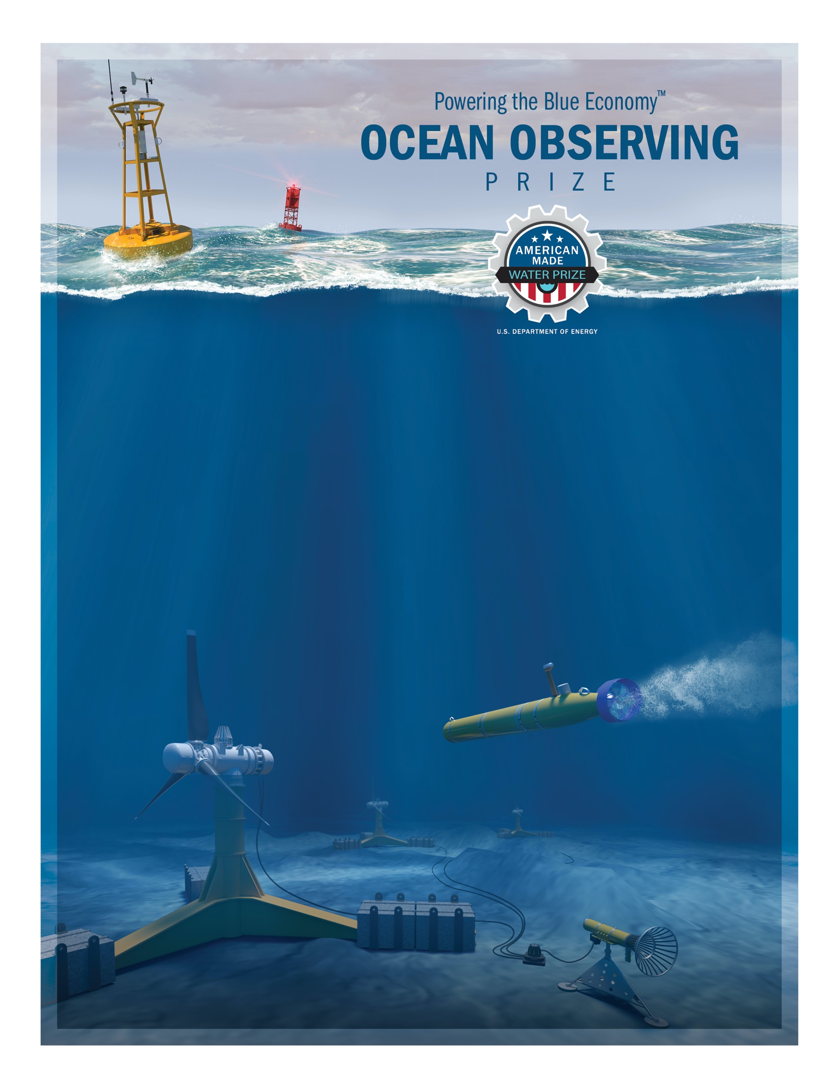

[Team Name]
[Team tagline or max two sentence description]
DEVELOP COMPETITION
Design Contest Narrative

General

Design Philosophy
[Discuss the team’s approach when designing the system, what elements the team focused on as most important, how the prototype is working towards a commercial system, etc.]

Market Opportunity
[Aside from the intended mission, discuss other ocean observing applications for the proposed design that the team thinks would be viable pathways to commercialization.]

Team Experience
[Describe the team, its relative experience, and available resources. Highlight unique attributes that set the team apart from the competition or give them an advantage over others.]

System Architecture

Hull Design and Structure
[Describe the hull design and component placement for the system. Describe the shape of the hull, principal dimensions, weights, materials used, depth rating, safety features, buoyancy, etc.]

Wave Energy Harvesting
[Describe the wave energy harvesting method, its principles of operation, anticipated power output, the power take-off method, etc.]

Propulsion
[Describe the means of propulsion for the system and justify that this method will be sufficient given the estimated drag and energy storage capacity of the system. Demonstrate that the system will be able to achieve the speed requirement.]

Payload and Sampling
[Describe how the system accommodates the selected CTD and the dummy payload package. Describe how the CTD and dummy payload package are situated in the system, how power is delivered, how data is collected and stored. Justify that the system will be able to control depth/altitude to collect data at specified depths.]

Communications
[Describe the communication subsystem to include such topics as: communication protocol, redundancy, data packet size, telemetry rate, range, and performance in indoor and outdoor settings.]

Navigation and Control
[Describe the navigation subsystem that allows the system to follow a course, turn, etc. Demonstrate the degrees of freedom desired for the system. Discuss the feedback and control method that allows the system to course correct. Discuss the different navigation methods for surface and subsurface operation. If a multi-body body system, describe how the two bodies will navigate in a coordinated fashion. Discuss the GPS subsystem chosen and its predicted performance. Discuss the method of how the system will control depth/altitude.]

Power Systems
[Describe the system’s power subsystem to include the battery, charging components, waterproofing, voltages, etc. Describe the power management subsystem and its control strategy. Discuss how the required kill switch will affect the system. Justify the minimum average power consumption of the system while its operating and collecting data. Estimate the operating duration of the prototype system when in normal operation.]

Safety and Environmental
[Describe any potentially hazardous materials, components or fluids that may pose a threat to human or environmental health. Describe any safety features on the system to protect operators. Discuss the weight of the prototype system and how this will be safely handled by crew.]

Operations

Energy Harvesting
[Describe how the system will perform in different wave conditions, the estimated power output, and how the rate of charge will be sufficient for the system.]

Sampling and Data Collection
[Describe how the prototype system will perform profiling of the water column using the CTD and dummy payload and how the data will be handled on board and/or processed. Describe how the system will control depth/altitude while sampling. Justify the estimated power consumption while sampling.]

Communications
[Describe how the contestant team will send commands and receive data to the prototype system]

Assembly, deployment and recovery
[Describe in general terms how the system will be assembled from it’s packaged-state, how long it is estimate to take, methods of safe deployment and recovery into and from the water using a vessel, and other aspects that relate to preparing the prototype system for deployment. Include how the system will be stored in the specified volume.]

Build Plan

Estimated Costs
[Describe the estimated costs for building the prototype. Contestant teams are not being scored on the cost of systems but in the accuracy of the information]

Tasks and Schedule
[Describe the major tasks that need to occur to build the proposed design, including the order in which they should occur and the estimated time to complete them.]

Risks and Mitigation Strategies
[Describe any perceived risks that the team might encounter in their build plan and how the team will effectively mitigate them]

System Modifications
[Describe future modifications to the prototype design that would make it suitable for the intended mission of a six-month deployment for hurricane monitoring in the Atlantic. This could include changes to the hull structure, control strategies, extreme sea-state survival strategies, material changes, etc.]

