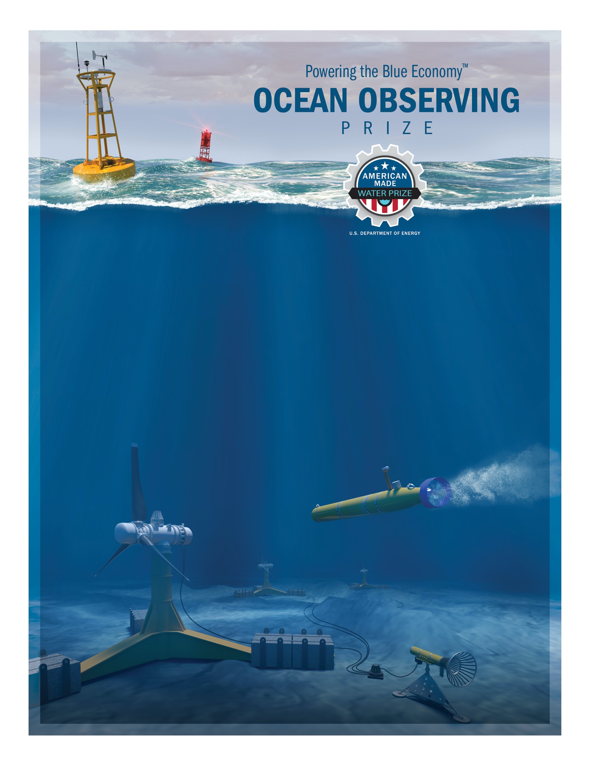
DEVELOP COMPETITION

Dummy Payload & Power Monitor (DPPM)

Overview
Contestant teams wishing to compete in the Ocean Observing Prize DEVELOP Competition must incorporate the DPPM into their designs as outlined in this document. The DPPM serves two purposes: (1) mimic a commercial acoustic doppler current profiler (ADCP) for monitoring water currents and (2) measure the power produced by the wave harvesting subsystem. If contestants successfully design their systems to accommodate this DPPM, later modifications to the system to accommodate a real ADCP will ideally be less onerous. The electronics module within the DPPM will monitor power production and consumption by the AUV system and provide a dummy payload that can be powered for scoring in accordance with the DEVELOP Competition rules and system requirements.

Detailed CAD models of the DPPM can be on the HeroX Resources page (https://www.herox.com/oceanobserving/resources) under the file OceanObserving_DPMM.step.

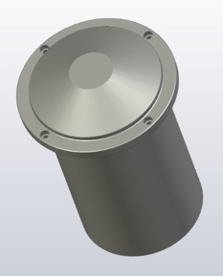
Physical Dimensions
Physical dimensions will be based on a commercially available ADCP, please see drawings (DEVELOP Competition DPPM Models- OceanObserving_DPMM.step) on the HeroX resources page for dimensions. The DPPM will be neutrally buoyant at the time of testing. The DPMM will be a 138 mm diameter cylinder with a flared 182 mm head that is 262 mm long.

Mounting
The DPPM must be mounted in the system body such that the face of the instrument points directly down towards the ocean floor when the system is sampling. The face must be in contact with water with no obstructions to its field of view. The DPPM will have four ¼ inch mounting points as located in the attached drawings (DEVELOP Competition DPPM Models OceanObserving_DPMM.step)

Connectors and Interfacing
The contestant team’s power system will be integrated into the DPPM for power monitoring and scoring purposes. All power from the wave energy converter and battery will be actively monitored through two connectors, a 4-pin power connector to measure current and voltage from the WEC and battery system, and an 8-pin connector to provide system ground and payload interfaces.
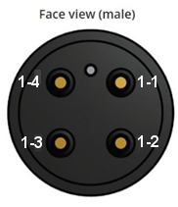
WEC Power Output
DPPM
Pin-out
AUV System
System Battery (+)
1-2
1-3
1-4
1-1
DPPM Power Connector Pins

1-1 WEC Power (output)
1-2 WEC Power (AUV System)
1-3 System Battery (+)
1-4 AUV System

The DPPM will have a male Subconn 4-pin wet-mateable connector as specified at:

http://ocean-innovations.net/OceanInnovationsNEW/SubConn/high_power_4_contacts.pdf

To interface with the DPPM, contestants will use the above Power Connector Pin Labels with the below graphic to integrate their system to the DPPM.

Dummy Payload Connections and Power
The DPPM will be connected to the contestants AUV with an 8-pin connector, specifications for which can be found at:

http://ocean-innovations.net/OceanInnovationsNEW/SubConn/circular_6-8and10_contacts.pdf

The DPPM will have an 8-pin male connector with the following pinout. The contestant team’s male connector should have the following pinout.

Payload Connector Pin Labels
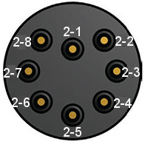
Payload
System Ground
Payload Power
2-1
2-2
2-1 Payload Power (+)
2-2 System Ground (-)
2-3 Reserved for judge’s use
2-4 Reserved for judge’s use
2-5 Reserved for judge’s use
2-6 Reserved for judge’s use
2-7 Reserved for judge’s use
2-8 Reserved for judge’s use

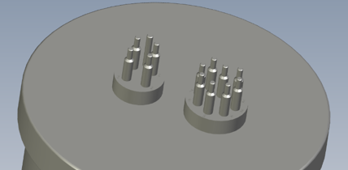
For all dimensions, connector locations and orientation please consult the CAD file DEVELOP Competition DPPM Models “OceanObserving_DPMM.step”.

Connector Placement

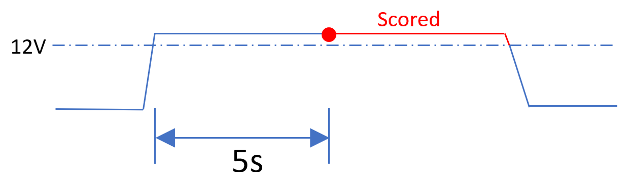
For scoring purposes, the dummy payload may be powered by applying 12-48 DC volts to the input of the DPPM (Pin 1) on a 100W load. If the voltage drops below 12V the DPPM will stop drawing power. The load will only be considered powered for scoring purposes when actively drawing 100W.
Powering the payload

A Note on Internal Batteries
There shall be no batteries or other energy storage devices except those specified in the competition rules apart from small primary batteries integrated into clocks/GPS/memory assemblies. If there are any questions on whether a given battery is allowable, please email the Prize Administration team at OceanObserving@nrel.gov

