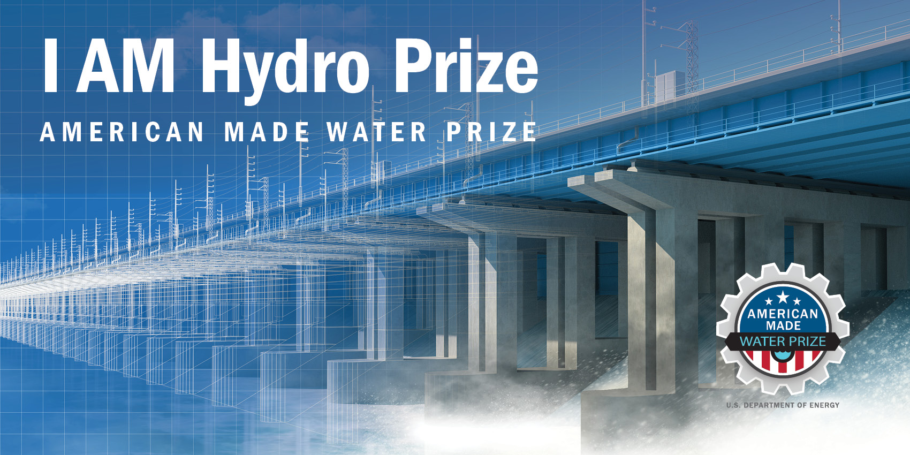

TECHNICAL NARRATIVE TEMPLATE
I AM Hydro Prize

DESIGN STAGE

Project Name [Enter your team’s name]

Technology Area [Enter one of the four categories]
Joining Coating and Repair
Additive Manufacturing
Casting Forming, and Machining
Advanced Materials

Technical Narrative Template
Write a detailed narrative describing your solution. There is a template on the HeroX platform to use in drafting the Technical Narrative. The total length of the Technical Narrative cannot exceed 2,500 words. You may include up to five supporting visualizations or graphics. The Technical Narrative must be submitted as a PDF onto the HeroX platform along with the other submission documents. Information contained in hyperlinks to external sources will not be reviewed or considered by the reviewers or judge.
You should address each of the following four criteria:
- Criteria 1: Impact – What is the challenge the proposed solution is addressing, and why is solving it important?
- Criteria 2: Innovation – How will the advanced manufacturing solution improve the state of the art?
- Criteria 3: Feasibility – What is the technical feasibility of the proposed solution?
The following table below describes the content that should be provided in the narrative to successfully address each criteria question. The right-hand column contains the scored statements that the reviewers will be using for each of the three criteria questions. Individual reviewers will assign a 1–6 score for each scored statement after reviewing the Technical Submission. The left-hand column includes suggested content for each criteria question. The suggested content provided is not mandatory and competitors will not be judged against it; these are examples of details to include to help guide your responses, but you are welcome to use other information as you see fit.

What Is the Challenge the Proposed Solution is Addressing, and Why Is Solving It Important?
Suggested Content You Provide  - Description of the problem, including a quantification of its significance with relevant metrics, and a compelling argument for why solving the problem is particularly urgent or critical  - Demonstration of the problem’s relevance for hydropower with supporting evidence (e.g., interviews with users, case studies, literature)  - Description of the current state of the art, including estimates for costs and performance  - Explanation of how advanced manufacturing presents a viable solution pathway | Each Statement Scored on a 1-6 Scale  - The competitor identifies a critical problem with clear linkage and relevance to the hydropower industry using compelling analysis  - The competitor’s assessment shows a strong understanding of the current state of the art  - The competitor shows a strong understanding of how incorporating advanced manufacturing can provide a viable solution pathway
How Will the Advanced Manufacturing Solution Improve the State of the Art?
Suggested Content You Provide  - Description of how the solution wholly or partially incorporates advanced manufacturing into the fabrication of a tool, component, or equipment directly relevant to hydropower  - Description of the solution’s unique value proposition, and identification of the advanced manufacturing category it corresponds with  - Supporting drawings (e.g., images of 3D CAD drawings) of the proposed concept  - Identification of the hydropower plant component(s) and scale(s) that the technology is applicable to (see Appendix B for reference)  - Explanation of how the proposed solution will lead to reductions in levelized costs of hydropower, and provide supporting data, calculations, and/or analysis |  |  | Each Statement Scored on a 1-6 Scale  - The solution is innovative and compelling and demonstrates promising new manufacturing approaches for the hydropower industry  - The solution is built on reasonable assumptions, valid technical foundations, and lessons learned from other notable efforts in this space  - The solution has the potential to drive down levelized costs of hydropower by reducing annual costs and/or increasing annual energy production
What Is the Technical Feasibility of the Proposed Solution?
Suggested Content You Provide  - Description of the expected costs, performance, and scalability of the proposed solution  - Supporting body of knowledge that demonstrates the solution is capable of performing as intended  - Explanation of how the system will be built, deployed, maintained, and recovered and/or decommissioned at the end of its useful life  - Description of the commercialization pathway for the proposed solution, including resources needed for realization (e.g., testing infrastructure, estimated financial support, potential partners, and end users) |  | Each Statement Scored on a 1-6 Scale  - Cost and performance goals and metrics are reasonable, ambitious, and attainable  - The competitor has identified credible methods for manufacturing, installing, operating, and maintaining the proposed system  - The competitor shows a strong understanding of the critical path to commercializing the proposed solution

Your Response:
[Enter your response here]

Supplementary Information

TECHNICAL NARRATIVE WORD COUNT: _______ TOTAL WORDS

