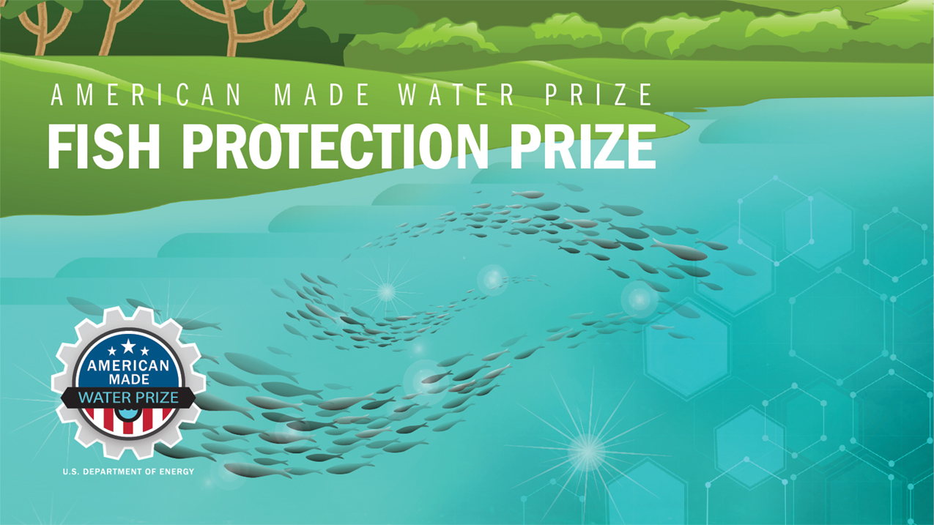

TECHNICAL
NARRATIVE TEMPLATE
DISCOVER
COMPETITION

DESIGN STAGE

Project Name [Your team’s name]
Tagline: [Your mission or idea as a single catchy sentence]

Short Description:
[A clear and concise description of your idea that anyone can understand in 80 words or less]

Team Information:
[Fill in the information below for each team member. The first team member listed should be the Team Lead]
Team Lead Name: [first, last]
Team Member 2: [first, last]
Team Member 3: [first, last]
Team Member n: [first, last]

90-Second Video
Post your publicly accessible video online (e.g., YouTube, Vimeo, etc.). Be creative and produce a video that conveys the suggested content listed below or any other information that will help the reviewers understand your solution in an exciting and interesting way, but do not focus on time consuming activities that only improve production values (i.e., technical elements such as décor, lighting, and cinematic techniques). The reviewers will score the video based on the content you have provided.

Technical Narrative
The Technical Narrative should address the technical innovation, technical feasibility, market feasibility, and overall research and development plan. There are four criteria you will be evaluated against for your Technical Narrative. You can use up to 5,000 words (excluding references) and up to 10 supporting images, figures, or graphs. Do not include any hyperlinks other than your video pitch in your submission—they will not be viewed. More information on suggested content to include in the narrative can be found in the rules document.

The four criteria are as follows:

- Criteria 1: Innovation—Does your concept represent a novel solution that offers an effective fish exclusion system for one or more species?
- Criteria 2: Technical Feasibility—Is your solution technically feasible?
- Criteria 3: Market Feasibility—Can you prove the financial feasibility of your proposed solution, including the potential for commercialization and successful market adoption?
- Criteria 4: Research and Development Plan—What is your plan to achieve your goals?

Your Response:
[Enter your response here]

Supplementary Information

NARRATIVE WORD COUNT: _______ TOTAL WORDS
Please use the HeroX Platform to submit your Summary Slide and the optional Letters of Commitment or Support documents for the complete submission package.

