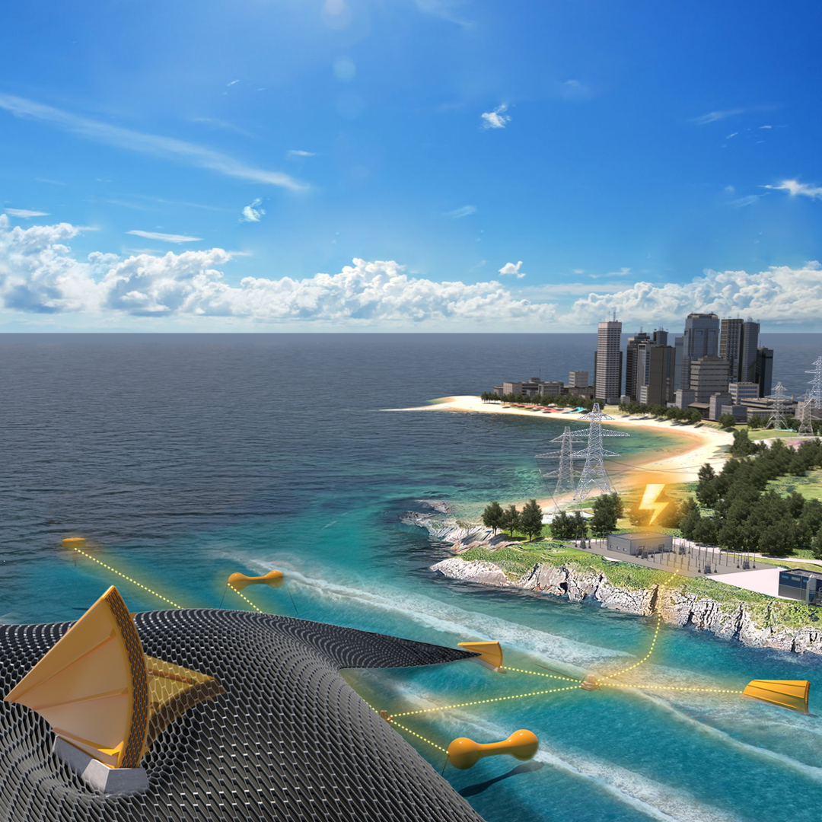
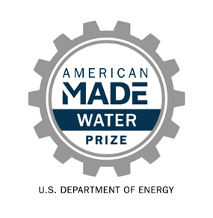



Innovating Distributed Embedded
Energy Prize (In DEEP)
[Official Team Name Here]
Technical Narrative
January 2025: Phase III

[Please write a Technical Narrative to describe the solution approach, provide a clear description of the concept, and provide responses to the evaluation statements outlined in Table 7 of the official rules document. The technical narrative should represent the idea and the innovation process that led to the solution. Competitors can use up to 5,000 words and up to five supporting images, figures, or graphs to populate the template. The suggested content bullets are only suggestions to guide responses; competitors decide where to focus their responses. The Prize Administration Team also strongly recommends competitors review the evaluation criteria, also outlined in the rules document, as these are the specific scoring statements the Technical Narrative will be scored against.]

[Please delete bracketed guidance text prior to submission]
Table of Contents
Team Information: 2
Short Description: 2
Technical Narrative: 3
Team Characteristics & Excellence 3
Innovation Process 3
Viability of the Concept 3
Future Plans to Mature Technology 4

Team Information:
[Fill in the information below for each team member. The first team member listed should be the Team Lead]
Team Lead Name: [first, last]
Team Member 2: [first, last]
Team Member 3: [first, last]
Team Member 4: [first, last]

Short Description:
[A clear and concise description of your team/organization and mission. Recommended length: 50-200 words, does not count towards 5000-word limit.]

Technical Narrative:

Team Characteristics & Excellence
[Suggested content:
- A description of the current team and the technical gaps missing to successfully develop the proposed concept.
- A description of the proposed approach or support mechanisms offered that the team intends to leverage to resolve the technical gaps.]

Innovation Process
[Suggested content:
- A description of the starting point for the innovation (i.e., did you start with an underperforming system and seek to improve it, did you start with a pre-existing solution from another industry that is newly applied to wave energy, did you start with a requirements statement and ideate an entirely new solution, or something else?).
- A description of the systems engineering methodology, including a description of the innovation technique used.
- A description of the vision to mature the concept and what is needed to guide the innovation process, during and after the prize.
- A description of how systems engineering approaches, TPL insights, engagement of competitor support, and use of innovation methodologies influenced the design thinking in a way that increases the likelihood of the technology’s long-term success.]

Viability of the Concept
[Suggested content:
- A description of how the team plans for innovation are relevant to a DEEC-tec metamaterial and not just innovation of the individual DEECS.
- A description of what energy goes into your DEEC-Tec metamaterial, the energy transformation(s) that occur and the net useful energy output.
- A description of which parameters (directions, magnitudes, frequencies, etc.) were chosen and their influence on the efficiencies of the energy conversion for your DEEC-Tec metamaterial or if you are using alternative parameters, identify and justify those here.
- A description of any mechanisms that transform, influence augment, enhance, boost, and/or filter the energy the DEEC-Tec metamaterial encounters.
- Provide a set of drawings or sketches representing the DEEC-Tec metamaterial geometry, size and their deformation or other changes during operation. These drawings or sketches could include simple geometric profile drawings of the DEEC-tec metamaterial.
- Provide a concept storyboard to represent how individual DEECs interact with each other within the DEEC-Tec metamaterial and how they will generate useful energy.
- A description of how test results provided the evidence that there is a likely pathway to long-term viability of the concept.]

Future Plans to Mature Technology
[Suggested content:
- A description of the plans to overcome the identified challenges in the technology development path, building from the concept descriptions developed in the Technical Narrative Criteria 1-3.
- A description of how continued use of systems engineering approaches, TPL insights, and use of innovation methodologies will influence your future plans in a way that increases the likelihood of the long-term success of the technology.
- A description of plans for further advancement of the DEEC-Tec metamaterial.
- A description of opportunities to improve DEEC-Tec metamaterial post prize.
- Provide a separate risk register for project management and technology risks.
- Provide an outline of the risk management approach to project design, including a description for how the planned work will reduce missing information and reduce risks and increase prospects of successful outcome.]

