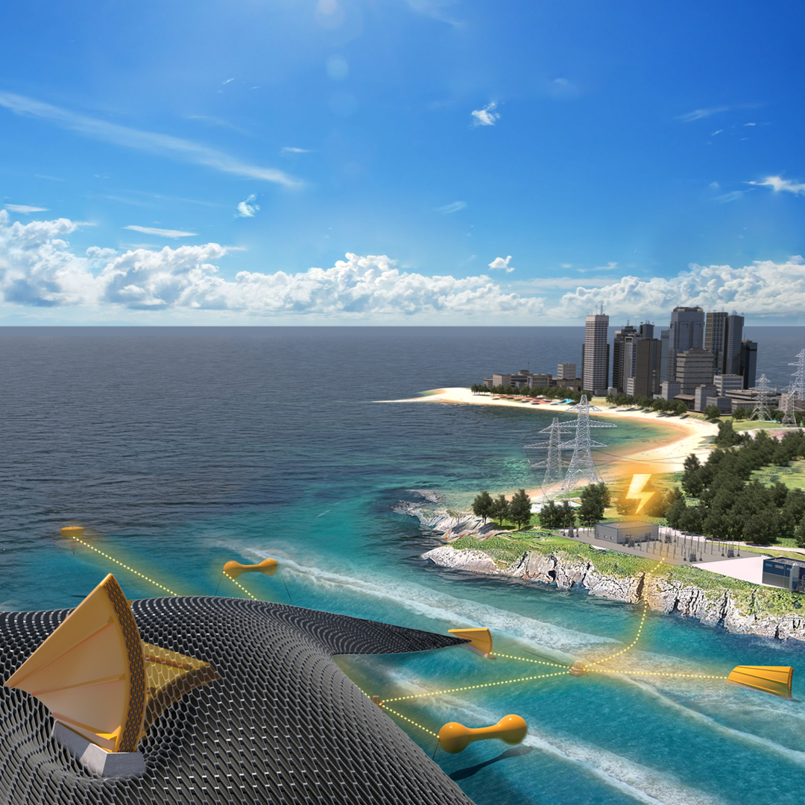

Innovating Distributed Embedded
Energy Prize (In DEEP)
[Official Team Name Here]
Technical Narrative
May 2024: Phase II

[Please write a Technical Narrative to describe the solution approach, provide a clear description of the concept, and provide responses to the evaluation statements outlined in Table 10 of the official rules document. The technical narrative should represent the idea and the innovation process that led to the solution. Competitors can use up to 5,000 words and up to five supporting images, figures, or graphs to populate the template. The suggested content bullets are only suggestions to guide responses; competitors decide where to focus their responses. The Prize Administration Team also strongly recommends competitors review the evaluation criteria, also outlined in the rules document, as these are the specific scoring statements the Technical Narrative will be scored against.]

[Please delete bracketed guidance text prior to submission]
Table of Contents
Team Information: 2
Short Description: 2
Technical Narrative: 3
Team Characteristics & Excellence 3
Innovation Process 3
Viability of the Concept 3
Planned Development for Phase III 4

Team Information:
[Fill in the information below for each team member. The first team member listed should be the Team Lead]
Team Lead Name: [first, last]
Team Member 2: [first, last]
Team Member 3: [first, last]
Team Member 4: [first, last]

Short Description:
[A clear and concise description of your team/organization and mission. Recommended length: 50-200 words, does not count towards 5000-word limit.]

Technical Narrative:

Team Characteristics & Excellence
[Suggested content:
- A description of the formation and origin of the team and how the team incorporates a diverse makeup, including disciplines, backgrounds, experience, industries and sectors
- A description of the team’s background in system’s engineering and innovation methodologies, and specific methodologies in which the team has expertise
- A description of what work was contributed by each team member and highlight successful collaboration and focus on how non-ocean wave energy specialists were introduced to ocean wave energy
- A description of how you have shared information with other InDEEP teams
- A description of how you evaluated your current team and the technical gaps missing to successfully develop the proposed concept and an approach and/or support mechanisms offered the team intends to leverage to resolve these gaps in the next phase
- A description of how the team cultivated a culture of inclusion to ensure all team member’s contributions are considered and facilitates team excellence
- A description of potential challenges the team may face in creating an inclusive environment and making accommodations for team members, and how the team plans to address those challenges.]

Innovation Process
[Suggested content:
- A description of the literature search conducted to inform the team’s understanding of the current state of the technology and previous related work
- A description of the starting point for the innovation (i.e., did you start with an underperforming system and seek to improve it, did you start with a pre-existing solution from another industry that is newly applied to wave energy, did you start with a requirements statement and ideate an entirely new solution, or something else?)
- A description of the systems engineering methodology, including a description of the innovation technique used
- A description of the vision to mature the concept and what is needed to guide your innovation process, during and after the prize
- A description of the target or requirements that you seek to meet.]

Viability of the Concept
[Suggested content:
- A description of what energy goes into your DEEC, the energy transformation(s) that occur and the net useful energy output
- A description of what parameters (directions, magnitudes, frequencies, etc.) influence the efficiencies of the energy coversion for your individual DEEC
- A description of any mechanisims that transform, influence augment, enhance, boost, and/or filter the energy the DEEC encounters
- A description of how individual DEECs interact and whether they are independent and redundent
- Provide a set of drawings or sketches representing the individual DEEC geometry, size and their deformation or other changes during operation. These drawings or sketches could include simple geometric profile drawings of the individual DEEC
- Provide a concept storyboard to represent how the DEEC-Tec metamaterial will generate useful energy.]

Planned Development for Phase III
[Suggested content:
- A description of the plans to overcome the identified challenges in the technology development path, building from the concept descriptions developed in the Technical Narrative Criteria 1-3
- Analyze and describe the impact of your project design based on the potential environment or community it would be located in, as well as any relevant assessments of target audiences and/or end users
- Develop a Phase III Gantt chart, schedule, and work breakdown structure
- Provide a separate risk register for project management and technology risks
- Provide an outline of the risk management approach to project design, including a description for how the planned work will reduce missing information and reduce risks and increase prospects of successful outcome
- Propose what would be needed to successfully test the metamaterial on site at a national lab in Phase III.]

