EPIC Prize Round 2
  - Prove It! Submission

Project Name

Organization Name

Program Requirement(s) you are addressing

Team – Key Project Members

Names, roles, contact info, and LinkedIn profiles

Your city, state, and nine-digit zip code
Relevant Partners and Affiliates (if applicable)

Link to your 90 second video

Online Video: 90-Second Video (Public)
Suggested content you provide
- Describe your organization
- Describe your MVP and the need that is addressed
- Showcase what you have accomplished since the Design It Phase

You should update your video from previous phases to illustrate the work you have accomplished over the course of the competition. While there is no specific scoring criteria for the video, it will be evaluated as part of the entire submission package. The video serves as a first introduction of your organization, MVP, and progress to the reviewers, who may be different for each phase. This video may also be used to share your accomplishments with the public.

Post your video online (e.g., YouTube, Vimeo). Be creative and produce a video that conveys the required information in exciting and interesting ways, but remember that time-consuming activities that only improve production value (i.e., technical elements such as décor, lighting, and cinematic techniques) are not necessary.

Core Narrative
You should answer each of the following four questions. The content bullets are only suggestions to guide your responses. You decide where to focus your answers. The individual answers to the four questions do not have a word limit; however, the aggregate response to these four questions must not exceed 2,500 words at 12-point font size, not including captions, figures/graphs, or references. A word count must be included at the end of your submission. You may also include up to five supporting images, figures, or graphs. The reviewers will score the questions based on the content you have provided.

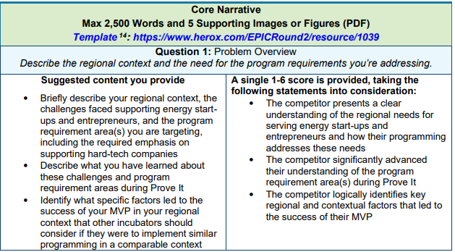

Response to Question 1:
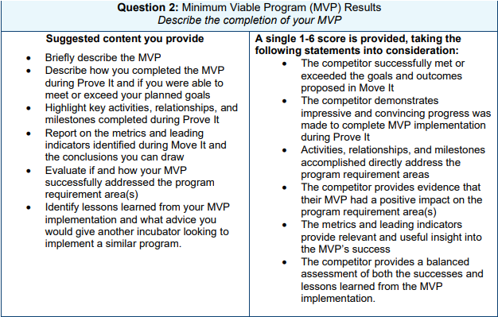

Response to Question 2:

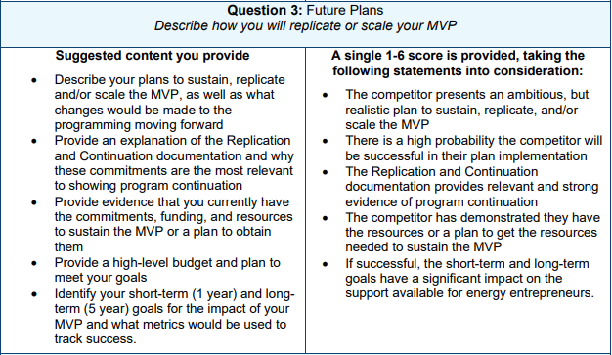

Response to Question 3:

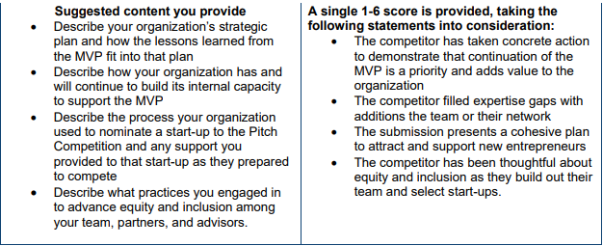

Response to Question 4:

Supplementary Information

Four question narrative word count: _______ total words

Submission Summary Slide (a PowerPoint slide, will be made public)
Make your own public-facing, one-slide submission summary that contains information about your organization, MVP, and plan for implementation. There is no template, so feel free to present the information as you see fit. Please make any text readable in a standard printout and conference room projection.

Replication and Continuation Documentation
Competitors must provide the best documentation possible that this program will be sustained, replicated, and/or scaled. Documentation could include legally binding commitment from partners, state sponsorships, etc.
Combine and upload as a single file one-page letters from relevant entities (e.g., partners, potential customers) to provide context. Any letters of commitment or support must be on letterhead, uploaded as a single file, and readable by Microsoft Word or Adobe PDF.

Interview Day Event
You are required to participate in a Virtual Interview Day event with a panel of expert reviewers. Details about the format for the Interview Day will be provided prior to the Prove It submission deadline.
Please read and comply with additional requirements about your submission in the Official Rules.
COMPETITORS THAT DO NOT COMPLY WITH THESE REQUIREMENTS MAY BE DISQUALIFIED.

