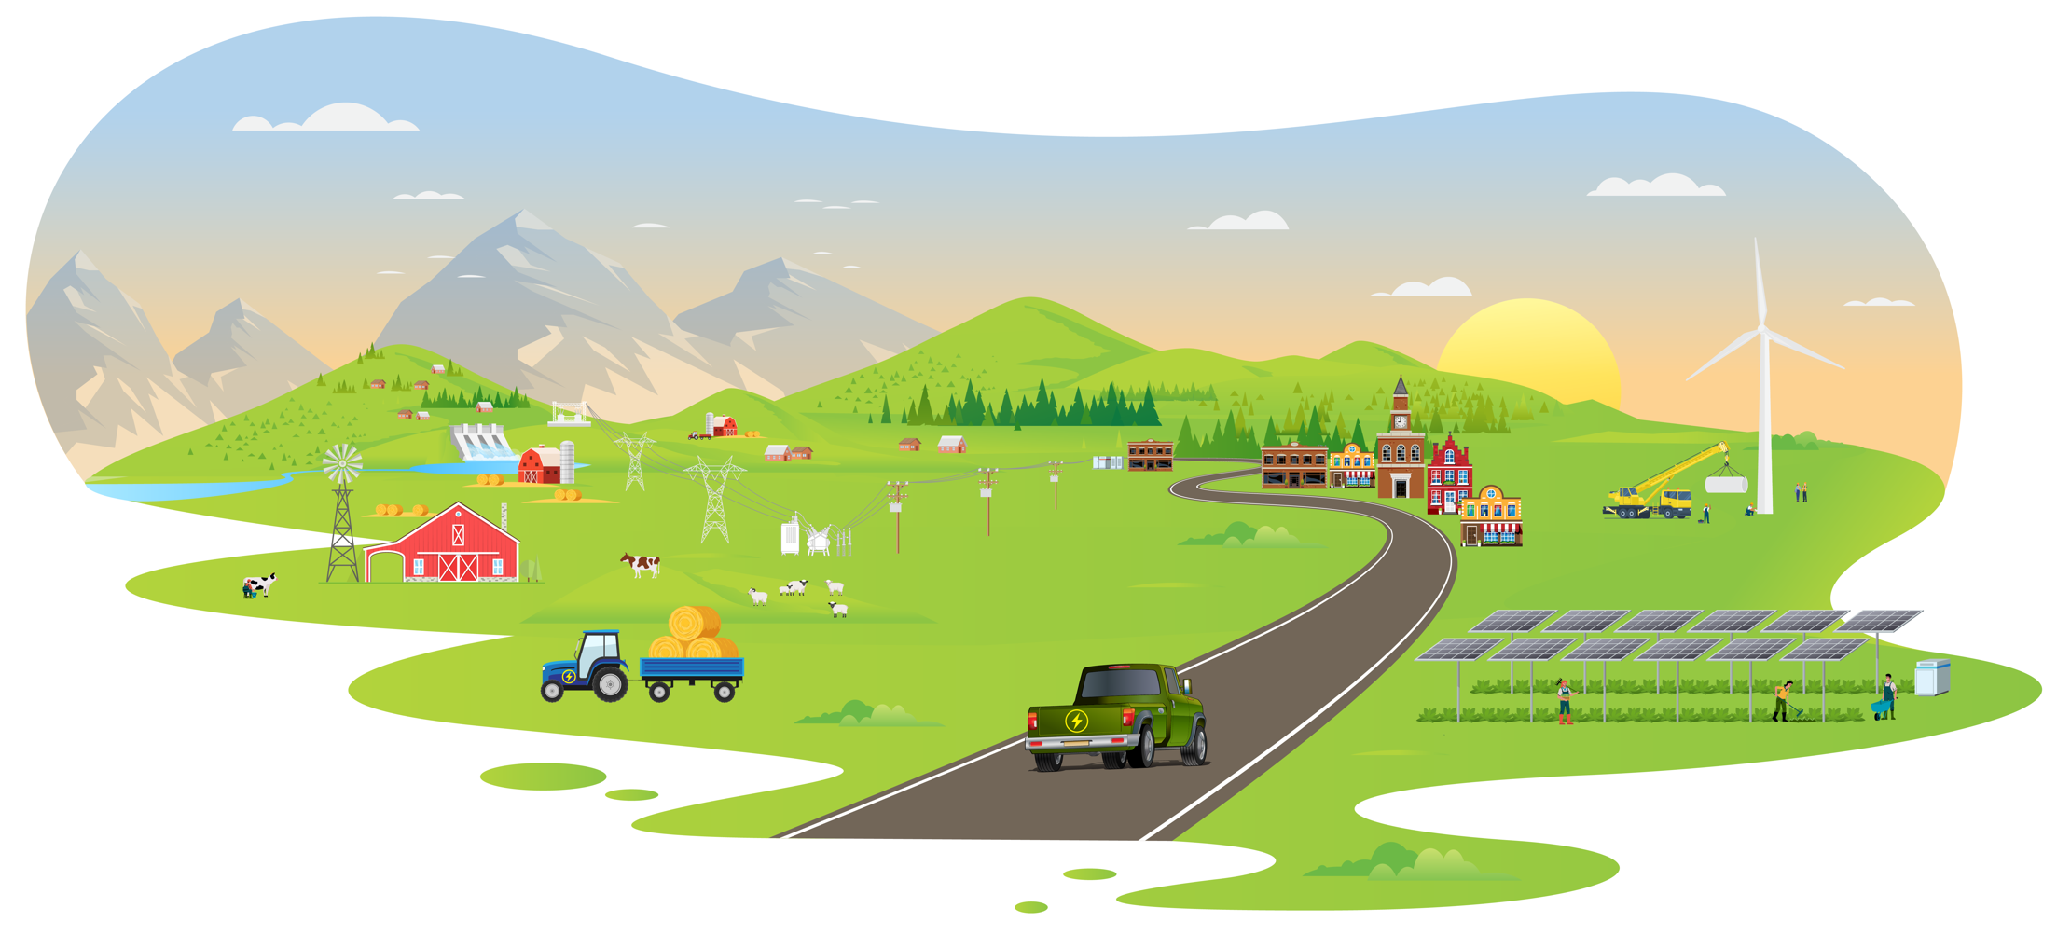
Phase Two
Month Year

Energizing Rural Communities Prize
[Official Team Name Here]
Partnership Packet

Write a detailed Partnership Packet in a narrative describing the competitor’s responses to all scoring criteria. Competitors must submit evidence of commitment (e.g., letters of commitment, contracts, memoranda of understanding) from community leadership to verify engagement with the Location of Primary Benefits. This evidence should be submitted as a separate file and does not contribute to the word or visualization limit in the partnership packet.
The total length of the Partnership Packet cannot exceed 5,000 words. This plan may include up to five supporting visualizations or graphics. Information contained in hyperlinks to external sources, and any text or graphics beyond the designated limits, will not be reviewed or considered by reviewers or the judge.
The plan must be submitted as a PDF, via the HeroX platform, along with the other submission documents.
Competitors should address the Prize Goals in Section 2.2 of the Official Rules Document and be guided by all three scoring criteria (see Section 4.2.2.2 of the Official Rules Document to see suggested content to provide for these criteria):
- Criterion 1: Partnership Activities Pursued During Phase Two of the Prize.
- Criterion 2: Outcomes, Impacts, and Success Metrics.
- Criterion 3: Strategy for Achieving Community Energy Goals After Completion of the Prize.
Use of this template is optional.
** PLEASE DELETE THIS TEXTBOX FROM YOUR FINAL SUBMISSION **

Write a detailed partnership plan in a narrative describing the competitor, planned activities, resources and capabilities, and anticipated outcomes.
The total length of the partnership plan cannot exceed 5,000 words. This plan may include up to five supporting visualizations or graphics. Information contained in hyperlinks to external sources, and any text or graphics beyond the designated limits, will not be reviewed or considered by reviewers or the judge.
The plan must be submitted as a PDF, via the HeroX platform, along with the other submission documents. Competitors may also include proof of commitment from organizations with which a competitor will be partnering, such as letters of commitment, contracts, and/or funding agreements. These materials should be uploaded in a separate file to HeroX.
The partnership plan should address the Prize Goals in Section 2.1 of the Official Rules Document and be guided by all five scoring criteria (see Section 3.2.2.2 of the Official Rules Document to see suggested content to provide for these criteria):
- Criterion 1: Relevant Experience
- Criterion 2: Proposed Partnership Activities During Phase Two of the Prize
- Criterion 3: Expected Outcomes, Impacts, and Success Metrics
- Criterion 4: Budget, Staff, and Other Resources
- Criterion 5: Strategy for Achieving Community Energy Goals After Completion of the Prize
Use of this template is optional.
** PLEASE DELETE THIS TEXTBOX FROM YOUR FINAL SUBMISSION **

[Please delete bracketed guidance text prior to submission]
Contents
Team Information: 3
Project Location(s): 3
Short Description: 3
Partnership Packet: 3
Partnership Activities Pursued During Phase Two of the Prize 3
Outcomes, Impacts, and Success Metrics 4
Strategy for Achieving Community Energy Goals After Completion of the Prize 4
Concluding Remarks 4

Team Information:
[Fill in the information below for each team member. The first team member listed should be the Team Lead. Does not count towards 5000-word limit.]
Team Lead Name: [first, last]
Team Member 2: [first, last]
Team Member 3: [first, last]
Team Member n: [first, last]

Project Location(s):
[A list of the locations that are the primary beneficiaries of your project. At least one location must be rural or remote as defined in the official rules document for the submission to be eligible. Commitment letters are required to verify engagement with the Location of Primary Benefits. The Location of Primary Benefits submitted on February 1, 2024, must match the submission on July 12, 2024. Submissions that do not satisfy this requirement will be considered ineligible and removed from further evaluation. Recommended format: City/Municipality, State, Zip code. Does not count towards 5000-word limit.]

Short Description:
[A clear and concise description of your team/organization, mission, and the goal of your activity and long-term clean energy project. Recommended length: 50-200 words, does not count towards 5000-word limit.]

Partnership Packet:

Partnership Activities Pursued During Phase Two of the Prize
[Describe the activities undertaken during Phase Two of the prize in working with the identified community that primarily benefited from the activities.
Suggested content:
- A description of what occurred during Phase Two including a detailed description of the activities, achievements, deliverables, and milestones and how these map to the proposal in Phase One.
- A description of project partners and their roles in undertaking the activities. What partner organizations were involved? Was any DOE-provided assistance used (e.g., technical assistance, Power Connectors)?
- An overview of a community engagement strategy the team pursued to successfully implement the project plan and garner community buy-in.
- A description of the challenges encountered during Phase Two and how these were overcome.]

Outcomes, Impacts, and Success Metrics
[Describe the specific outcomes, impacts, and measurable metrics for success that came out of the implementation of the proposed project. This should include methods for measuring success and changes from the original Phase One proposal.]
Suggested content:
- A description of strategies and methods the competitor used to build trust and strengthen relationships and partnerships with and within rural or remote communities, particularly overburdened and underserved communities, as indicated by DOE’s Energy Justice Dashboard, the U.S. Environmental Protection Agency’s (EPA’s) EJScreen, the Council on Environmental Quality’s Climate and Economic Justice Screen Tool, or another explanation.
- A description of activities the competitor has carried out that leveraged newly developed or existing partnerships to facilitate clean energy projects in rural or remote communities. Partnerships should have effectively connected communities to engineering services or other resources to support clean energy projects, and/or aggregate similar energy projects in multiple rural or remote communities.
- Evidence of commitment from partner organization(s), such as letters of commitment, memoranda of understanding, contracts, and/or funding agreements. This evidence does not contribute to the word or visualization limit in the partnership packet.
- A description of how activities increased access to funding for rural or remote communities.
- A description of credible methods and metrics the competitor used to evaluate the achievement of activities pursued during Phase Two, such as through Specific, Measurable, Achievable, Relevant, and Time-Bound (SMART) goals.]

Strategy for Achieving Community Energy Goals After Completion of the Prize
[Describe how the activities supported energy improvement(s) in the community that benefited from prize activities. Describe how participation helped move the team toward a long-term project vision or goals.
Suggested content:
- A description of how the activities undertaken helped create or advance the community’s energy improvement goals and/or a specific clean energy project.
- A description of how the long-term vision and goals of the clean energy project evolved as a result of the prize.
- A description of how the activities, including partnership building, project development, and/or community engagement, could be replicated in other rural or remote communities.
- A description of how the activities undertaken helped overcome systemic barriers to energy improvements in rural or remote communities.
- A description of how the team is ensuring this project will continue, including any additional funding sources that will support the sustainability of the project.]

Concluding Remarks
[Briefly highlight any key points if desired and any other pertinent information for reviewers and administrators.]

