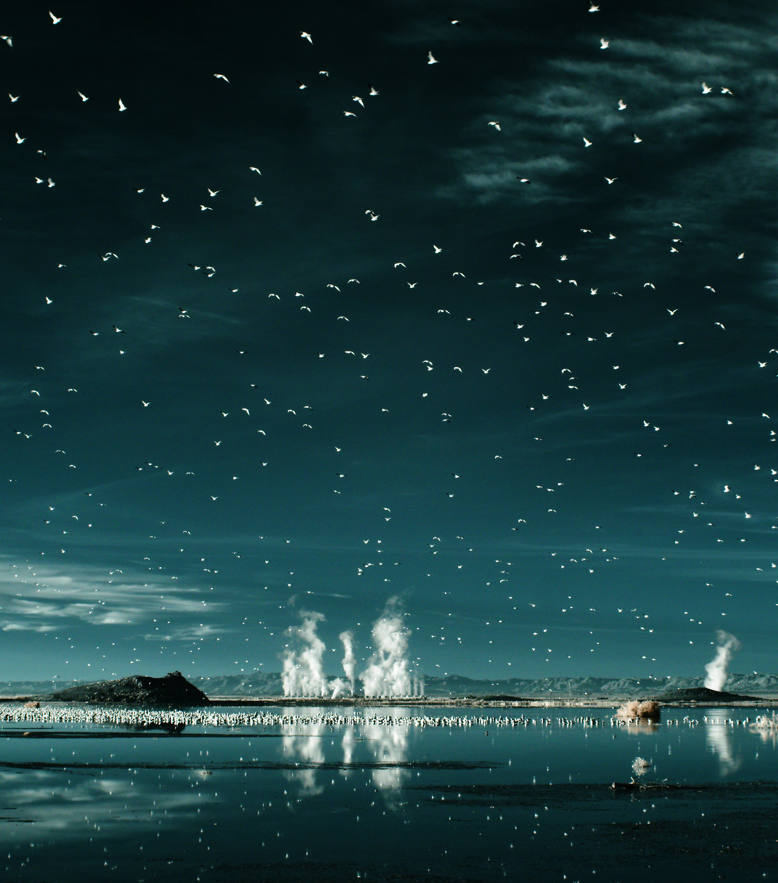
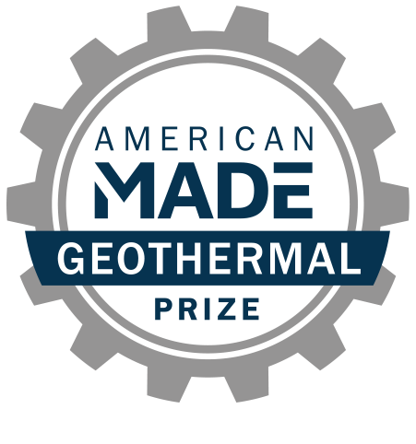
AMERICAN-MADE GEOTHERMAL LITHIUM EXTRACTION PRIZE
Phase 3 Submission
Team Name + Project Name

PROJECT NAME

Innovation tagline (e.g., your mission in a few words)
Keyword tags

TEAM
Names, geographic locations, contact info, and LinkedIn profiles

PARTNER SUPPORT
Key project partners and organizations (if any)

PHASE 3 TECHNICAL NARRATIVE

Your technical narrative should answer each of the following questions:
- Fabricating—How has your team fabricated a solution to the problem?
- Testing & Validation—What steps has your team taken to test and validate the solution?
- Next Steps—What are the next steps to scale your solution?

For convenience, these questions are provided in the headings of the tables starting on page 4, along with suggested content (and corresponding judging statements) to help guide your responses. You decide where to focus your answers.
The individual answers to the three questions do not have a word limit; however, the aggregate response to these questions must not exceed 20 pages when printed using standard 8.5 x 11 paper with 1” margins (top, bottom, left, and right) and 12-point or larger font size.
Images, figures, graphs, footnotes, and cited references must be included in the 15-page limit of your Technical Narrative. Expert reviewers will score the questions based on the content you have provided that conforms to the previously described limits.
Save the Technical Narrative in a single PDF file using the following convention for the title: “TeamName_TechnicalNarrative”.
Responses should not be entered into the existing table format for each question (Question tables may be deleted prior to submission).

Question 1: Fabricating
How has your team fabricated a solution to the problem?
Suggested content:  - Describe the process of fabricating your  final prototype, and include all steps and  assumptions made.  - Describe any barriers your team  overcame in fabricating your technology.  - Provide final design drawings and design  notes.  - Describe instructions for how to assemble  the prototype and any special expertise or  tools that are required.  - Describe your design process. How did  you settle on the final design? What other  designs did you consider? How did  different members of your team or outside  support influence the design process?  How did you select materials (if  applicable)? | Each statement will be scored on a 1–6 scale according to the following criteria:  - The competitor has advanced and  fabricated a solution to their Phase 2  innovation.  - The competitor has detailed a process that includes all assumptions, and barriers to their designs.  - The competitor has detailed an assembly  plan of their prototypes.

Response to Question 1:

Question 2: Testing & Validation
What steps has your team taken to test and validate the solution?
Suggested content:  - Describe and demonstrate your progress  on your team’s DLE innovation, including  documentation of proof-of-concept design  (see special instructions).  - Describe how you worked with your IAP  member to advance your design, how  their mentorship was important, and how  the feedback changed your design  process.  - What steps did you take to test your  prototype, and what documentation can  you provide?  - What testing acceptance criteria did you  use?  - What type of brine did you use? What is  the composition of the brine? | Each statement will be scored on a 1–6 scale according to the following criteria:  - The solution represents an innovative  approach, built on reasonable assumptions, valid technical foundations, and lessons learned from other notable efforts in this space. Competitors provided necessary figures, models, tables, assumptions, and documentation used in their approach.  - The planned innovation is reasonably  ambitious and validates critical assumptions needed to advance the proposed solution.  - A considerable amount of high-quality effort was put into defining and advancing the proposed concept.  - The competitor has demonstrated a clear  path to lowering overall DLE costs.

Special Instructions for Question 2
Although design documentation will be application-specific, documentation should clearly show the
functionality and performance benefits of the proposed innovation over conventional technology.
This documentation should include the design engineering steps taken that support the submitted
design basis. Example design engineering content includes computer-aided design (CAD) model
renderings, engineering calculations, finite element analysis along with a description of the
calculation basis, and other approaches that credibly quantify potential impacts.
All design documentation must be included in the 20-page limit as described in the Final Technical
Report elements listed in Table 17, and in the same readable PDF format. CAD drawings or other
modeling content that requires specific software licensing will not be judged.

Response to Question 2:

Question 3: Next Steps
What are the next steps to scale your solution?
Suggested content:  - What steps, assumptions, and alterations to  your design will be needed to test your  solution in the field at a geothermal power  plant or an operating geothermal field at the  Salton Sea?  - How will your technology operate in varied  brine flow states of the geothermal power  plant?  - Where will your technology be installed or  incorporated into an operating geothermal  power plant or operating geothermal field at  the Salton Sea? What design alterations will  be needed? What impacts to the power  plant operations may occur? How would  you suggest addressing those impacts?  - How durable is your technology? How long  will it operate before needing maintenance  or replacement?  - If you used a synthetic brine for testing and  validating, in what ways does your design  need to be modified to accommodate real-  world brines?  - What are the next steps for scaling up and  manufacturing your prototype? What  manufacturing methods will you consider? What are the next steps for scaling up and  manufacturing your prototype? What  manufacturing methods will you consider?  - What are the barriers, if any, to scaling your  solution to field operations? How can those  barriers be overcome? What additional  testing and validation may be needed?  What are the key performance indicators to  validate your prototype?  - What is the vision for your prototype after  the prize? What success metrics and  timeline goals has your team outlined?  - What are the plans to work with an industry  partner and/or university technology  transfer office to advance your prototype? | Each statement will be scored on a 1–6 scale according to the following criteria:  - The stated Phase 3 goals are ambitious,  reduce risks related to technology  demonstration and deployment, and show  a commitment to an accelerated  development cycle.  - The proposed plan is appropriate and  logical to achieve the stated goals.  - Meeting the stated goals demonstrates  critical progress toward next steps in  scaling up and manufacturing the  functionality of the innovation in a real-  world setting.

Response to Question 3:

Technology Demonstration Video
Suggested content:  - Brief introduction of the team and university  lead organization.  - Working demonstration of your technology  in a laboratory or real-world setting.  - Real-time explanation of process with  voice-over or transcription in the video.  - Evidence of lithium extraction and analysis.  - Visual evidence of related metrics and  values being validated.  - Clear visual information or voice-over of the  size of the system and scale relative to  commercial lithium extraction processes.  Required submission format:  - Videos should be uploaded to YouTube, on  July 3, 2023, by 5 p.m. EST using the  following convention for the title:  “TeamName_TechDemoVideo”.  - The video should not exceed 5 minutes.  - The video needs to be accessible to view  by other users by setting permissions to  “public”. | The video will be scored on a 1–6 scale according to the following criteria:  - Clearly demonstrated and provided a  detailed step-by-step explanation of the  technology.  - Provided evidence of lithium extraction  and clear explanation of metrics and  values being evaluated.  If a team does not submit a video, they will be disqualified and ineligible to win.

