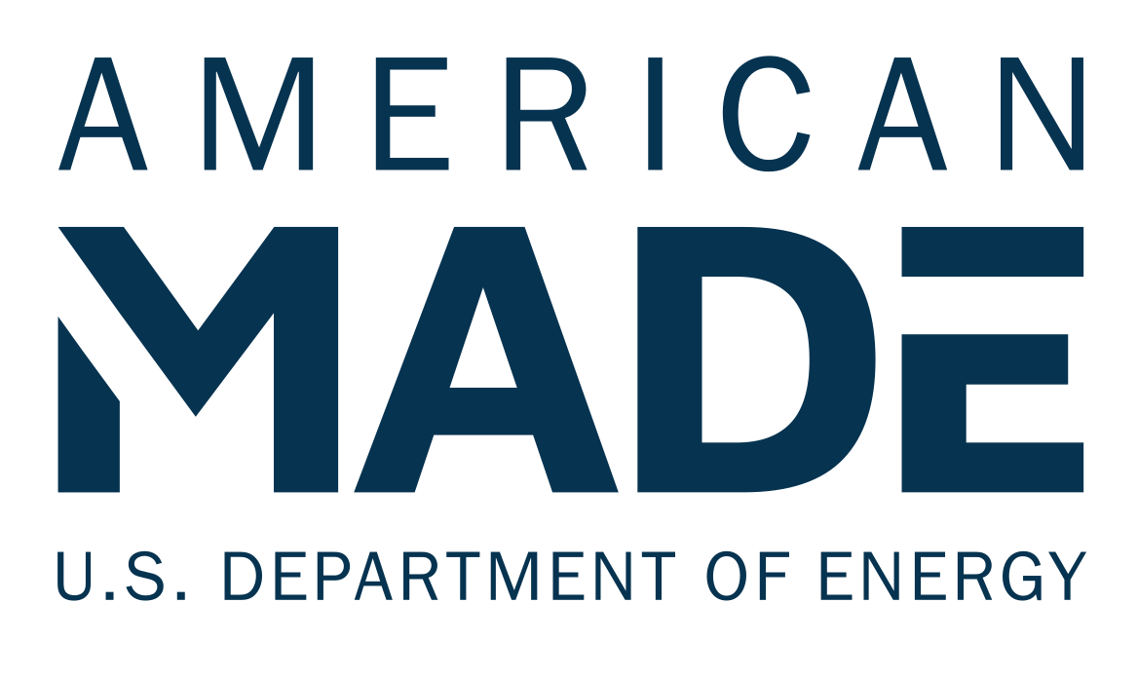

Project/Program Name [Enter your team’s name]

Tagline: [Your mission or idea as a single catchy sentence]

NARRATIVE TEMPLATE

2023 SUNNY AWARDS

Cover Page Information

Project Portfolio and Program Details: please provide information on each of the projects in the nominated project portfolio (between 1-5 projects) or the nominated community solar program.
Community Solar Project Name(s) (include between 1-5 projects) or Community Solar Program Name | Date when the program was launched, or the project was energized and fully operational | Project’s City and State / Program’s State | Projects 9-Digit Zip Code | Project or program size (kW or MW capacity)
Ex: Sample Community Solar Project | 01/25/2021 | Sample, KY | 40163-4321 | 1.5 MW

Narrative Template
Narrative: All competitors should provide responses to the prompts in Section 1. In Section 2, competitors should provide responses to the prompts for any category for which they would like to be considered for a Meaningful Benefits or Engagement Award.

Competitors must respond to at least two meaningful benefit categories to be eligible for any Sunny Award. The aggregate response to these four sections must not exceed 2,000 words. The reviewers will score the sections based on the content you have provided.
250 words per section, for a maximum of 2,000 words

Section 1: Tell us about your project portfolio, state, or utility program (background information, 250 words maximum).
Example content to provide  - Briefly describe the development timeline of your community solar project portfolio, state, or utility program, from conception to operation or implementation (bullet points are acceptable).  - Describe the subscribers and the community/communities served by the project portfolio, state, or utility program.  - Describe the roles of the project portfolio, state, or utility program team members and how team members worked together to support the project portfolio, state, or utility program.  - (Project portfolio only) What practices have you replicated across the projects in your project portfolio to provide meaningful benefits, and how easy would it be for you to build a similar project again? Examples of this can include financial structure, subscription models, outreach, or other replicable program elements. | This section is scored on a 1–6 scale  The statement comprehensively outlines the development timeline of the project portfolio, state, or utility program.  The statement has a complete description of the types of communities the state or utility program or project portfolio serves.  The statement includes a clear description of the roles of project portfolio, state, or utility program team members.  (Project portfolio only) The statement has a clear description of the replicability of projects within the portfolio.

Your Response:
[Enter your response for Section 1 here]

Section 2: Tell us about the meaningful benefits the project portfolio or state or utility program is delivering.
Project portfolio submissions must be able to demonstrate that their community solar project portfolio provides at least two of the five Meaningful Benefits listed below (categories 1–5) in order to be eligible for any Sunny Award or recognition. State and utility program submissions must be able to demonstrate that their state or utility program supports at least one project that provides at least two of the five Meaningful Benefits to be eligible for any Sunny Award or recognition. Details on supporting evidence can be found in Section 5. (250-word maximum per category.)
Category 1: LMI Household Access  Project portfolio: Please describe the following:  - The percentage of LMI subscribers (minimum of 40% required for eligibility)  - How LMI subscribers are acquired and verified  - Differences between LMI and market rate subscription benefits, if any  - Any other relevant information about LMI subscriptions.  How does your project portfolio achieve this level of LMI household enrollment and benefits? Consider and describe these elements:  - Specific financing or other funding (including grants or settlements and RECs)  - State or utility program/policy incentives or requirements  - Unique business model  - Any other elements vital to providing LMI subscriptions.  State and utility programs: Please describe the following:  - How many projects supported by your program include at least 40% LMI households  - Percentage of LMI household delivered by projects supported by your program  - How projects supported by your program verify households and what they include in subscription terms  - Any other relevant program support for enrolling LMI households.  How does your program support LMI household participation? Consider and describe these elements:  - Financing or other program funding  - State program/policy incentives or requirements  - Any other support provided through the program. | This section is scored on a 1–6 scale  The narrative demonstrates a strong level of LMI household engagement in the project portfolio, state, or utility program, with at least 40% of the residential subscribers being LMI households.  The narrative demonstrates the project portfolio, state, or utility program elements that support LMI household participation.
Category 2: Greater Household Savings  Project portfolio: Please describe the following:  - Percentage of bill savings (minimum of 20% required for eligibility)  - How bill savings are calculated  - How bill savings are distributed among subscribers  - At what intervals bill savings are distributed  - How bill savings are credited  - Any other relevant information about bill savings for this project portfolio.  How does your project portfolio achieve these bill savings? Consider and describe these elements:  - Specific financing or other funding (including grants or settlements and Renewable Energy Credits (RECs))  - State or utility program/policy incentives or requirements  - Unique business model  - Any other elements vital to achieving bill savings.  State and utility programs: Please describe the following:  - How many projects supported by your program provide at least 20% bill savings  - Percentage of bill savings delivered by projects supported by your program (minimum of 20% required for eligibility)  - How projects supported by your program calculate and distribute bill credits  - Any other details on bill savings for projects supported by your program.  How does your program support these bill savings? Consider and describe these elements:  - Providing financing or other program funding  - State program/policy incentives or requirements  - Any other support provided through the program. | This section is scored on a 1–6 scale  The narrative demonstrates how subscriber bill credits are allocated and provides evidence of at least 20% bill savings on average.  The narrative demonstrates the project portfolio, state, or utility program elements that allow for or support the bill savings delivered.
Category 3: Resilience and Grid Benefits  Project portfolio: Please describe the following:  - Do any projects within the project portfolio include battery storage?  - What is the capacity of the battery storage in the project portfolio (kWh)?  - Can the batteries provide backup power in the event of an outage? If so, for how long?  - Is there an emergency power outage plan, including who runs battery power and impacted subscribers?  - Are there any additional forms of resilience provided by the projects in the project portfolio (i.e., microgrids, demand and response/virtual power plant, community resilience hubs, or other relevant concepts)?  How does your project portfolio achieve this resiliency? Consider and describe these elements:  - Specific financing or other funding (including grants or settlements and RECs)  - State or utility program/policy incentives or requirements  - Unique business model  - Other elements vital to providing resilience.  State and utility programs: Please describe the following:  - How many projects supported by your program include battery storage or other forms of resilience  - What types of battery storage or other forms of resilience (i.e., microgrids, demand and response/virtual power plants, resilience hubs, etc.) are delivered by the projects supported by the state or utility program  - Beneficiaries of the storage/resiliency from the projects supported by the state or utility program  - Any other relevant state or utility program elements around resilience.  How does your state or utility program support resiliency? Consider and describe these elements:  - Financing or other program funding  - State program/policy incentives or requirements  - Any other support provided through the program. | This section is scored on a 1–6 scale  The narrative demonstrates that the community solar project portfolio, state, or utility program provides power in the event of a grid outage or strengthens grid operations through demand response and other actions.  The narrative demonstrates the project portfolio, state, or utility program elements that support resilience.
Category 4: Community Ownership  Project portfolio: Please describe the following:  - What percentage of the project portfolio is community owned?  - What are the specific benefits of community ownership in this project portfolio (i.e., voting rights, project equity, dividends or financial returns, ability to claim tax credits, etc.)?  - What are some of the specific terms of community ownership in this project portfolio (i.e., membership fees, contract length, participation requirements, etc.)?  - Any other relevant information on community ownership.  How does your project portfolio achieve this community ownership? Consider and describe these elements:  - Specific financing or other funding (including grants or settlements and RECs)  - State or utility program/policy incentives or requirements  - Unique business model  - Other elements vital to supporting community ownership.  State and utility programs: Please describe the following:  - How many community-owned projects are supported by the program  - What types of models of community ownership are developed by projects supported by the program  - Any other relevant program information regarding community ownership.  How does your state or utility program achieve community ownership? Consider and describe these elements:  - Financing or other program funding  - State program/policy incentives or requirements  - Any other support provided through the program. | This section is scored on a 1–6 scale  The narrative demonstrates how the project portfolio, state, or utility program provides opportunities for community ownership or wealth-building.  The narrative demonstrates the project portfolio, state, or utility program elements that support community ownership.
Category 5: Equitable Workforce Development and Entrepreneurship  Project portfolio: Please describe the following:  - Any specific project labor agreements that require the use of women-owned or minority-owned businesses (WMBEs) and/or reduce income disparities across race and gender lines  - Any union labor used  - Any training programs used, including pathways to full-time employment  - Number of full-time hires resulting from training programs or apprenticeships  - Any other relevant workforce development information.  How does your project portfolio achieve this equitable workforce development? Consider and describe these elements:  - Specific financing or other funding (including grants or settlements and RECs)  - State or utility program/policy incentives or requirements  - Unique business model  - Other elements vital to supporting equitable workforce development and entrepreneurship.  State and utility programs: Please describe the following:  - How many projects supported by the program include workforce development or entrepreneurship activities  - What kinds of workforce development or entrepreneurship benefits (i.e., training programs, use of union labor, prevailing wage, etc.) are delivered by projects supported by the state or utility program  - Any other relevant program details on equitable workforce development and entrepreneurship.  How does your state or utility program achieve equitable workforce development? Consider and describe these elements:  - Financing or other program funding  - State program/policy incentives or requirements  - Any other support provided through the program. | This section is scored on a 1–6 scale  The narrative demonstrates how the project portfolio, state, or utility program provides opportunities for equitable workforce development, including union labor, project labor agreements, training programs, etc.  The narrative demonstrates the project portfolio, state, or utility program elements that support equitable workforce development.
Category 6: Community Participation  Project portfolio: Please describe the following:  - How the project teams solicited feedback from community members on project design  - How community input led to changes in project design (i.e., project siting, subscription terms, benefit delivery, etc.)  - Any other relevant information on community engagement.  State and utility programs: Please describe the following:  - Any program efforts to solicit feedback from community members that led to changes in state or utility program design  - How many projects supported by the state or utility program included community participation  - Any program support or incentives for community-led project design (i.e., project siting, subscription terms, benefit delivery, etc.)  - Any other relevant program information for community participation. | This section is scored on a 1 – 6 scale  The narrative demonstrates how the project portfolio, state, or utility program used community engagement to implement design changes, including project siting, subscription terms, benefits delivery, program design, etc.
Category 7: Inclusive Outreach  Project portfolio: Please describe the following:  - Any communication campaigns in the project portfolio, including target audiences and objectives  - Communication channels leveraged during the campaign(s)  - Results of communication campaign(s) (qualitative or quantitative metrics tracked)  - Any other relevant information on inclusive outreach.  State and utility programs: Please describe the following:  - Any communication campaigns delivered by projects supported by the program, including target audiences and objectives  - What communication channels were leveraged during the campaign(s)  - Results of the communication campaign(s) delivered by the projects supported by the program (qualitative or quantitative metrics tracked)  - Any other relevant information on inclusive outreach. | This section is scored on a 1–6 scale  The narrative demonstrates how the project portfolio, state, or utility program provides opportunities for inclusive outreach.

Your Response:

Category 1: LMI Household Access
[Enter your response here]

Category 2: Greater Household Savings
[Enter your response here]

Category 3: Resilience & Grid Benefits
[Enter your response here]

Category 4: Community Ownership
[Enter your response here]

Category 5: Equitable Workforce Development and Entrepreneurship
[Enter your response here]

Category 6: Community Participation
[Enter your response here]

Category 7: Inclusive Outreach
[Enter your response here]

