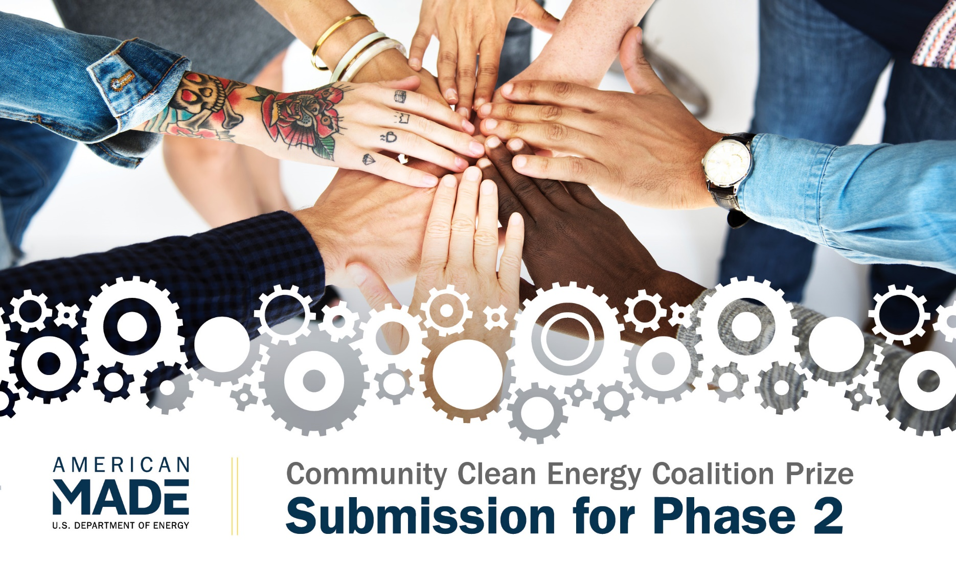
PROJECT NAME
Innovation tagline (e.g., your mission in a few words)
Keyword tags

TEAM
Names, geographic locations, contact information, and LinkedIn profiles

COMMUNITY(IES) AFFECTED
Cities, states, counties, areas, etc.

PARTNERS AND AMERICAN-MADE NETWORK
Key project partners and organizations
The Connector that significantly helped you advance your solution and the major items they helped with (if applicable)

VIDEO - Link to your video

Online Public Video (Will Be Made Public)

0BOnline Public Video

Tell us about your coalition, the Coalition Implementation Plan, its relevance to one or more DOE Justice40 Initiative policy priorities and clean energy solutions, and progress made from Phase One, in 90 seconds.
It is suggested the competitor provides:  - A summary overview of the coalition, team members, and committed partners, and any substantive changes since Phase One (e.g., new partners, expanded capacity, change in community identified).  - An overview of the Coalition Implementation Plan and how implementation will advance the mission of the coalition, the relevant DOE Justice40 Initiative policy priorities, and clean energy solutions.  - Any significant progress since Phase One. | A single score on a scale of 1–6 is provided, taking the following statements into consideration:  - The video clearly and concisely communicates the Coalition Implementation Plan, the relationship to the relevant DOE Justice40 Initiative policy priorities and clean energy solutions, and progress to date.

NARRATIVE CONTENT

The Coalition Commitment Narrative must not exceed 2,000 words. Submissions can also include up to five supporting visuals or graphics and unlimited letters of support (optional).

Topics
There are four topics that need to be addressed in the Coalition Implementation Plan:
- Topic 1: Community and Coalition Overview
- Topic 2: Coalition Development Progress
- Topic 3: Coalition Implementation Plan
- Topic 4: Vision and Anticipated Long-Term Impacts.

Topic 1: Community and Coalition Overview
Describe the community or communities being served and steps to engage and represent the community(ies).
It is suggested the competitor provides:  - Provide details about the coalition’s scope and depth of representation of the identified community(ies).  - Provide specific and actionable steps for maintaining and expanding engagement of the represented community(ies).  - Provide specific and actional steps for how the coalition will represent the identified community(ies). | A single 1–6 score is provided, taking the following statements into consideration:  - The competitor demonstrates a strong understanding of the identified community(ies) in the context of the defined energy challenge.  - The competitor demonstrates the ability to engage and represent the identified community(ies).  - The competitor’s engagement and representation include one or more disadvantaged communities.  - The competitor makes a compelling case for how their coalition will have a positive impact on the community(ies).

Response to Topic 1:

Topic 2: Coalition Development Progress
Describe the progress you have made in building and convening your coalition.
It is suggested the competitor provides:  - Describe the steps established to continue and build your coalition.  - Describe specific coordination activities you have taken for your coalition (including hiring, meetings, planning, activities, and stakeholder engagement).  - Identify how the activities to maintain and build the coalition advance the relevant DOE Justice40 Initiative policy priorities.  - Describe any outstanding coalition partnership commitments and their status.  - Describe other stakeholders outside the coalition members that are engaged. | Each statement scored on a 1–6 scale:  - The coalition members have demonstrated commitment to the coalition’s mission and success.  - The coalition has undertaken activities to strengthen its structure, membership, and voice in the community.  - The coalition has identified steps to strengthen and develop the relevant DOE Justice40 Initiative policy priority(ies) in the community served.  - The coalition demonstrates active engagement with stakeholders relevant to addressing the defined energy challenge.

Response to Topic 2:

Topic 3: Coalition Implementation Plan
Describe your plan and how you will achieve it.
It is suggested the competitor provides:  - Specify the approach and steps to address the defined energy challenge and advance the relevant DOE Justice40 Initiative policy priority(ies) and clean energy solutions. Include specific activities, milestones, or events.  - Describe how the coalition will engage, build trust, and strengthen relationships and partnerships with the identified community(ies) as well as with other relevant stakeholders.  - Identify the methods and metrics that will be used to evaluate your progress through specific, measurable, achievable, relevant, and time-bound (SMART) goals.  - Provide a budget for the proposed activities.  - Describe the resources (funding, personnel, and expertise) the coalition currently has available to implement this plan and how needed funds will be addressed. | Each statement scored on a 1–6 scale:  - The competitor’s proposed activities are appropriate and will likely result in successfully addressing the defined energy challenge.  - The competitor’s proposed activities are likely to deliver equitable benefits to local communities in support of DOE’s Justice40 Initiative policy priorities and to advance clean energy solutions.  - The competitor’s proposed activities are likely to build trust and strengthen relationships and partnerships with the community(ies) being served, as well as with other relevant stakeholders.  - The competitor’s metrics to evaluate success and the relevant SMART goals are well-suited to provide an accurate indication of success in meeting one or more of the goals of this prize.  - The description of proposed activities and the associated proposed budget are of adequate detail and indicate that the activities are well thought-out and achievable.  - The competitor has demonstrated that they will have access to the necessary resources and capabilities to execute their proposed plan or have a sufficient plan to address resource and capacity needs.

Response to Topic 3:

Topic 4: Vision and Anticipated Long-Term Impacts
Describe your short-term and long-term strategy to continue advancement of the coalition’s mission, consistent with the DOE Justice40 Initiative policy priority(ies).
It is suggested the competitor provides:  - Describe the anticipated short-term (1 year) and long-term (5 year) impact of your coalition and your coalition’s activities.  - Describe the coalition’s role in continuing to build the coalition in the identified community.  - Describe the strategies the coalition will employ to secure ongoing funding to build upon the proposed activities to ensure sustainability of the proposed activities.  - Describe the progress toward a clean energy transition that the competitor could achieve with ongoing funding beyond the initial award from this prize.  - Describe how you will measure success in the long term. | Each statement scored on a 1–6 scale:  - The competitor effectively describes their role in expanding the coalition beyond the initial award from this prize.  - The description of expected results from the competitor’s efforts after 1 and 5 years is achievable, impactful, and in line with DOE’s Justice40 Initiative goals.  - The proposed metrics are relevant and appropriate to the activities and desired outcomes.

Response to Topic 4:

FOUR TOPIC NARRATIVE WORD COUNT: ____________ total words

SUBMISSION SUMMARY SLIDE (WILL BE MADE PUBLIC)

Make a public-facing, one-slide submission summary that introduces the coalition and general plan highlights. There is no template, so competitors are free to present the information in any format. Any text must be readable on a standard printed page and a conference room projection and should be in at least 14-point font.

LETTERS OF COMMITMENT OR SUPPORT

In a single file, combine and upload one-page letters from relevant entities (e.g., coalition members, relevant stakeholders) to provide context for your coalition and outlined activities. Any letters of commitment or support must be written on letterhead or a template with the organization’s name on it, uploaded as a single file, and limited to a single page.

