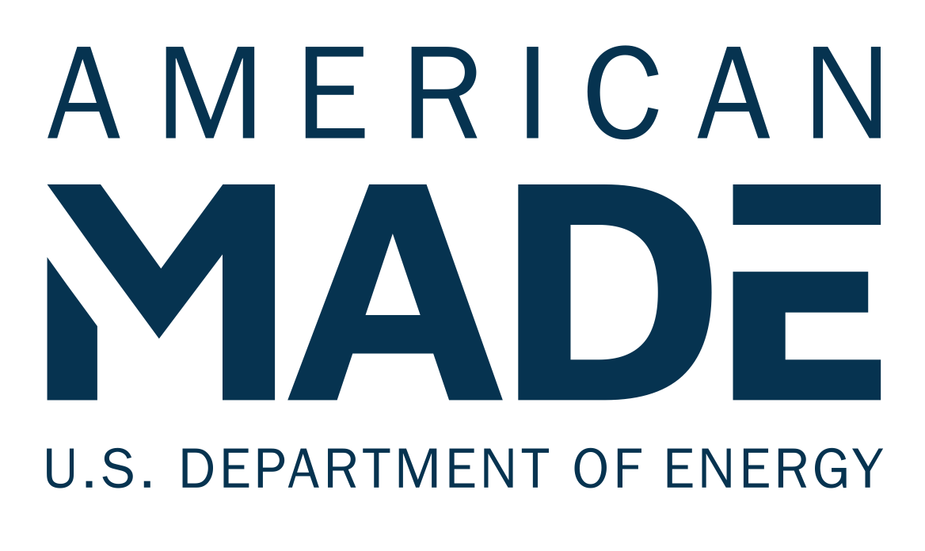

Project/Program Name [Enter your team’s name]

Tagline: [Your mission or idea as a single catchy sentence]

NARRATIVE TEMPLATE

SUNNY AWARDS

Narrative Template
All competitors should provide responses to the prompts in Section 1. In Section 2, competitors should provide responses to the prompts for any category for which they would like to be considered for a Meaningful Benefits Category Special Recognition. Competitors must respond to at least two sections to be eligible for a Sunny Awards Grand Prize. The aggregate response to these two sections must not exceed 2,400 words.
The reviewers will score the questions based on the content you have provided in your narrative and your other submission elements.

Section 1: Tell us about your project or program (background information, 300 word maximum)
Example content to provide  - Briefly describe the development timeline of your community solar project or program, from conception to operation or implementation. (Bullet points acceptable)  - What are the objectives/goals of the community solar program/project?  - Describe the subscribers and community/communities served by the project/program.  - Describe the roles of the project or program team and how team members worked together to support the project/program. | This section is scored on a 1–6 scale  - The statement comprehensively outlines the timeline of the project  - The statement comprehensively outlines the objectives/goals of the program or project  - The statement has a complete description of the types of communities the program or project serves  - The statement includes a clear description of the roles of project or program team members.

Your Response:
[Enter your response for Section 1 here]

Section 2: Tell us about the meaningful benefits the project or program is delivering
Each submission must be able to demonstrate that their community solar project or program provides at least one of the five primary Meaningful Benefits listed below (Categories 1-5) in order to be eligible for any Sunny Award or Recognition. In order to be eligible for a Sunny Grand Prize Award competitors must demonstrate that their community solar project or program provides 2 or more meaningful benefits listed below (Categories 1-7). In addition to this narrative, competitors will need to provide evidence to support their statements on the benefits they are providing. Details on supporting evidence can be found in Section 5. (300 word maximum per category)
Category 1: Greater Household Savings  Example content to provide  - Project: Describe how the project allocates subscriber bill credits, including the percentage of bill savings being realized by residential and non-profit subscribers (with a minimum of 20% savings for residential subscribers as compared to consumers not participating in community solar). Describe how your organization calculates bill savings.  - Program: Describe how the program supports community solar projects in ensuring residential and/or non-profit subscribers receive at least 20% or more bill savings (this could include state program incentives or other financial support programs). Describe how your program calculates bill savings. | This section is scored on a 1–6 scale  - The statement demonstrates how subscriber bill credits are allocated and provides evidence of at least 20% bill savings on average
Category 2: LMI Household Access  Example content to provide  - Project: Describe how your project acquires and maintains LMI household subscribers (include the percentage/number of households of LMI households subscribed)  - Program: Describe how the design of the program prioritizes LMI household participation including any unique benefits in addition to bill savings  - Describe how your project or program defines LMI. Competitors are encouraged to use their state community solar program’s definition for LMI or the federal definition for LMI (see Key Terms for details). If your project or program uses another method (census tract, self-certification, etc.) please describe those methods here. | This section is scored on a 1–6 scale  - The statement demonstrates strong level of LMI household engagement in the project or program with at least 40% of the residential subscribers being LMI households
Category 3: Resilience & Grid Benefits  Example content to provide  - Project: Describe how the project provides improved resilience for households or strengthens grid resilience (this might include providing storage as back-up power during an outage for households, critical facilities, or community hubs or reducing peak load through virtual power plans or other demand response action). Include examples, if possible, of when this system has been used to deliver back-up power or otherwise support more resilient or reliable provision of energy.  - Program: Describe how the program supports community resilience (household or community facilities) or strengthens grid resilience. | This section is scored on a 1–6 scale  - The statement demonstrates that the community solar project or program provides power in the event of a grid outage or strengthens grid operations through demand response and other actions
Category 4: Community Ownership  Example content to provide  - Project: Describe how the project incorporates community ownership or other measures that build wealth for subscribers or community members, including a description of the ownership model and how benefits are accrued or determined by community members.  - Program: Describe how the community solar program supports community ownership, including but not limited to community ownership of assets, community wealth-building measures, or community-member control over community solar projects | This section is scored on a 1–6 scale  - The statement demonstrates how the project or program provides opportunities for community ownership or wealth building
Category 5: Equitable Workforce Development  Example content to provide  - Describe how the project or program supports the creation and retention of good-paying jobs where workers are properly classified as employees, and have a free and fair choice to join, form, or assist a union.  - Describe how the project or program supports women-owned or minority-owned businesses (WMBEs) and/or reduces income disparities across race and gender lines  - Describe how the project or program ensures a trained and available workforce that is reflective of the community where the project or program is located  - Describe how the project or program ensures a safe work environment that is devoid of hostility and harassment | This section is scored on a 1–6 scale  - The statement demonstrates how jobs created by the community solar project will provide livable wages and benefits  - The statement describes how the project partners with underrepresented businesses and other partners  - The statement demonstrates the ways in which the project or program engaged with and if necessary, trained the local workforce during the timeline or development to operation through local workforce boards, pre-apprenticeship or registered apprenticeship programs, community colleges, etc.  - The statement describes how the construction project and/or training program ensures a safe working environment
Category 6: Community Engagement  Example content to provide  - Describe how your project or program included community engagement and who was involved during planning, building, and operation stages of the project or program  - Describe how community groups drove and designed the outcomes of the project or program | This section is scored on a 1–6 scale  - The statement comprehensively demonstrates how the project or program included authentic community engagement, what the process looked like and who was involved  - The statement comprehensively demonstrates how community groups drove and designed the outcomes of the project or program
Category 7: Innovation in Impact  Example content to provide  - Describe all other benefits the project or program is delivering to the subscribers and community that are not listed in this document | This section is scored on a 1–6 scale  - The statement demonstrates new or ground-breaking innovation in the benefits a community solar project or program is delivering to the subscribers or community

Your Response:

Category 1: Greater Household Savings:
[Enter your response here]

Category 2: LMI Household Access
[Enter your response here]

Category 3: Resilience & Grid Benefits
[Enter your response here]

Category 4: Community Ownership
[Enter your response here]

Category 5: Equitable Workforce Development
[Enter your response here]

Category 6: Community Engagement
[Enter your response here]

Category 7: Innovation in Impact
[Enter your response here]

