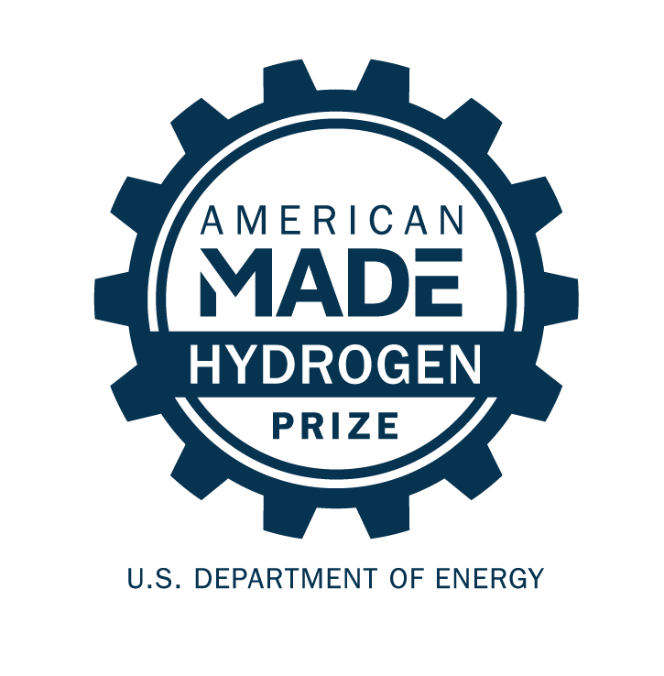
Link to your 90-second video

American-Made H-Prize: Hydrogen Shot Incubator

SUBMISSION FOR Phase 1: Propose!
PROJECT NAME
Innovation tagline (e.g., your mission in a few words)

TEAM
Names, geographic locations, contact info, and LinkedIn profiles

INNOVATION TAGLINE
(e.g., your mission in a few words)
Keywords that best describe your solution
Your city, state, and nine-digit zip code

Link to public video

Video Pitch: showcase your idea in 90 seconds

Post your publicly accessible video online (e.g., YouTube, Vimeo. Be creative and produce a video that conveys the required information in exciting and interesting ways, but do not focus on time-consuming activities that only improve production values (i.e., technical elements such as décor, lighting, and cinematic techniques).
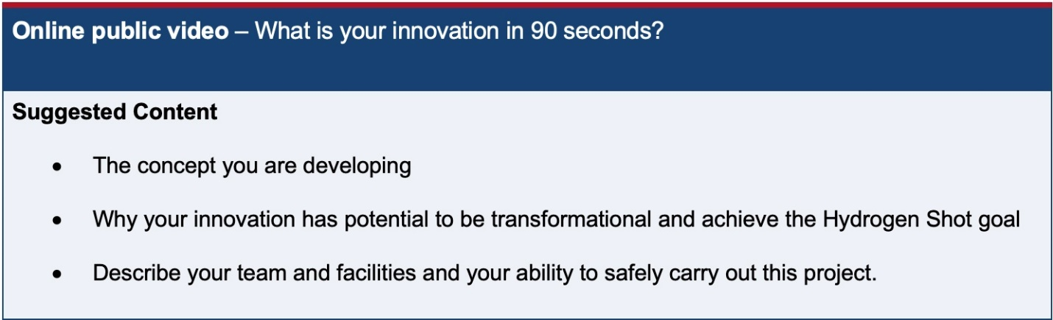

FOUR Question Written Narrative

Answer each of the following four questions:
- Innovation - What is the innovation and what is its potential to drive down the cost of clean hydrogen production?
- Potential – Why will your innovation by successful?
- Accomplishment and Team– What have you done to date, and what qualities give you a competitive edge?
- DEI Plan

For convenience, these questions are provided in the headings of the tables on pages 3-6 along with suggested content (and corresponding judging statements) to help guide your responses. You decide where to focus your answers.
The content bullets are only suggestions to guide your responses. You decide where to focus your answers. The individual answers to the questions do not have a word limit; however, the aggregate response to these four questions must not exceed 1,500 words, not including captions, figures/graphs, or references. You must include a word count at the end of your submission. You may also include up to five supporting images, figures, or graphs. The reviewers will score the questions based on the content you have provided.

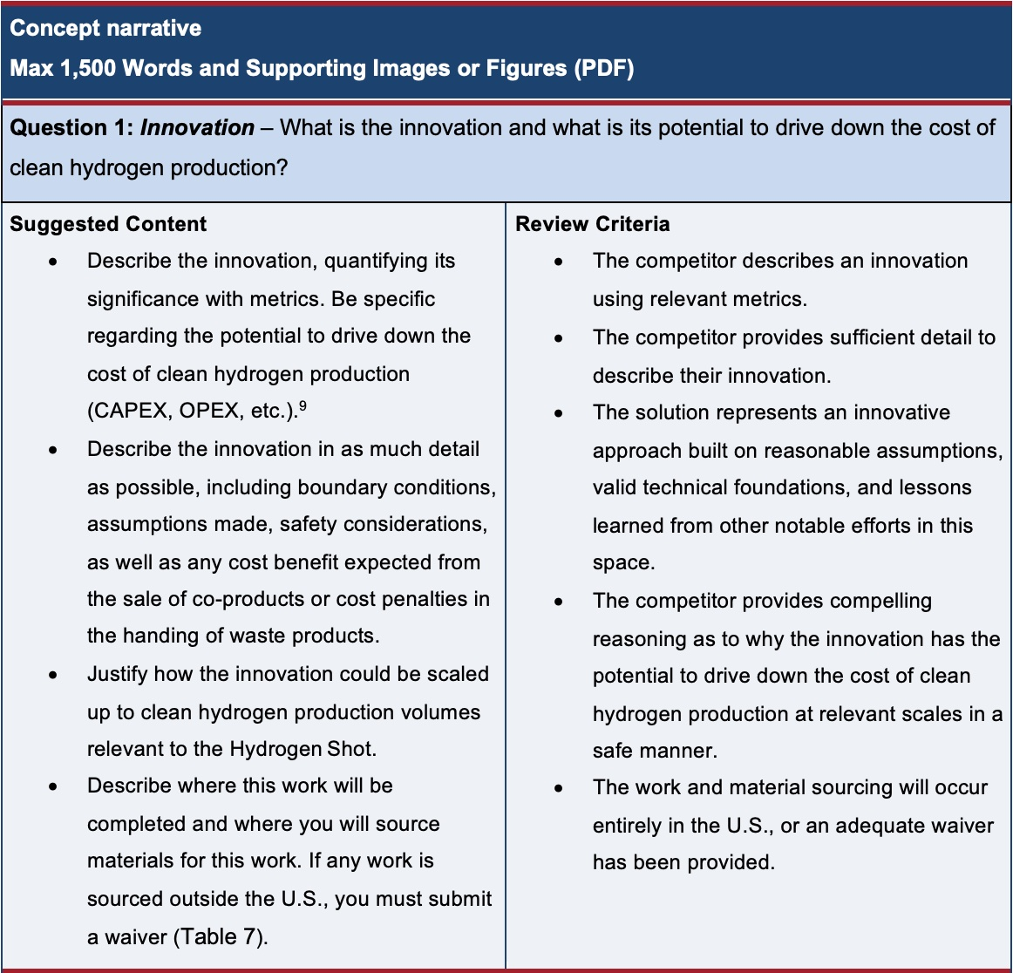

Response to Question 1:

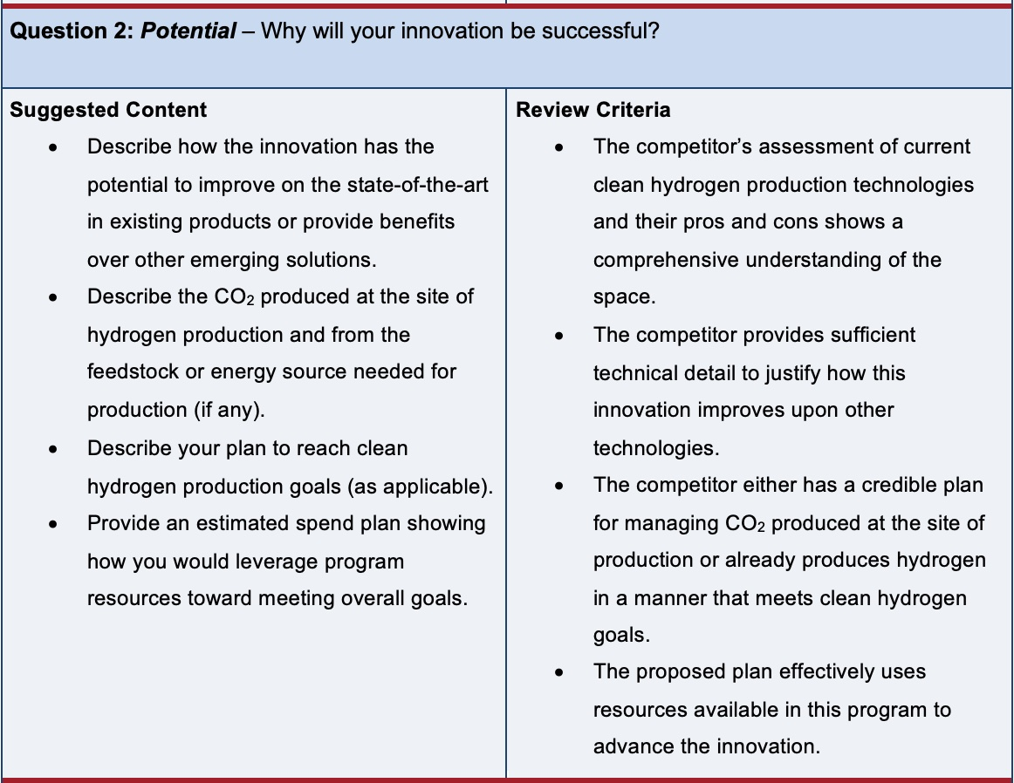
Response to Question 2:
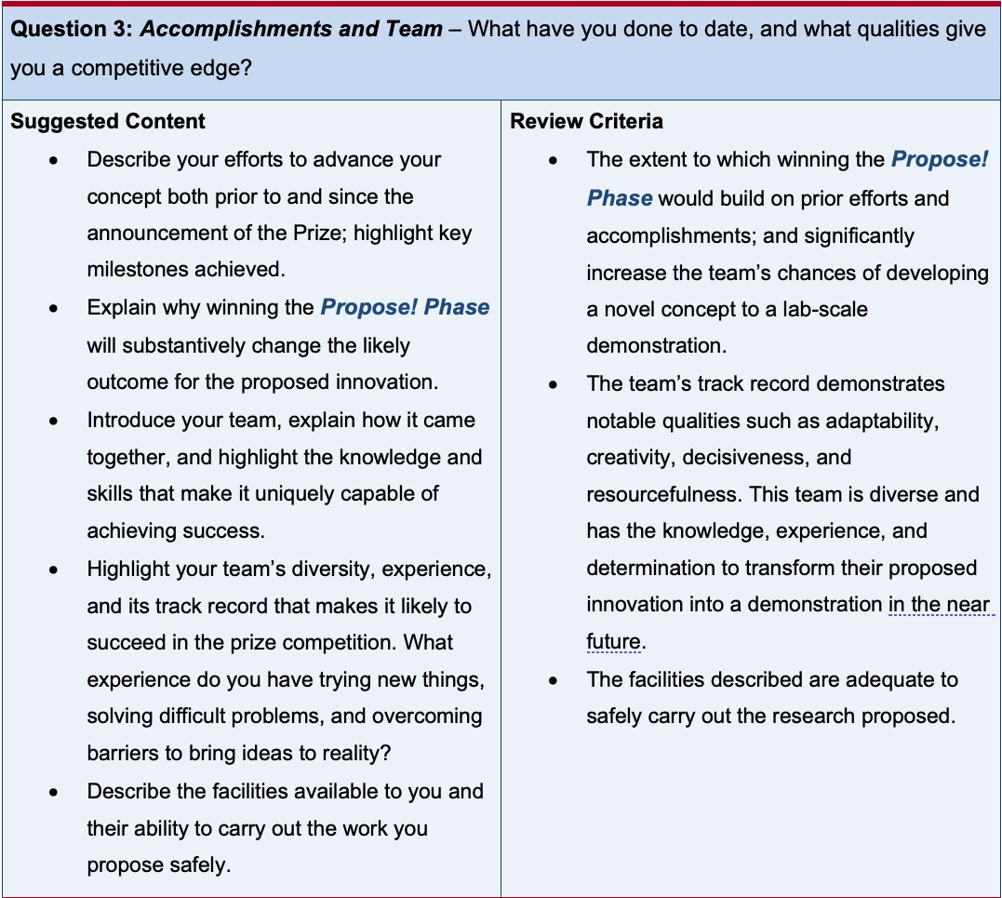
Response to Question 3:
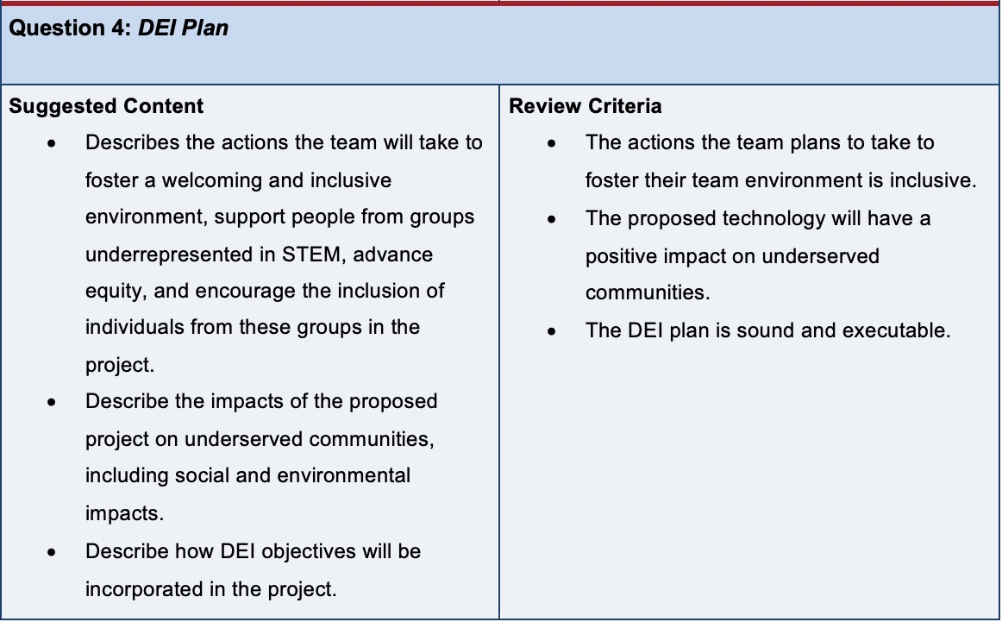
Response to Question 4:

supplementary Information

FOUR question narrative word count: _______ total words

sUBMISSION SUMMARY SLIDE
A PowerPoint slide, will be made public

Make your own public-facing one-slide submission summary that contains technically specific details but can be understood by most people. There is no template, so feel free to present the information as you see fit. Please make any text readable in a standard printout and conference room projection.

LETTERS OF COMMITMENT OR SUPPORT
Optional

Attach one-page letters (of support, intent, or commitment) from other relevant entities (e.g., potential users of the proposed innovation) to provide context. Letters of Support from partners or others that are critical to the success of your proposed solution will likely increase your score. General letters of support from parties that are not critical to the execution of your solution will likely not factor into your score. Please limit letters of support to one page each.

