Technical challenge

Executive summary
The development of manmade geothermal resources requires stimulation using large volumes of water mixed with proppants (i.e. the stimulation fluid), to create or increase the permeability of natural fractures. The high-pressure of the stimulation fluid relieves the vertical stress and enables the shearing of the predominantly sub-horizontal fractures. This increases the permeability of the natural fractures and the multiple fractures allow each well to deliver steam/heat at commercially viable rates. Each of fractured interval in any well can be independently stimulated, and the flow into or out of the stimulated fractures can be more accurately controlled for reservoir and heat management purposes. Zonal isolation barriers allow for isolation between fractures to facilitate stimulation and flow control.
Welltec is exploring an all-metal barrier for manmade geothermal wells. The design is based on using a hydroformed metal sleeve to create hydraulic barriers in wells. Welltec successfully created devices that compensate for the natural spring back of the metal sleeve after hydroforming. The complex shape of the product requires CNC machining and welding of different parts to the expansion sleeve. Incorporating additive manufacturing in the design will significantly reduce the complexity of the manufacturing of the product and will make it more robust due to the elimination of welds.

WAB™ Design
The Welltec open-hole metal expandable packer (WAB™) uses a metal outer sleeve mounted on the OD of the liner or casing as shown in Figure 1-1 below. The ends of the expansion sleeve are welded to the casing (liner). Surface pressure-activated elastomer seal elements are housed within seal carriers and are mounted on the metal outer sleeve (expansion sleeve). The metal outer sleeve is hydraulically expanded radially using well fluids until it contacts the formation. The well fluid is communicated from the liner via ports within the walls of the liner. During the hydraulic expansion, the metal outer sleeve yields (the yield pressure is a function of the material grade, wall thickness, and the diameter) and then plastically deforms to conform to the profile of the wellbore (open or closed). The metal outer sleeve is manufactured with a high ductility alloy that work hardens as it expands. The result is a uniform expansion of the material that conforms to the borehole shape creating a long-lasting annular seal.
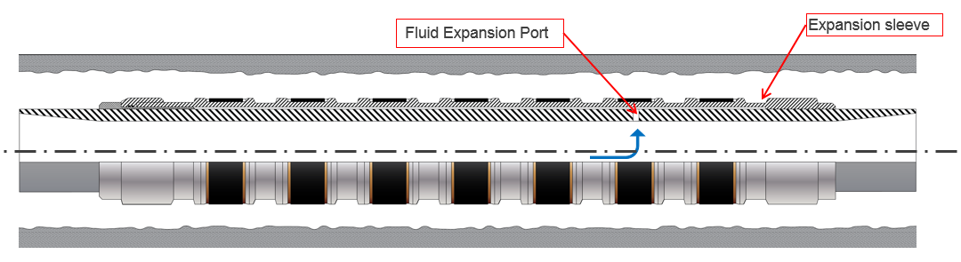
Figure 1-1 - WAB™mounted on casing
Figure 1-2 -Un-expanded WAB™ Mounted on Casing
The design is seamlessly integrated with the completion as it utilizes the same casing or liner without decreasing its internal diameter. On reaching the desired depth the WAB™ is hydraulically set via surface control and it expands as shown in Figure 1-3 below. The WAB™ is resilient under varying well conditions and is unaffected by the fluctuating environmental variables i.e. salinity, viscosity, and temperature over the life of the well.
Figure 1-3 - Expanded WAB™ Mounted on Casing

Technical assistance description
The sealing system is composed of metal membrane seal bodies that are welded to the expansion sleeve. Welltec would like to explore the use of additive manufacturing to create the expansion sleeve and seal bodies thereby decreasing material waste and eliminating the need for expandable welds.
The technical challenge is to create an expansion tube with alloy 28 chemical composition capable of at least a 40% expansion ratio (elongation). The material must be uniform, predictable, and have only small variations along the tube. The dimension of the tube is expected to be about 2 meters long and will have an outside diameter of about 0.22 meters.
The expansion tube must be able to withstand post-manufacturing heat treatment without significant deformation.
The award will allow us to obtain the necessary technical support to explore the properties of different metals at different temperatures and their impact on the solution. The solution will be made in the U.S.A. thereby achieving a key objective of the U.S. Department of Energy to further “catalyze manufacturing innovation in the American geothermal industry by harnessing the rapid advances additive manufacturing can provide in improving the design, fabrication, and functionality.”

