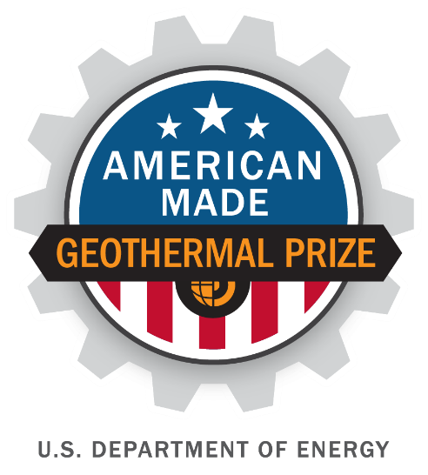

American-Made Geothermal Manufacturing Prize
SUBMISSION FOR READY!

PROJECT NAME :
Using Additive Manufacturing to design and fabricate Pipeline Interventions Gadget (P.I.G.) for Removal of Scale Deposition from Geothermal Wells

Keyword: Pipeline Intervention Gadget, Geothermal Scaling, Corrosion
TEAM
Names, geographic locations, contact info, and LinkedIn profiles
- Dr.William Gosnold, Grand Forks, ND, william.gosnold@und.edu, 701-777-2631,https://www.linkedin.com/in/william-gosnold-94093843?trk=
- Dr.Stephan Nordeng, Grand Forks, ND, stephan.nordeng@und.edu, 701-777-3455,https://www.linkedin.com/in/stephan-h-nordeng-a84a9181
- Samsideen Olamilekan Ajala, Lafayette, LA, samsideen.ajala1@louisiana.edu, 337-326-0529,https://www.linkedin.com/in/samsideen-ajala-470b47b6
- Moones Alamooti, Grand Forks, ND, moones.alamooti@und.edu, 662-202-7737,https://www.linkedin.com/in/moones-alamooti-89621253
- Emmanuel Chukwuemeka, Grand Forks, ND, emmanuel.chukwuemeka@und.edu, 701-777-2571,https://www.linkedin.com/in/emmanuel-chukwuemeka-b298a813a?trk
- Rebecca May, Grand Forks, ND, rebecca.may@und.edu, 701-777-5000,https://www.linkedin.com/in/rebecca-may82
- Nnaemeka Ngobidi, Grand Forks, ND, nnaemeka.ngobidi@und.edu, 701-777-5988,https://www.linkedin.com/in/nnaemeka-ngobidi-a336036b
- Rita Esuru Okoroafor, Stanford, CA, ritaok@stanford.edu, 650-382-8012,https://www.linkedin.com/in/rita-esuru-okoroafor-19232b7
- Chioma Onwumelu, Grand Forks, ND, chioma.onwumelu@und.edu, 701-739-9132, https://www.linkedin.com/in/chioma-onwumelu-43762765?trk
- Ogochukwu Ozotta, Grand Forks, ND, ogochukwu.ozotta@und.edu, 701-777-5000,https://www.linkedin.com/in/ogochukwu-ozotta?trk=
- Jerjes Porlles Hurtado, Grand Forks, ND, j.porlleshurtado@und.edu, 701-777-2533,https://www.linkedin.com/in/jerjes-porlles-909bb62a?trk=
- Ashish Kotwal, Grand Forks, ND, ashish.kotwal@und.edu, 701-777-5986,https://www.linkedin.com/in/ashish-kotwal-und?trk=
- Olusegun Tomomewo, Grand Forks, ND, olusegun.tomomewo@und.edu, 701-777-5986,https://www.linkedin.com/in/olusegun-stanley-tomomewo-mba-pmp-1712a797
PARTNERS AND AMERICAN-MADE NETWORK SUPPORT
Key project partners and organizations :
Harold Hamm School of Geology & Geological Engineering  Leonard Hall Room 101  81 Cornell St Stop 8358  Grand Forks, ND 58202-8358  P 701.777.2248  F 701.777.2811  und.gge@UND.edu  https://engineering.und.edu/academics/geology-and-geological/ | Energy & Environmental Research Center  University of North Dakota  15 North 23rd Street, Stop 9018  Grand Forks, ND 58202-9018  701.777.5000  eercinfo@undeerc.org  https://undeerc.org/about/index.html
https://youtu.be/kNyUDncTv48
1

|

American
-
Made Solar Prize Official
Rules

Question1: Problem Definition
Scale buildup in geothermal fluid lines negatively impacts flow and heat transport and efficiency of operations by requiring downtime for cleaning. We propose to design and fabricate a novel device for scale removal that will lead to higher enthalpy, reduced cost, and higher efficiency. The fabrication techniques include 3D printing (Additive Manufacturing) of the novel device with specialized engineered material sustainable at higher temperatures and pressures.
When parameters such as temperature, pressure, composition, or pH change during geothermal power operations the equilibrium of the system shifts resulting in scale buildup in the fluid lines. Andritsos et al., (2002) point out that scaling is a major obstacle in the development of geothermal energy. The most common problems are related to the chemistry of the geothermal fluids (Gunnlaugsson et al., 2014).
As an example, the Cerro Prieto geothermal field, which is one of the largest geothermal fields in the world Ocampo et.al. (2005). The scale is a major problem in geothermal operations. Zarrouk (2014), explains scaling shows a dramatic impact on the long-term operating performance of geothermal heat exchangers. Scaling affects both the flow hydrodynamics and the heat transfer resistance. The cleaning of binary plants is important because it reduces pipeline pressure, reducing the risk of potential damage. According to Nergaard et.al. (2010), the cost of scale removal can be quite costly around 40 % of the maintenance budget. Scaling condition slows transmission and distribution capacity and can require more than just routine maintenance if it remains unaddressed. Interior corrosion, scaling, and leakage in pipeline systems will adversely impact bottom-line operations.
Common scaling mechanisms are:
Particulate scaling: This results from sediment of dust, rust, fine solids, and other entrained solids.
Crystallization scaling: A concentration of dissolved solids by repeated partial evaporation of the water is the main factor that causes calcium carbonate scale which is Crystallization scaling.
Biological scaling: This occurs when biological organisms grow on inner pipe surfaces. Problems arise from algae and other microbes such as barnacles and zebra mussels.
Chemical reaction scaling: This type of scaling occurs when the depositions are formed as a result of a chemical reaction.
The currently existing process of pigging in oil and gas fields is not cheap. The total pigging cost on that 15 miles of pipeline would be $335,000 - $380,000 or roughly $35,000 per mile, $59 billion to run this standard pigging operation on all US pipelines one time.
Role of additive manufacturing:
Numerous advanced manufacturing methods, such as 3D-printing (AM), have received increased R&D as well as commercial attention in recent years because of their ability to rapidly prototype complex parts in corrosion management fields, Sireesha et.al. (2018), and Vendra et.al. (2018). 3D-printed hydrophobic surfaces Wang et.al. (2016), Jafari et.al. (2019), 3D-printed ancillary devices for condensation removal for reducing scaling and corrosion, such as the examples define the use of AM for tackling issues of scales in Oil and Gas as well as Geothermal industry Al-Janabi (2015). The Conventional Manufacturing (CM) processes are high cost and material inclusive, and although the processes are currently widely used in industries, the complex micro-structured composites are difficult to manufacture. With the help of additive manufacturing (AM), the 3D printing processes can deliver desired roughness and structure without wasting material, reducing overall cost, Jafari et.al. (2019). With modern process improvements, AM facilitates access to parts with better production-ready quality at faster speeds and reduced costs. Production-grade material properties are required to master as specific application orientated.
Question 2: Innovation
Our novel mitigation strategy is cyclic scale management as operational analysis data indicate the need for assertive action. (Figure 1 for more details).
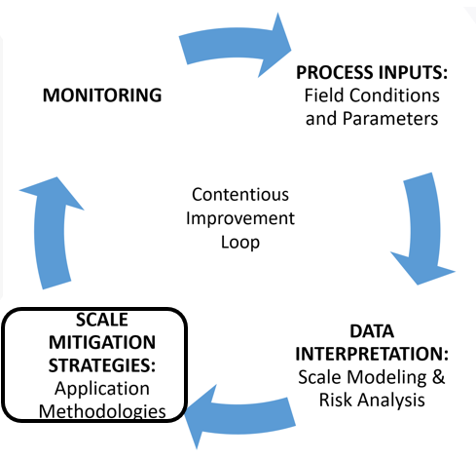
Figure 1: Scale management as a continuous process improvement loop
Though the enthalpy of fluids is higher than fluids dealt with in oil and gas fields, a sustainable material at high temperatures and enthalpies can be utilized for geothermal system pigging devices. Previous work suggests that detection scale buildup at injection well lines can be detected by monitoring pressure drop (Brown, 1995; Stock and Orser, 1990) Klein (1995) recently developed methodologies for predicting and suppressing scales in reinjection lines and wells. Arata, Erich, and Paradis (1996) provide insights on pigging as a process for removing geothermal reinjection well lines.
We propose that the pigging process can be utilized at lines near production wells in conjugation with reinjection wells with specified material and its manufacturability tested by AM. Its tested endurance at high thermal stresses in high pressurized systems test operations can be a feasible solution for use of pigging or pigging similar scale removal systems in geothermal power generation facilities.
Design of Pipeline Interventions Gadget (PIG):
In previous experiences with the process of pigging three major problems were observed, 1) breakage of the front guided roller, 2) rapid deterioration of the propulsor materials and 3) the inability to accurately track the location of the tool due to faulty electronics. [2] In the process of pigging, the device exclusively moves with applied pressure forces at the backplate and with the internal mechanism of the brush scraper along the walls of pipes. A backplate of this Pipeline Intervention Gadget (PIG) is planned and installed with a corrugated pattern similar to turbine blade geometry. Thus, executing tangential components in effect with linear components of velocity, developing vorticity, and as result rotational movement for the whole PIG. Due to faster rotations, propulsors are required sufficient to hold the backpressure as well as acting as bendable smooth uniform contact across the inner walls of the pipe. This rotational part shall act as an excavator/drill reducing the thickness of scale along pipe walls. The launcher serves the purpose of launching PIG in pipelines, like the mechanism of executing processes in the oil and gas industry. Thus, the design of launchers can have dimensions and properties of launchers used in the oil and gas industry. The flow rates from launchers to receivers, and vice versa, can be up to 50 percent less than that of the flow rates utilized in the pigging process in the oil and gas industry. The following table shall give an approximate idea of the PIG, its process of utilization, and the forces acting during the process.
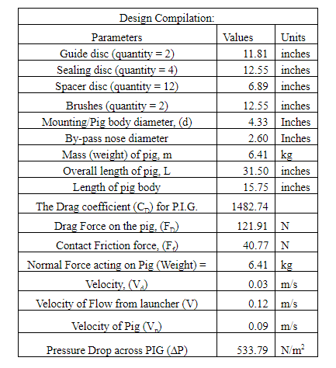
Table.1: approximate design compilation with fundamental dimensions
A rippled structured insulation jacket is possible to provide a dual work solution, which is the cleaning of scales and protection from temperature.
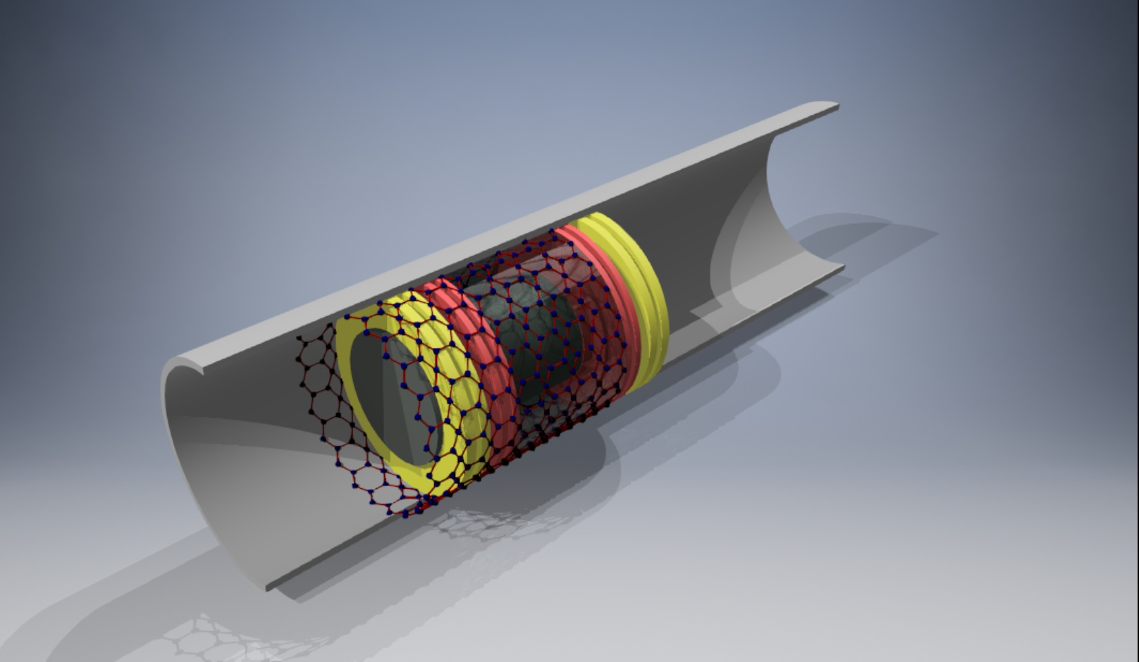
Figure 2: Schematic of Pigging device. (Not as per scale).
Implementation of Additive Manufacturing (AM):
Each part can be built by use of various 3D printing techniques, and then can be assembled using conventional manufacturing skill, while other methodology, the entire device can be fabricated using AM one technique. Techno-Economic Analysis (TEA) can be evaluated based upon two routes of manufacturing and design by fabricating a 1:5 scale prototype. The prototypes can be tested at various thermal and pressure conditions by applying continuous tensile or compressive stresses at elevated temperatures. Speculations upon results shall lead to comprehensive decisions among all team members. The AM steps are required to break down in several scenarios and assessments with required additional attention towards material considerations and dimensional tolerances associated with it because the AM compatible materials are not currently available for all parts. In certain scenarios, we might use a hybrid approach towards specific parts such as a combination of Additive Manufacturing (AM) and Subtractive Manufacturing (SM). Generally, to achieve final tolerances and finishing for surfaces, the addition of Conventional Manufacturing (CM) (e.g., heat treatment, nitriding, etc.) is required. (As shown in figure 3)
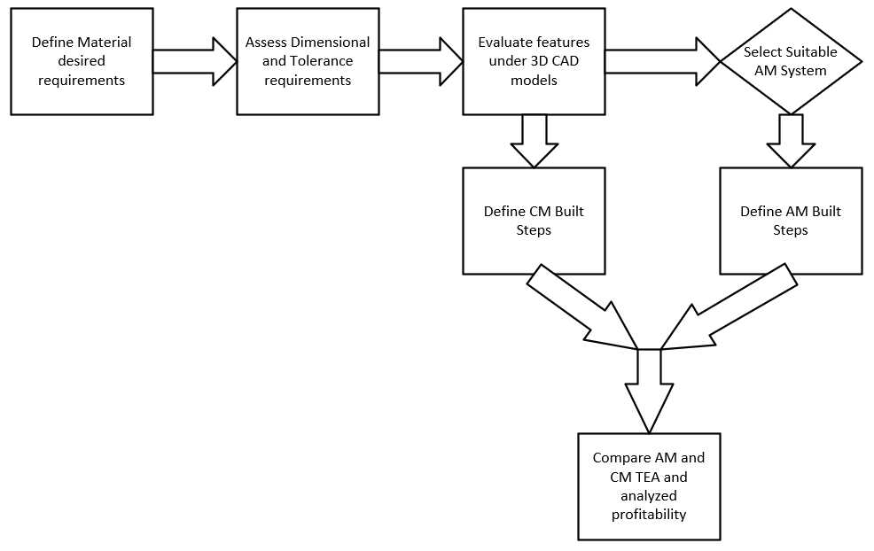
Figure 3: Generalized manufacturability assessment process flow
The TEA of this process is approximately 5 to 10 percent lower than previously existing pigging processes in oil and gas fields. The feasibility aspects of this device are statistically implementable by reviewing the current state of technology and material science development compared to nano-micro structured coatings across the inner walls of pipelines.
Question 3: Team
Our team, “Dreamer Geothermophiles”, is a group of highly motivated faculty members, graduate, and undergraduate students with different scientific backgrounds to outperform competitors.
Faculty Members:
Dr. William Gosnold:
- Chester Fritz Distinguished Professor in Geology and Geological Engineering, University of North Dakota (UND).
- Career spans: 42 years
- Research: heat flow, geothermal energy.
- Geothermal energy research: Williston Basin, first commercial demonstration of geothermal power using low-temperature waters in an oil and gas setting.
- Memberships: 1. Founding Member, US National Geothermal Data System for the DoE. 2. Custodian: Global Heat Flow Database of the International Heat Flow Commission from 2001 until 2019.

Dr. Stephan Nordeng:
- Associate Professor of Geological Engineering at the UND.
- Experience oil and gas: 8 years with the NDGS working on numerous Bakken-Three Forks-related petroleum resource investigations 2006-2014.
- Research: source rock kinetics of various rock formations in the Williston Basin.
Student members:
Moones Alamooti:
- Ph.D. student of Geophysics at the UND
- Member: GRC student committee.
- Research focus: Application of geophysics in finding geothermal resources.
- Skills: Additive Manufacturing (Basic).
Samsideen Ajala:
- M.Sc., Geology, University of Louisiana.
- Previous member: Drilling team at Shell in Nigeria.
Emmanuel Chukwuemeka:
- Ph.D. student, Mechanical Engineering, UND.
- Skills: CAD drawings, flow analysis (CFD).
- Award: “Petroleum and Shell Undergraduate Scholarships Outstanding Student”, 2015.
Rebecca May:
- Research assistant: Energy and Environmental Research Center (EERC).
- Pursuing BS, geology and environmental science, UND.
- Skills: data mining, environmental management.
Nnaemeka Ngobidi:
- Ph.D. student, Geology, UND.
- Experience: Supervisor, World Bank, and AFD assisted projects in the water sector, emphasis: pipe reticulation pressure testing and sterilization.
Rita Esuru Okoroafor:
- Ph.D. student, Energy Resources Engineering, Stanford University.
- The president of the GRC student committee.
- Experience: Principal reservoir engineer, Schlumberger.

Chioma Onwumelu:
- Ph.D. student, petroleum geology, UND.
- Experience: Geoscience Intern, Research Assistant, and Wellsite Geologist.
- Member: GRC student committee.
Ogochukwu Ozotta:
- Ph.D. student, petroleum engineering, UND.
- Experience: QAQC on structures, rocks, construction materials, geophysical subsurface investigation, reservoir characterization.
- Member: GRC student committee.
Jerjes Porlles Hurtado:
- Ph.D. student, petroleum engineering, UND.
- Experience: Supervisor, gas plant with scaling issues, oil and gas reservoirs expertise, and analogical applications in geothermal projects.
- Skills: Fluid flow simulation through pipelines (Pipesim and GAP) and scaling generation.
Ashish Kotwal:
- Ph.D. student, Energy Engineering at the UND.
- Experience: 1 year, power transformers copper winding corrosion issues.
- Skills: 3D CAD Modeling, computational mathematical modeling (CFD, CSD), additive manufacturing (AM)
Olusegun Stanley Tomomewo:
- Ph.D. student, energy engineering (UND).
- Experience: 14 years, well development engineer, and general energy asset management, Schlumberger.
- Skills: Certified project manager (PMP certification, PMI).
The team has the opportunity to work under the supervision of distinguished professors and highly experienced professionals in the geothermal industry. Initialized work by discussing the existing issues in this industry with the team and gathered literature review. Later, we discussed the benefits and disadvantages of each option. We decided to work on scaling issues which not only reduces the quality of implementation but also increases the cost of the project. We found AM is a key solution that could handle both cost and quality issues in scaling, leading us to understand how AM had worked so far regarding this issue, and how design can be improved.
By winning Ready! Contest, we could better work on improving our design and creating the initial prototype. Additionally, we are planning to attend workshops related to the project and to register 1-2 team members in AM training courses. Those achievements would help to 1) use AM more efficiently in our project, 2) find the potential defects in prototypes, and 3) to be well prepared before Make! Contest.
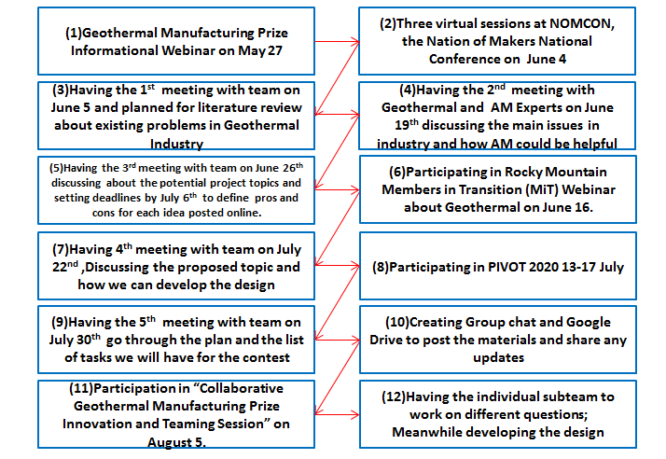
Figure 4:Flowchart showing the key milestones in the project
Question 4: Plan
The novel device is in a concept development phase only and does not have a working prototype. The device that the oil and gas industry operates on higher pressures, while our technology is defined to work on mid to small scale discrete power generation facilities such as geothermal plants established for providing the energy to 17 to 21 houses. The pressure exitance at small to mid-scale power plants holds less than 1000 psig in production and reinjection wells.
The team will go through detailed analysis and development under Set! Phase of the geothermal challenge. Components fabrication using AM needed to be analyzed and speculated. If the whole part is built from 3D printing, then how does it sustain under various thermal and structural stresses caused by impulsive hydrodynamic forces compared to building an assembly of parts? The goal is to produce documents highlighting detailed analysis and methods of creating this device.
Using the design developed and certified from Set! Phase the device will start manufacturing in Make! Phase. Under this phase the factors such as time, space, and finances which are initially evaluated on Set! Phase would be deployed. The time required building a cylinder of 1 cm diameter and 10 cm height using various 3D-printing techniques will be monitored and the technology which is operating with optimal timing and providing results sustainable at higher temperature and pressure will be chosen. The goal is to have an optimized prototype completed or near completion.
At the Geo! phase, we will apply actual test conditions to the manufactured prototype. The device will be evaluated at a geothermal power station in South Dakota where we plan to contact during the Make! Phase, or leverage on the America-Made Network for such a facility.
Our AM team has been divided into talented subgroups with experience in manufacturing. Tasks were distributed based upon individual strengths and time limits. In terms of resources, we have a geothermal library, advisors, and opportunities for training in the execution of this project. The most critically required resource is the financial provision from contests as well as other financial sources. The various tech facilities and knowledge support from experienced faculty available at the UND campus give viable solutions to the challenges. However, certain resources can be obtained from industrial machine shops for the development of novel technology.
We have also factored in our time commitments to also execute the SET and GEO phases of the project. We estimated approximately $1.5M for the execution of all stages of the project. Please check the attached timeline for the project and the estimated budget distribution according to different stages.
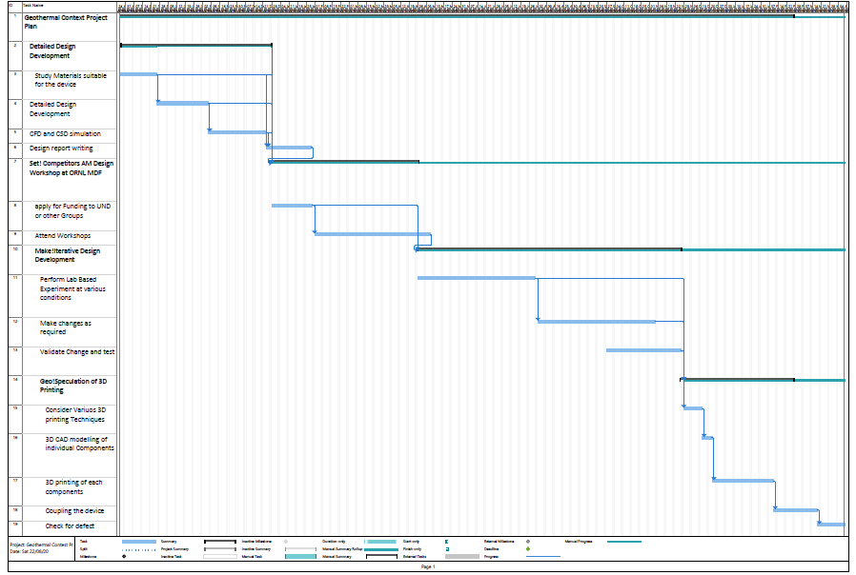
Figure 5: Project Plan
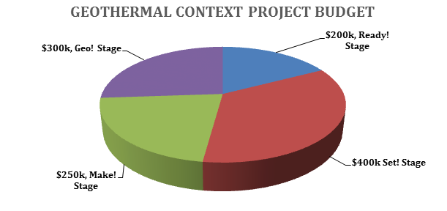
Figure 6:Geothermal Context Project Budget

Citation:
[1] Andritsos, N. & Karabelas, Anastasios & Koutsoukos, Petros. (2002). Scale Formation in Geothermal Plants.
[2] Arata, E., Erich, R., Paradis, R., (1996). Recent innovations in pigging technology for the removal of hard scales from geothermal pipelines. Geotherm. Resour. Council Trans. 20, 723-727.
[3] Al-Janabi, A., & Malayeri, M. R., (2015). Nano-coated surfaces to mitigate fouling in thermal water services. Desalination and Water Treatment, 55(11), 2909-2917.
[4] Brown, D.W., (1995). Verification flow testing of the HDR reservoir at Fenton Hill, 661 New Mexico. Geothermal Resources Council Transactions, Davis, CA
[5] Gunnlaugsson E, Armannsonn H, Thorhallsson S, Steingrimsson B, (2014). Problems in geothermal operation. Scaling and corrosion. In: Short Course VI on utilization of low- and medium enthalpy geothermal resources and financial aspects of utilization, organized by UNU-GTP and LaGeo, in Santa Tecla, El Salvador.
[6] Jafari, R., Cloutier, C., Allahdini, A., & Momen, G. (2019). Recent progress and challenges with 3D printing of patterned hydrophobic and superhydrophobic surfaces. The International Journal of Advanced Manufacturing Technology, 103(1-4), 1225-1238.
[7] Klein, C. W., (1995). Management of Fluid Injection in Geothermal Wells to Avoid Silica Scaling at Low Levels of Silica Oversaturation. GRC Transactions, 503-511.
[8] Nergaard, M., &amp; Grimholt, C., (2010). An Introduction to Scaling causes, problems and solutions. Term paper for the course TPG
[9] Ocampo, D.J., de, D., Valdez, B., & Schorr, M. (2005), “Corrosion and scaling problems in Cerro Prieto geothermal ﬁeld”, Proc. 2005World Geothermal Congress, Turkey, pp. 1-5
[10] Sireesha, M., Lee. J., Kiran, A.S.K, Babu, V.J., Kee, B.T. and Ramakrishna, S., (2018). A Review on Additive Manufacturing and its way into the Oil and Gas Industry, Roy. Soc. Of Chem. Advances, 8, 99. 406-468.
[11] Stock, D.D. and L.L. Orser, L.L. (1990). Geothermal Reinjection at Dixie Valley, Nevada. In: Proceedings of the Symposium on Subsurface Injection of Geothermal Fluids, held in Santa Rosa, CA,October 29-30, 1990. Underground Injection Practices Council Research Foundation.
[12] Vendra, L. and Achanta, A., (2018). Metal Additive Manufacturing in the Oil and Gas Industry, Solid Freeform Fabrication 2018: Proc. 29th Ann. Int. Solid Freeform Fab. Symp., pp. 454-460.
[13] Wang, Y., Zhang, H., Liu, X., & Zhou, Z. (2016). Slippery liquid-infused substrates: a versatile preparation, unique anti-wetting and drag-reduction effect on water. Journal of Materials Chemistry A, 4(7), 2524-2529.
[14] Zarrouk, S. J., Woodhurst, B. C., & Morris, C. (2014). Silica scaling in geothermal heat exchangers and its impact on pressure drop and performance: Wairakei binary plant, New Zealand. Geothermics, 51, 445-459

