3D Printed, Continuous Fiber, Composite Frac Plugs for Geothermal Systems
Bhushan Pendse, Laurent Alteirac, Huilin Tu
Schlumberger
The accessible EGS resource in continental USA is estimated to be around 800-3600 million TWh, about 15 million years of the electricity consumption of New York City. So EGS presents an enormous potential as a renewable energy resource. One of the key technologies to enable the production of geothermal energy from EGS is isolation plugs that can withstand the typical temperatures of geothermal wells. For EGS wells with bottom-hole temperature of 400 °F and above, there is only very limited selection of compatible isolation plugs.
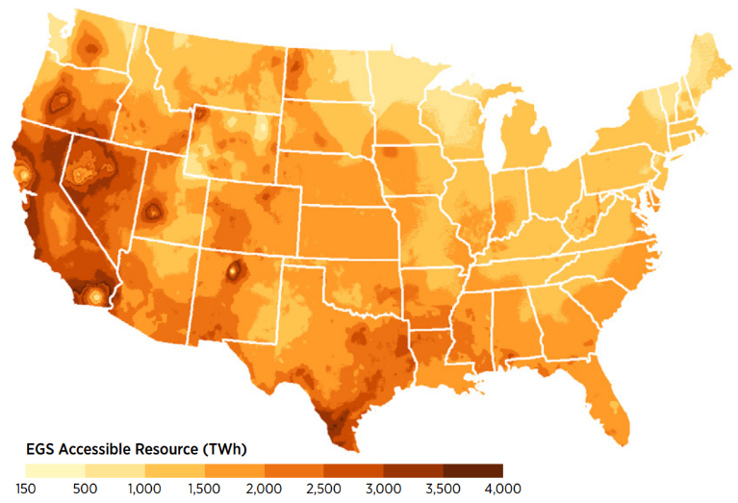
Challenges:
Due to the high temperature requirements, conventional isolation products often fall short due to:
- Lack of structural strength in composites due lower glass transition temperature (Tg), inadequate reinforcement in fiberglass composites.
- Inability of sealing component to maintain integrity through the application lifecycle.
- High amortized cost involved with conventional manufacturing methods, thus limiting scope to customize fit for application products.
- Human intervention required for assembling components leading to added cost and higher nonconformance.

Our team brings domain expertise and testing experience in geothermal stimulation solutions, with direct industry application as an outcome of the scope of work outlined in this proposal. To develop a 3d printed composite frac plug for geothermal applications, technical assistance is required in:
- Material Selection
- 3D Printing of prototypes using continuous fiber
- Targetted reinforcement techniques

Resources:
To accomplish the goals listed above, the resources that we would like to collaborate with are:
- Vendors capable of 3D Printing with continuous fiber for Prototype manufacturing
- University Business Incubator for material research

