American-Made Geothermal Manufacturing Prize
Technical Assistance Request

The Problem

Well-bore energy production systems like conventional geothermal or oil and gas use Electric Submersible Pumps (ESPs) for the production of brine, steam, crude oil, or water. Despite their prevalence, reliance on ESPs causes two major problems: first, the parasitic power required adds substantially to the production cost of geothermal energy, oil and gas and second, generally the power consumed diminishes the environmental benefits associated with geothermal energy;

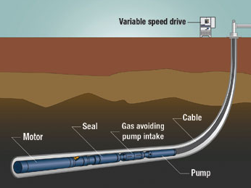
The annual cost of operation and maintenance for pumping a single well can exceed a million dollars annually using conventional ESPs. ESP failures not only require costly repairs or replacement, but also causes lost production.
Figure 1
The dependability, reliability and efficiency of (ESPs) declines as conditions become more extreme at 7,000 to 10,000 ft. underground:
- Deep underground, maintenance or replacement is very difficult
- Environmental temperatures can exceed 400F
- Environment can range from highly acidic to highly caustic

These conditions combine for frequent failure. Electrical components account for 60% of all failures while the combined electrical efficiency losses of motors and Variable Frequency Drives can exceed 45%. Annual power costs reach $250,000 to $500,000 annually and more than double in offshore applications. The high failure rate means complete replacement every 2 to 4 years causing costs that exceed several million dollars.

The Solution
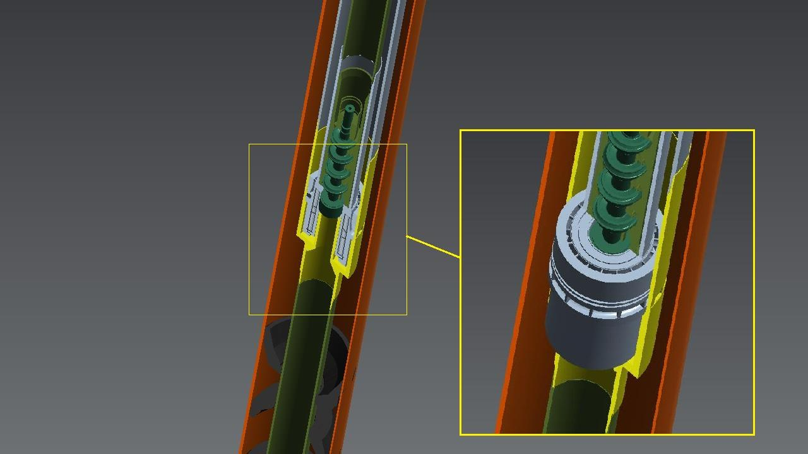
GFE’s innovation, is an in-wellbore, thermally-driven motor that drives an integrated pump that moves liquid from the wellbore to the surface. Called GreenDrive, the thermal motor is a turbo-expander that improves net hydrothermal well efficiency significantly. To achieve maximum performance, each unit is manufactured for the specific wellbore size, temperature, and flow rate. This flexibility can be economically achieved only with additive manufacturing.
Figure 2

The turbo expander is a proprietary, patented design that is mated to a closed loop, a pipe-in-pipe Rankine Cycle system, combined with a thermosiphon at depths from 5,000 to 9,000 feet. A working fluid, such as sCO2 or R-126, in the system in the downward flowing column is compressed by column weight and becomes supercritical. Entering the expander, the fluid expands as vapor, powering the rotor.

The rotor is mounted circumferentially around the inner production tubing and is coupled magnetically through the production tubing wall to the pump shaft/impellor assembly. Thus, the produced fluid is pumped upward through the inner tubing. See Figure 2 above.

Technical Assistance From Private Facilities, Connectors and/or National Laboratories.

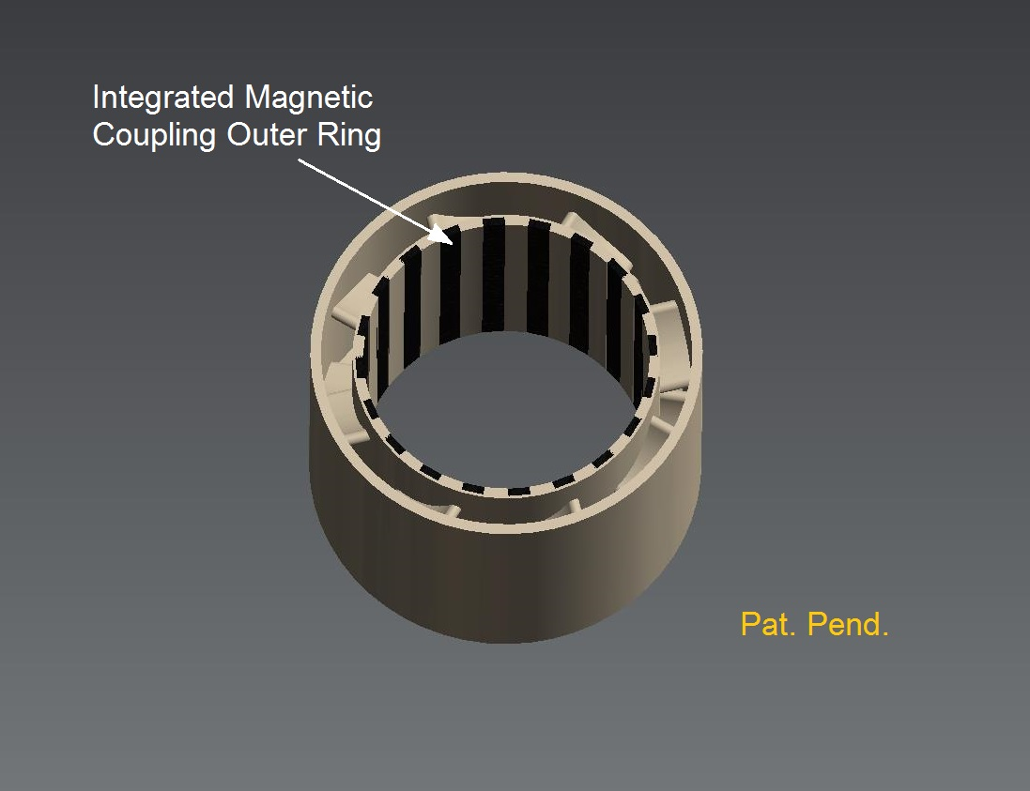
The first commercial concept design was completed by Concepts NREC of White Junction, NH. It was designed to fit standard oil production tubing of 2.875 in ID. The rotor materials were commercially available but the size required special and highly expensive machining capability and time to produce. See Figure 3
Figure 3.
Figure 3

There are several principle areas in which GreenFire requires assistance and seeks support from private facilities, Connectors and/or National Laboratories. They are:
- A total Product Development Plan must be prepared to match the size and capacity of a GreenLoop System to a GreenDrive design. The Product Plan must optimize each GreenDrive model through component synergy and fabrication processes.
- The specifications for performance, design manufacturing and quality must also be developed.
- A final determination of the AM fabrication process using MDLM including cost estimates for the subject components compared to using 5 axis milling machines for shaping and finishing.
- The original concept design to be evaluated to optimize the AM manufacturing processes and still retain critical operating tolerances.
- Evaluate various materials and associated fabrication processes for durability and reliability while reducing manufacturing cost and complexity.
- Identify a cost effective way to improve on the surface quality of current MDLM fabrication.
- Develop a testing protocol that includes pre-fabrication, post fabrication, pre-installation and post installation to assure in-service durability and reliability standards will be met.
- A Manufacturing and Assembly process and procedure, including a total quality system must be prepared for the complete manufacturing process

