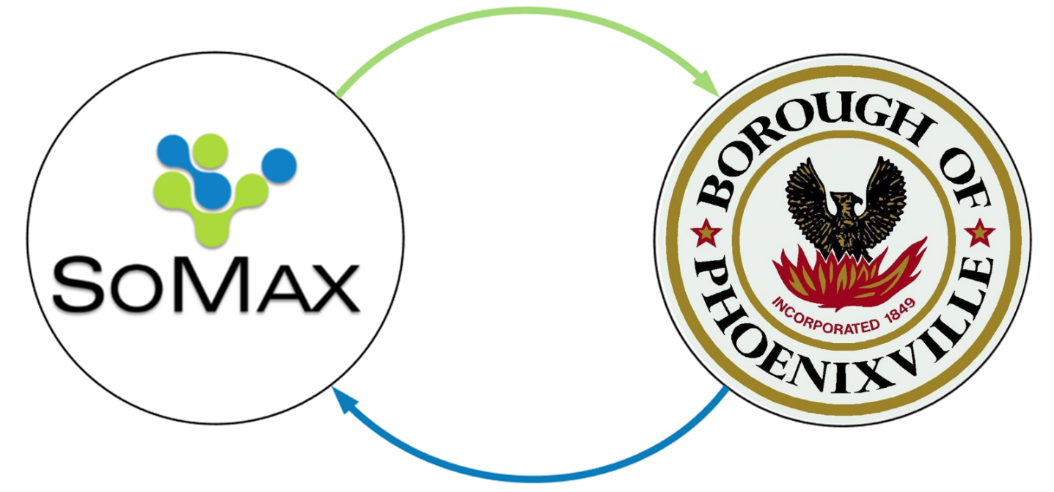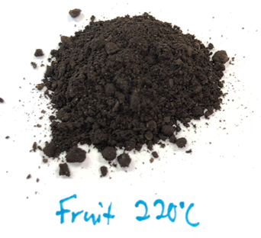
Resource Recovery via Hydrothermal Carbonization of Organic Waste

The Borough of Phoenixville Wastewater Treatment Plant, in partnership with SoMax BioEnergy, is implementing Hydrothermal Carbonization as a means of biomass conversion and resource recovery. The Borough utilizes biosolids and local food wastes to efficiently create renewable energy that powers their wastewater treatment and creates excess energy that will be used to reach their goal of using 100% renewable energy by 2035.
Submitted by: SoMax BioEnergy – Spring City, PA

Dan Spracklin - https://www.linkedin.com/in/dan-spracklin/
Dan@graybrothersinc.com
1 (215) 834-2021
Jeremy Taylor - https://www.linkedin.com/in/jeremyrtaylor/
Jeremy@graybrothersinc.com
1 (918) 607-2902

