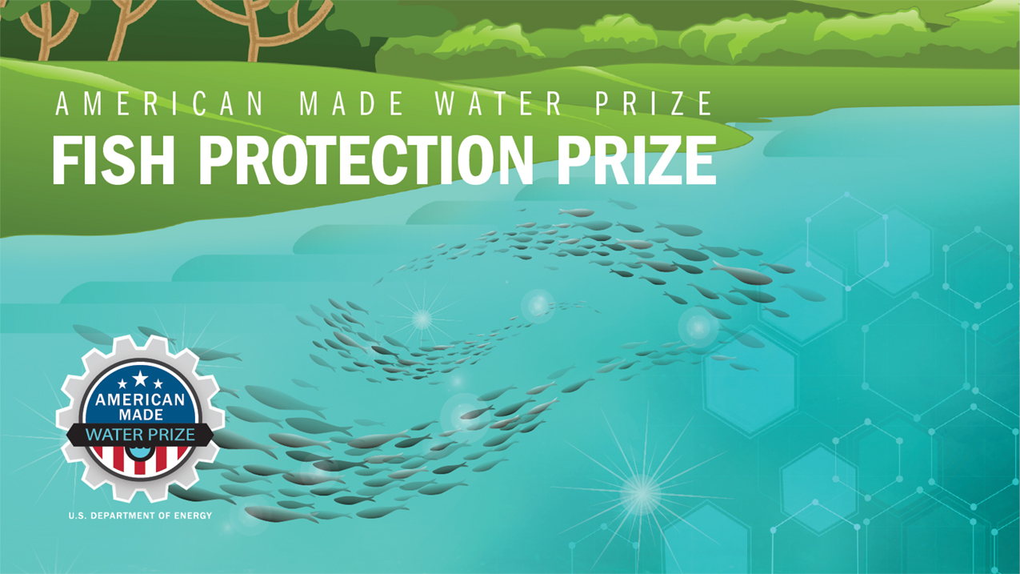

TECHNICAL NARRATIVE TEMPLATE
DISCOVER COMPETITION

HydroChute
Energy without Environmental Damage

Bladeless HydroChutes are a low-impact, fish-friendly, wildfire-reducing way to extract distributed energy from wild rivers. HydroChutes use no hazardous materials.

Team Lead Name: Joy Montgomery
Team Member 2: Joe Santos
Team Member 3: Mark Baretto
Team Member 4: Lee Gonsalves

Short Description:
Bladeless HydroChutes are a low-impact, fish-friendly, wildfire-reducing way to extract distributed energy from wild rivers. HydroChutes use no hazardous materials.

Team Information:
Team Lead Name: Joy Montgomery
Team Member 2: Joe Santos
Team Member 3: Mark Baretto
Team Member 4: Lee Gonsalves

90-Second Video
Post your publicly accessible video online (e.g., YouTube, Vimeo, etc.). Be creative and produce a video that conveys the suggested content listed below or any other information that will help the reviewers understand your solution in an exciting and interesting way, but do not focus on time consuming activities that only improve production values (i.e., technical elements such as décor, lighting, and cinematic techniques). The reviewers will score the video based on the content you have provided.

Technical Narrative
The Technical Narrative should address the technical innovation, technical feasibility, market feasibility, and overall research and development plan. There are four criteria you will be evaluated against for your Technical Narrative. You can use up to 5,000 words (excluding references) and up to 10 supporting images, figures, or graphs. Do not include any hyperlinks other than your video pitch in your submission—they will not be viewed. More information on suggested content to include in the narrative can be found in the rules document.

The four criteria are as follows:

- Criteria 1: Innovation—Does your concept represent a novel solution that offers an effective fish exclusion system for one or more species?
- Criteria 2: Technical Feasibility—Is your solution technically feasible?
- Criteria 3: Market Feasibility—Can you prove the financial feasibility of your proposed solution, including the potential for commercialization and successful market adoption?
- Criteria 4: Research and Development Plan—What is your plan to achieve your goals?

Your Response:
INNOVATION:
HydroChutes create energy by placing controlled parachutes into wild rivers without the need for dams or turbines. Fish can easily pass through the devices. The nature of HydroChute’s innovation is easily understood. Have you held your hand out of your car window and felt the force of wind as it passes your hand? Swimmers cup their hands to propel themselves. So, why not apply this theory for energy conversion from flowing water?
The Department of Energy (DOE) states that water is 800 times denser than air and that in similar volumes, 12 mph water flows contain the equivalent amounts of energy as 110 mph winds and many rivers and tidal currents consistently flow at half this speed year-round, approximately six mph. The specific innovation that HydroChute will prove is the feasibility of sustainably generating commercial-scale energy from naturally occurring resources which are currently considered to be out of reach for existing hydropower technologies without environmental damage.
We will demonstrate the ability to generate extreme amounts of energy from naturally occurring low-pressure, low-speed, high-volume water flows with parachute technology. Parachute technology allows us to create energy without the need for head development. In addition to targeting out-of-reach resources, HydroChutes can also produce energy that turbines are incapable of.
Parachutes are the most efficient method of capturing energy from a fluid moving mass and have been widely implemented for various uses. The power of a moving mass lifts 200 lb. kite surfers 30 feet in the air and push land yachts over 70 MPH. Parachutes pull container ships across oceans and act as a brake for high-speed vehicles and vessels. Our chute supplier, Zack Smith, is the lead engineer for Fiorentino Para-anchor which makes chutes for NASA. It was only a matter of time before we learned to adapt parachutes to flowing water for energy conversion.

TECHNICAL FEASIBILITY:
HydroChute’s self-cycling, self-propelled water-piston engine will create electricity as well as drive a hydraulic system. HydroChute’s recent experiments in its private facility using an initial prototype subsystem confirmed mechanical potential energy as well as kinetic energy generation. Test data from HydroChute’s first fitted prototype subsystem with minimal refinement shows that a 30” diameter system in a one’ per second flow generates 47 lbs. of potential energy. The 47 lbs. of potential energy created 6.5 watts of kinetic energy by lifting 23.5 lbs., 1/2 of the potential energy, which traveled at 1/3 the flow speed. This validates the estimates of Dr. Valsecchi who is published in our AIAA paper. For further validation, HydroChute recently converted this into electricity and hydraulic system pressure. Although conditions were far from optimal, the efficiency was approximately 75% with obvious need for tuning and system refinement.

HydroChute has just recently collected this data and has not yet had time to experiment with the effects of tuning or other performance features. The physics equations to estimate a scaled pilot roughly indicate that two times increase in either flow or diameter will create a four-times increase to power. Based on preliminary baseline test data, we believe that a 10’ diameter system will generate over five kilowatts of power from a 6’ per-second flow during a power stroke. A dual-cylinder system could consistently generate kilowatts of energy. Farms of large machines could potentially add terawatts of consistent, sustainable, low-cost, clean energy from distributed resources to the grid. The ability to sustainably harness energy from these untapped resources could create consistent clean energy resources to add to the global clean energy portfolio and can also have far reaching social benefits for disadvantaged communities (DACs).

MARKET FEASIBILITY:
As much as 90% of flowing water is not in use for energy production. The usual solution is mega dams and turbines. Energy providers are actively seeking other options. With more than 1300 Electric utilities all under public scrutiny and government mandates in the United States alone, the need for more affordable, less damaging distributed energy is undeniable.

RESEARCH AND DEVELOPMENT PLAN:
We have the people and a plan and are actively working on research and development.
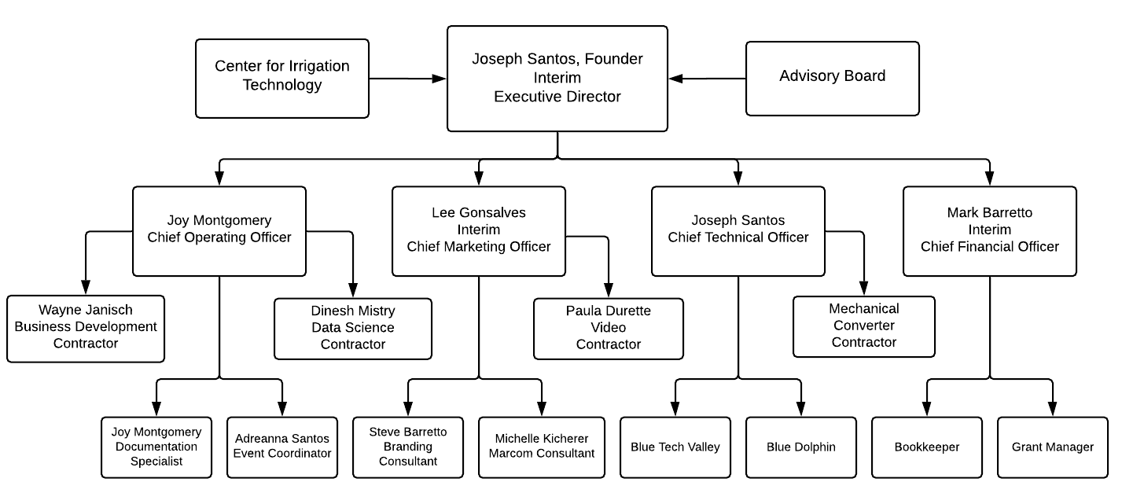
- Conduct Customer Discovery (in progress).
- Incorporate advice from Tech Futures Group (in progress).
- Develop an online presence (in progress).
- Finalize branding (in progress).
- Finalize design and manufacturing requirements.
- Develop the Licensing Agreement that includes our social benefits requirements (in progress).
- Define a social media campaign.
- Develop connections with Electric Energy Providers (in progress).
- Extend invitations to potential partners and send press releases.
- Do the first public demonstration in the Center for Irrigation Technologies in Fresno.
- Publish journal articles.

Supplementary Information

NARRATIVE WORD COUNT: _______ TOTAL WORDS
Please use the HeroX Platform to submit your Summary Slide and the optional Letters of Commitment or Support documents for the complete submission package.

