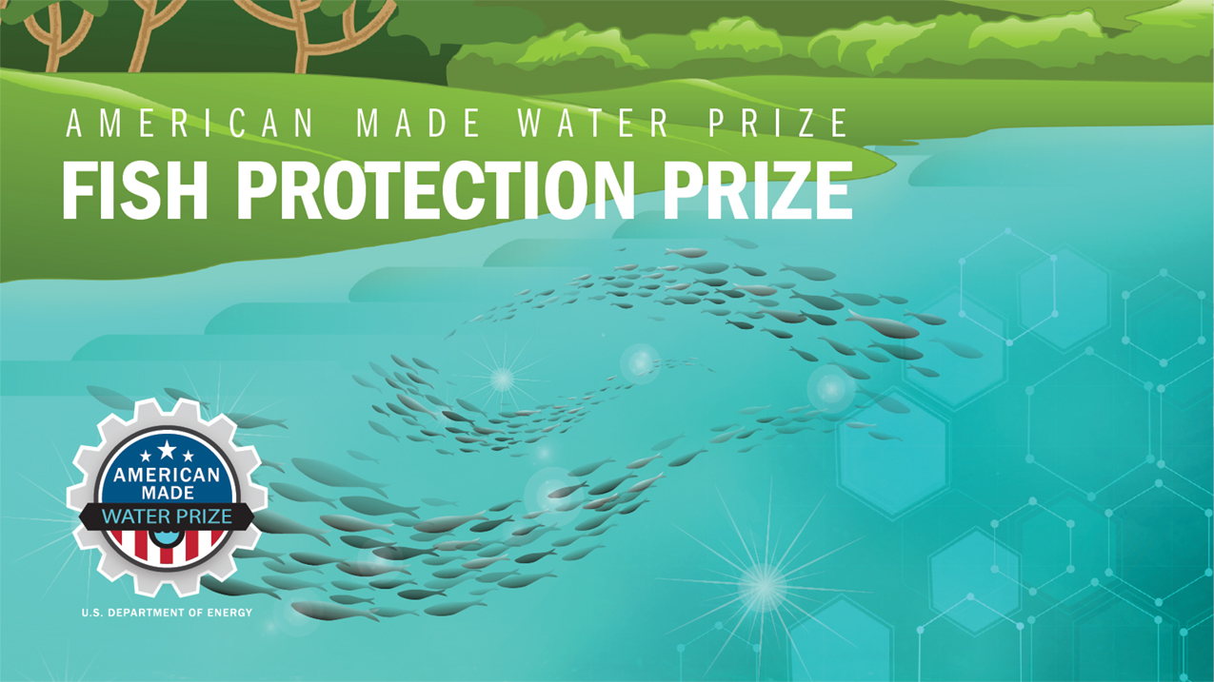

TECHNICAL
NARRATIVE
DISCOVER
COMPETITION

DESIGN STAGE

Fish Diversion Material and Inspection Improvements [Prometheus Innovations, LLC]
“Enhanced fish guidance netting systems for cost effective maintenance and sustainability.”

