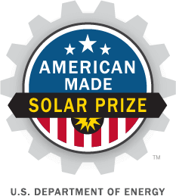
American-Made Solar Prize
TECH ASSIST FOR GO!

PROJECT NAME
Back-contacted silicon modules at the cost of PERC
Back-contact modules, aluminum interconnects, conductive backsheets

TEAM
Kathryn Fisher, Tempe, AZ, 85281, kathryn.fisher@asu.edu, (Kate's Linkedin)
Zachary Holman, Tempe, AZ, 85281, zachary.holman@asu.edu, (Zak's Linkedin)
Barry Hartweg, Tempe, AZ, 85281, bhartweg@asu.edu, (Barry's Linkedin)
Zhengshan (Jason) Yu, Tempe, AZ, 85251, zhengshan.yu@asu.edu (Jason's Linkedin)

PARTNERS AND AMERICAN-MADE NETWORK
Arizona State University: www.asu.edu
LaserStar Technologies: https://www.laserstar.net/en
ISC Konstanz: http://isc-konstanz.de/

Sunflex Solar 120-second video

1

|

American
-
Made Solar Prize Official
Rules

technical assistance request for go!

During the READY! Phase of the American Made Solar Challenge, Solar Prize Round 2 we built a proof-of-concept prototype of a new back-contact module architecture that has comparable costs to PERC modules with the efficiency of back-contacts. Our plan for the SET! phase is to scale from our 1-cell proof-of-concept mini-modules to 4-cell modules to demonstrate that a complete module package capable of producing power outdoors can be fabricated using our novel module design. To demonstrate this we have obtained two vouchers for work at national labs; one from NREL for certified measurements on four 4-cell mini-modules and one from Sandia National Lab for outdoor energy measurements on those same modules.
We believe that our 4-cell demonstration modules will be sufficient evidence for a module manufacturer to engage in a pilot production run of our technology at the 60-cell module level in the GO! phase. Customer interviews indicate that in a pilot production, run module manufacturers would want to fabricate enough modules to run an IEC61215 qualification test and deploy a full string of modules to an outdoor test bed, preferably in 2 different climactic zones. We are therefore seeking help form national labs and connectors in the network that can provide the following:

- IEC 61215 qualification test for crystalline PV modules
- Field testing of a full string of modules, preferably in 2 different climate zones

We are also seeking module component manufacturers who are interested in having their products incorporated into such a module test run. These include but are not limited to:
- Anti-reflection coated front glass
- Encapsulants
- Rear glass or transparent backsheets
- Junction boxes and potting agent for either of the above
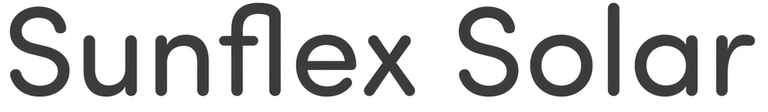
EFFICIENCY RISING

