Software Defined Power Management and Predictive Maintenance System

Technical Assistance Request

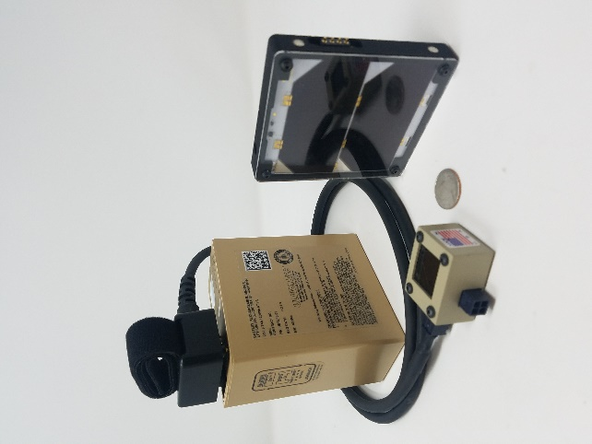
Utilizing AI-optimized control algorithms, the Teq Strategy power distribution system optimizes Photo Voltaic inputs for high performance applications. The advanced solar charging system is optimized through our patent pending software defined Battery Management System (BMS) and Maximum Power Point Tracker (MPPT). The Solar Charger Battery Management System’s dynamically computed charging waveform uniquely enables the most efficient charging of the battery regardless of solar panel illumination. This process characterizes PV input and individual cell performance and creates a matrix which allows for real time performance evaluation and preventative maintenance alerts for attached equipment.

The Teq Strategy project has 5 areas of need that the American Made Network and/or a National Labs can assist with which we have outlined below;

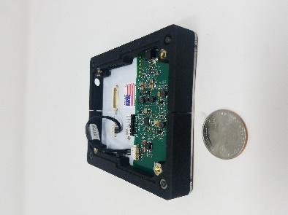
1: Power electronics design and testing. We are working in high performance applications where every possible effort will be made to improve efficiency over a wide variety of PV inputs. These inputs will be boosted to meet the specific battery needs. This needs to mesh seamlessly with controlling the output load and communications. We will have high frequency switching as well as digital and analog lines which need to be carefully considered.

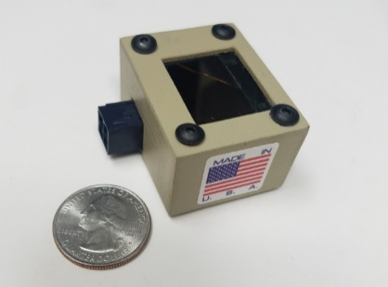
2: Testing and certifications and an initial standard that we want to work towards is MIL-STD-108. This requires us to look at potential water and dirt ingress. However, sealing the unit may cause some heat issues. Expertise in testing, certifications, ruggedization and enclosure design are key factors in a decision to work with you.

3: AI-optimized control algorithms determine real time performance evaluation and preventative maintenance alerts for attached equipment. This is used as part of our patent pending software enabled battery management system. We are looking to further characterize the performance and improve the efficiency of this system. Expertise in telematics, firmware development, preventative maintenance and data analysis is desired.
4: Asset Health. The system can collect and report data about power utilization, efficiency, potential obstructions on the solar panel based on its usage history and calculated typical power delivery statistics. Additionally, the system can record the power demand from equipment connected to the battery or PV source. This allows for collection of data pertaining to Voltage vs. Current measurements of power demand and supply, that can be used to evaluate the performance of attached equipment. System data is easily transferred using industry standard XML and other protocols to integrate with existing Enterprise software solutions as well as customized dashboard and application software.
Help with developing customer facing software dashboards for monitoring attached, powered assets would be a benefit.
5: Prognostics. For any attached motorized devices, for example, current motor health may be characterized and used to make predictions about motor health that allow for predictive maintenance to be performed. Systems are in use that detect incipient failure of brushes on DC motors that allow an equipment operator to schedule service before the motor fails in the field. Expertise in fleet and systems maintenance systems would help in identifying areas where leveraging prognostic capabilities is desirable.
5: Telematics. The system collects and analyses data with results stored in internal non-volatile memory for later retrieval. Data may be retrieved for analysis and device optimization across the assets in the fleet. Secure wired and wireless connections are used to retrieve data and program the units from the field. Help with integrating telematics data into existing asset tracking enterprise solutions would allow the addition of machine health and readiness to existing systems.

