Technical Assistance Request.
Integrated Silicon Technologies LLC of Pittsburgh PA is set to commercialize CMU technology for producing silicon wafers for solar cells. The new approach to horizontal ribbon growth (HRG) promises to reduce the final cost of standard 15x15 cm silicon wafers by 50%.

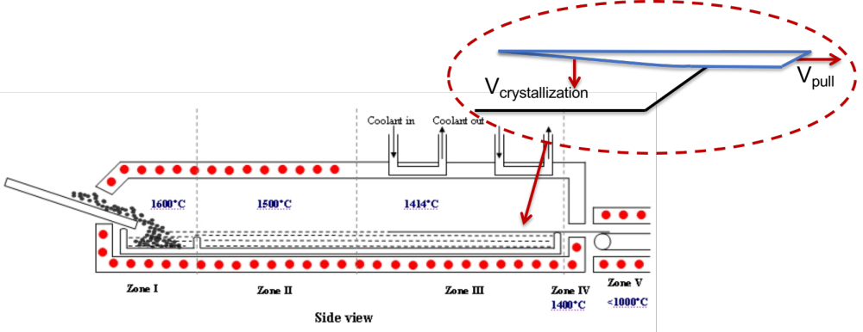
Figure 1: The Horizontal Ribbon Growth Process.

The concept for HRG (shown in Figure 1) has been known since it was disclosed by Shockley in 1962. However, the process is unstable and it is difficult to control crystal growth near the tip of the solidifying ribbon.

We have discovered a new way to operate the process and a new approach to control the micro- and nano-structure of growth near the tip of the ribbon. We have shown theoretically (in theory and detailed computer simulation studies) that we stabilize the process as seen in the inset in Figure 1. We will continue the theoretical work, but the main thrust of our program now is to verify the control concept in our $2M pilot plant system.

The 60kW system is capable of producing a 15cm wide ribbon continuously. Our first major milestone to be completed in the Round 2 of the American Made Solar Prize competition is to produce a 5 cm wide ribbon with controllable thickness and few crystal defects.

We work within a University Environment so we have access to advanced machining and analytical tools. Some technical assistance will be very helpful in the accelerating the horizontal ribbon growth project and demanding measurements and fabrication is beyond our capabilities.

- We need access to laboratories with capabilties to perform
  - Crystallographic characterization such as XRD
  - Electric property measurements.
  - Chemical analysis at ppm level (oxygen, carbon, iron,boron, phosophrous, …)
- We will need to make a number of dense graphite parts. We need to machine crucibles for melting. In order to make these parts it is necessary to SiC - CVD coat these parts.
- Cooperation with a cell fabrication facility that can perform
  - surface treatment and texturing,
  - doping and anti-reflective coating, etc., and
  - measure solar conversion efficiency
is important in the later stages, Round 3 Go!
- We need help in performing economic and market analysis.
- Later we will need partners that can help in engineering design, scale-up and general EPC work to help move the project to industrialization.

