TECHNICAL ASSISTANCE REQUEST FOR JOE BYLES’ TEAM, SOLARSTONE SOLPAVERS

- NREL – Technical assistance is requested to determine several performance metrics. We would like to work with NREL to determine the net solar output performance when considering the power reducing effect of the stone cloaking of the light permeable composite landscape paver balanced against the power output increasing effects of the ground placement operating temperature reduction and the light bending refraction of the light permeable layer of the units. Identifying the power output compared to equivalent sloped, roof mounted systems of the same rating will provide essential data needed for installation instructions, performance ratings and comparisons.

- NREL – Technical assistance is requested to determine stress, strain and stiffness and mechanical properties of the SolPavers compound panels and the performance of the embedded solar module and solar cells before, during and after these mechanical tests to point of failure.. Testing of pilot production units has shown a great increase in the mechanical characteristics (beyond 450 PSF) compared to conventional solar panels as demonstrated in this image:

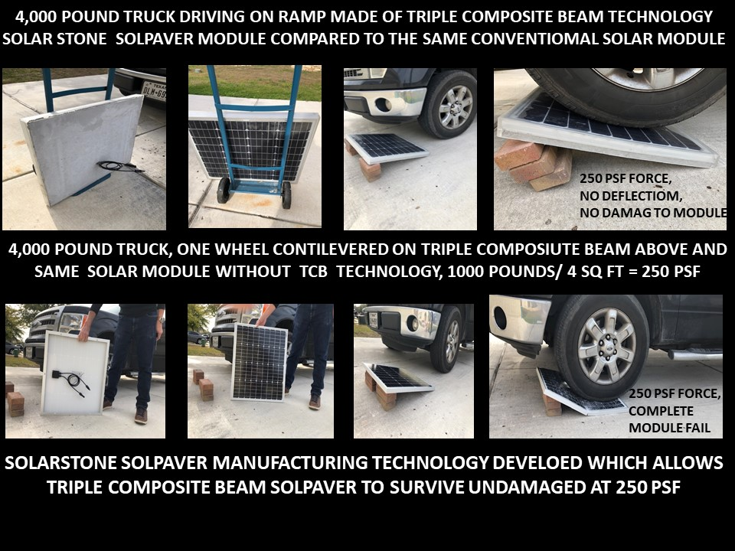

- LBNL– Technical assistance is requested to determine potential dust or soiling of the SolPavers system utilizing the test methods and equipment developed by the Heat Island Group to determine soiling and performance of cool white roofing materials exposed to environmental soiling. The SolPavers are installed in a horizontal position similar to low slope cool white roofing. This data will help determine long-term performance and maintenance requirements.

- FIU “Wall of Wind” facility– Technical assistance is requested to determine performance of the SolPavers performance in extreme Cat 5 hurricane force wind conditions. The system installed within the ground in an interlocking fashion will allow the system to withstand extreme wind conditions like those experienced during the most extreme hurricane conditions.

- LBNL - Technical assistance is requested to determine the performance of the SolPavers during a seismic event as determined by a seismic shake table available at the LBNL seismic laboratory. Verification of the stability and safety of the interlocking solar paver system during extreme seismic events. This data will help drive design and installation requirements of the system.

- INTERTEK Labs– Technical assistance is requested to determine performance of the SolPaver system during fire situations. It is theorized that the SolPaver system will be unparalleled as the compound paver bottom layer is concrete and all components are flame-proof and self-extinguishing. This analysis and data will provide design and installation best practices and expected performance.

