Request for Technical Assistance in the Go! Stage
Locally Grown Power Team

Our work resolves a problem that the solar industry calls hot-spots. These are localized spikes in temperature that damage cells and interconnects and cost millions in lost production. In rare instances, they can lead to fire.
The output of a solar panel is optimal when every cell in a string is subject to the same operating conditions. This allows the string to reach maximum power point (MPP), and hot spots do not occur under these circumstances.
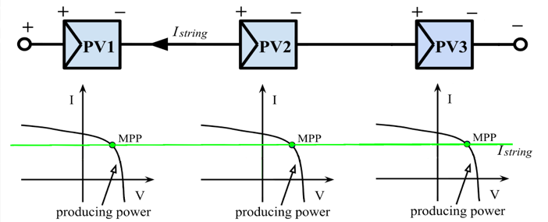
Kim, et al 2016.
Yet in the real world, it is impossible to assure that each of a string’s 20 or 24 cells always have identical electrical characteristics. A fallen leaf is all it takes to weaken a cell and cause it to sink power from other connected cells in a process known as reverse bias. This, in turn, can trigger a hot-spot. Shunts, microcracks and age- or weather-related degradation can also alter the electrical characteristics of a cell.
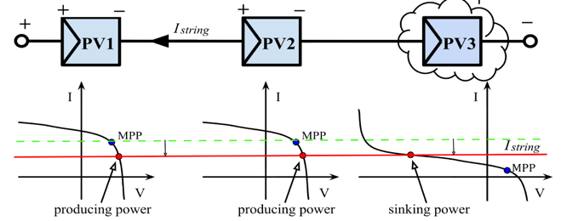
Kim, et al 2016.
Other manufacturers rely on mitigation techniques designed to avoid the worst consequences of hot-spots. The most important are bypass diodes, which provide a path around a string, establishing a limit to reverse bias. Yet mitigation measures still allow for repeated thermal cycles and fail to prevent full-blown hot-spots in many real-world circumstances.
Resolving this problem is more urgent than ever. As panels become more efficient, the power per unit of surface area left for the dissipation of heat is correspondingly reduced. In other words, hot-spots are harder to prevent in today’s panels than was the case in the past.
Contemporary mitigation techniques are also more costly than ever. Manufacturers now commonly resort to cells made from silicon that has been vaporized and re-condensed (silicon has a boiling temperature of 3,265º centigrade). One new panel features bypass diodes for every last cell. These measures and others would be wholly unnecessary were it not for the threat of hotpots. Meanwhile, we witness the emergence of a vast new industry: airborne surveillance in which heat-detecting drones are deployed to identify hot-spots that still emerge in solar panels, mitigation notwithstanding. One such company claims to save its clients $23 million per year in production losses. The mitigation approach, in short, is expensive and dangerously incomplete.
Our technology is the world’s first that completely eliminates hot-spots in solar panels. It achieves this by treating hot-spots as a symptom, instead eradicating their root cause: reverse bias. Our patented control card maintains voltage high and current low, preventing cells from entering reverse bias. Readers may wish to consult the mathematical proof and the patent.
The benefits of our innovation include unparalleled safety and durability, enhanced efficiency and vastly reduced manufacturing costs.
In extensive field tests carried out at Harvey Mudd College, a team of physicists was able to provoke hot spots in a matter of minutes in commercially available panels by means of partial shading. Our panels, on the other hand, resisted all attempts, regardless of how many partial shading scenarios were tested.
At present, current safety certification for PV modules is based on defect-free silicon. The process tests for damage from limited exposure to reverse-bias induced heating. There is no certification process for cells that have developed micro cracks in handling or installation or through weathering and thermal cycles. Likewise, there is no specific certification for a panel that never enters reverse bias—ours is the world’s first.
We wish to use the technical assistance voucher we would receive if winning in the Go! stage to develop a procedure to verify the elimination of reverse bias in the presence of repeatably induced cell defects, in particular nonlinear shunts and microcracks. Such a test would certify that our cells resist reverse bias and hot-spots even when subjected to every condition that is known to provoke these problems in conventional panels.
Defects would be created artificially so that cells with known defects can be created and reproduced. Populations of these pre-stressed and pre-aged cells are then utilized to make panels that reproduce, in a replicable way, defects that are normally the result of common manufacturing issues as well as defects that naturally emerge over years of weathering. These artificially pre-stressed and pre-aged panels would be used to verify reverse bias prevention under conditions that normally exist using cost-efficient manufacturing and after years of deployment.

Reference:
Katherine A. Kim et al, “Photovoltaic Hot-Spot Detection for Solar Panel Substring Using AC Parameter Charaterization,” IEEE Transactions on Power Electronics, Vol 31, No. 2, Feb. 2016.t efficient manufacturing and after years of deployment.

