Technical Assitance requested from NREL

This documents includes the technical assistance requested by Imagen Energy from NREL.

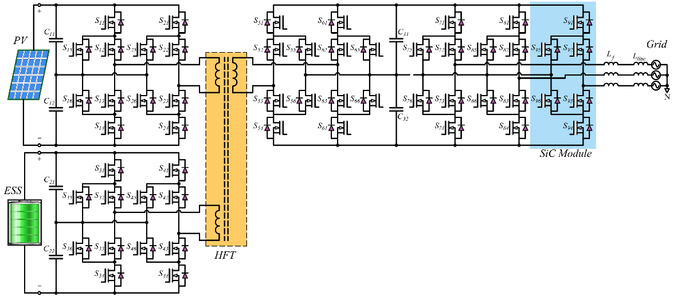

Figure 1. Power configuration and circuit topology of the proposed multi-port system

Table below describes the work that has to be completed and delivered to Imagen Energy LLC by NREL.

Task # | Task Name | Description | Work Location | Due Date | Deliverables
1  Priority 1 | 50kW/50kW-100kW, 50kHz and 100 kHz HF transformer design optimization.  (Note: Required to complete two design options for comparison ) | Magnetic modeling, design and performance prediction of the 50kHz-100kW and 100 kHz-100 kW HF Common core transformers which has two primary windings 50 kW each and a secondary windings of 100 kW | NREL | To be negotiated | a. CAD model of the XFmr, and weight for 50kHz and 100kHz operational frequencies  b. Xfmr specification sheet for procuring both transformer designs  c.Power Losses for both designs  d. Estimated XFmr eff at full load, and partial loads (25%, 50%, 75%) for both designs  e. Thermal performance at rated power at required cooling conditions for both designs  f. Summary report for a-e
2  Priority 2 | Thermal modeling and thermal performance analysis of the dual active bridges including HF Xfmr, and cold plate using CFD | Using Imagen Energy provided cold plate data and power module losses and using NREL computed HF XFmr thermal data determine the DAB thermal performance | NREL | To Be Negotiated | a. Thermal simulation model and simulation results showing the worst case thermal performance  b. Summary Report
3.  Priority 3 | Thermal modeling and thermal performance analysis of the three phase inverter including the cold plate using CFD | Using Imagen Energy provided cold plate data and power module losses for the inverter determine the inverter thermal performance. | NREL | To Be Negotiated | a. Thermal simulation model and simulation results showing the worst case thermal performance  b. Summary Report
4.  Priority 4 | Determine optimum electrical parameters by Matalb/Simulink control modeling | Determine the optimum DC Link capacitance and the transformer inductance required for optimal control of the Dual Active Bridge (DAB) | NREL | To Be Negotiated | Provide the minimal DC link capacitance and Transformer inductance for optimal performance of the DAB in a summary report including simulation results
Task # | Task Name | Task Description | Work Location | Due Date | Deliverables
5. Priority 5 | Support Imagen to develop control optimization for Dual Active Bridge(DAB) and 3-Phase Inverter and Validation testing | Provide required technical support and expertise to Imagen Energy to develop the DAB control and 3-phase Inverter Control using Imagen Energy’s control board and hardware. Design Validation testing also need to be supported | Imagen Energy | To Be Negotiated | Co-develop the DAB control strategy using Imagen Energy’s Altera FPGA based control board and hardware and support design validation testing

