technical assistance request (2 pages, including images, will be made public)

The creation and “proof of concept” for the HNZE Canopy has been a journey! From our initial analogue ideation, to iteration though computational design, to parametric analysis to optimize the solar/water sail tessellated surface for optimal radiation and rainwater capture, to digital fabrication of the prototype steel structure, to not one but two structural foundation solutions (!), to ultimately a functioning prototype. We have put blood sweat and tears into HNZE. And then, last Oct 31, 2018 we lit the installed prototype in Detroit! In early 2019 we were issued a US Design patent and copyright. We await our Utility patent. We have traction. We are ready to launch and scale!
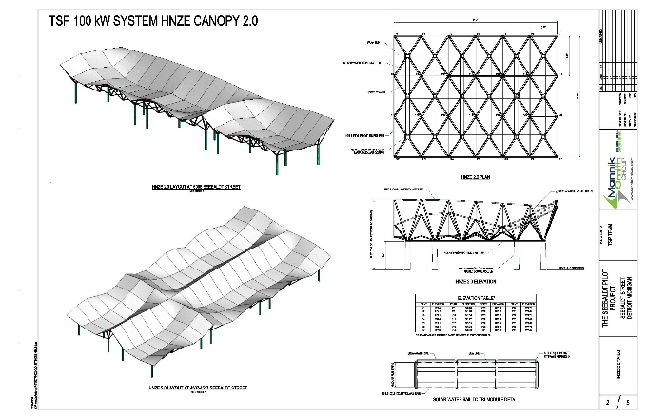
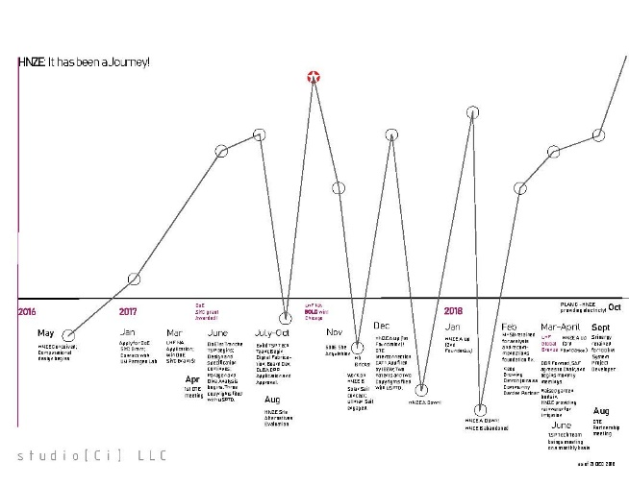

HNZE Canopy US Design Patent and Copyright issued to studio[Ci] 2018
We need the AMC and NREL! We seek partners who are willing to push boundaries. We have three primary needs which a partnership with a national lab, private facility, and/or member of the American-Made Network which could take us to market:
1) US Made Highly efficient PV Thin Film – we have searched for a PV Thin Film partner/supplier in Michigan. Uni-Solar went bankrupt. No one in the local ecosystem (NextEnergy, MEIBC, NRRI) seems to know what happened to the employee owners who took over inventory. We want a partner, if not in the region, then with someone in the US making PV thin film (Solo Power Systems in Portland, OR?). Someone innovating the most lightweight, efficient film (or other!) to adhere to our solar sail.
2) Solar/Water Sail “Tri-Modules” – we need shop drawing and prototype assistance to help us finalize our “Tri-modules” which comprise the solar/water canopy (see below). This partner could be a sail maker (as we engaged for the Prototype), or perhaps an awning maker.
3) Water storage bladder - we also need a fabrication partner who works with cuben fiber (or material with similar properties) for shop drawing and prototype assistance our proposed water storage bladders. Last year we integrated a more conventional water management/collection system (cisterns and overflows into onsite bioswales) into our HNZE prototype. We hope through the AMC we can connect with a partner who will help us achieve our submitted patent approach of integral conveyance and storage (see below).

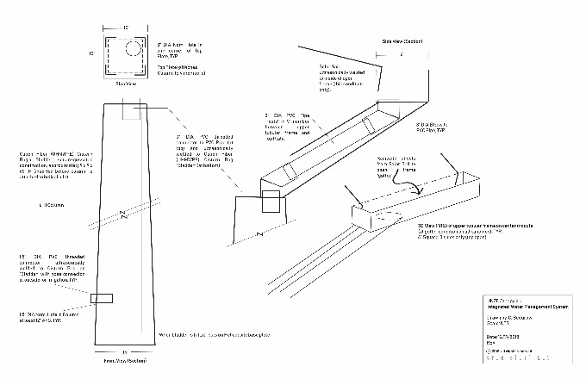
HNZE Canopy US Design Patent and Copyright issued to studio[Ci] 2018

At the suggestion of Tom Stanton, NRRI in Lansing, we would also like to explore and include the concept of heating water on the canopy solar/water sail surface to cool and increase efficiency of the PV film and provide users with additional functionality. In order to explore this, we would need an additional partner.

The HNZE team brings experience assembling and leading large, complex teams and managing DoE grants. In 2017, we were awarded one of several grants nationwide for the Solar in Your Community challenge. We created a team of over 17 different entities from both the technical and NGO sectors. Director and co-inventor Constance Bodurow led the technical team over 18 months which engineered the HNZE Canopy and installed the prototype (see below).


