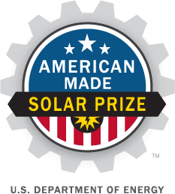

|  |
| --- |
| **American-Made Solar Prize**  **Request for Technical Assistance** |

**ICON Home Solar Dashboard**

Our team may require the following technical assistance:

1. 3D printing of prototype component:
2. Next generation ICON
3. Connectors
4. Wireless modules with invertors
5. Testing mechanical and electrical characteristics:
6. Cloud connection
7. Environmental aging test of components and assemblies.
8. IP consultation.
9. Technical consultation