Technical Assistance Request
The overall goal of this research is the development of local intelligence and system-level controls (software) that will maximize the benefits of introducing power flow control equipment (hardware) at existing tie locations on the distribution grid, including increased reliability, demand allowance, and solar output/hosting. This will be done through advanced mathematical modeling, computer simulation, and the development of outside-the-box control algorithms that will be verified in computer simulations. Our R&D will include automatic controls to optimize dispatch commands for one or multiple Power Routers (PRs) based on availability and production of distributed solar plants.
If successful, the proposed innovation will achieve an unprecedented level of control over primary distribution networks and allow utilities to take full advantage of the power routing/voltage control capability. When deployed at a normally open tie switch between two neighboring circuit feeders, an individual PR can minimize losses, increase demand allowance and distributed generation growth, and improve power quality and reliability on both feeders. The impact potential of these benefits will be both expanded and magnified with the ability to interactively control multiple PRs across wider segments of the distribution system, through the development of coordinating algorithms.
The complete Switched Source system will uniquely provide real-time control and optimization of the distribution system, where other “smart” grid attempts to optimize the network have failed due to dependence on existing legacy control hardware. Ultimately, we envision the application of smart grid technologies in conjunction with our solution to act as a “virtual” energy storage system, capable of deferring the need to install expensive large-scale energy storage solutions and increasing solar output and hosting capacity beyond our estimated values for PR hardware alone. This will facilitate more solar energy integration. Ultimately Switched Source’s technology will be one of the main components that transforms the distribution grid into a “smart grid” and unlocks its hidden potential.

Background: Power Router (PR)
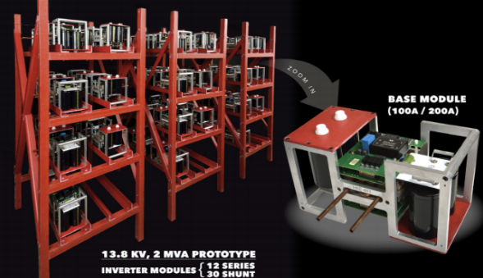
Figure 1. Prototype Unified Power Flow Controller (“Tie Controller”)
The PR is a power-electronics-based device that can independently control the flow of real and reactive power and connect together otherwise incompatible electrical circuits. Technology development began in 2012 with support from the Department of Energy (ARPA-e). A successful prototype was built and tested in 2015 by researchers at Michigan State University (Fig. 1). The device has been redesigned for field deployments with far greater power levels and an increased operating region. This new design is currently in manufacturing and will be deployed with two major utilities starting in Q3/Q4 of 2019.
Medium-voltage distribution systems tend to be designed in radial or loop-type configurations with a normally “open” tie on the system (Fig. 2). Under normal operating conditions, load is fed in one direction from the upstream substation. In the event of a fault, a manual (in limited cases, motor-operated) tie switch allows stranded load to be served by an adjacent feeder. Operating with the tie switch closed can cause stability issues associated with loop flows and also exposes the system to excessive fault currents. This can lead to equipment overloads and compromised protection schemes. Installation of the PR mitigates issues associated with system stability and strengthens the system by dynamically regulating real and reactive power flows between the two circuits (Fig. 2).
The PR increases the connectivity of the distribution grid and makes it behave more like a transmission network with the ability to lose a line without losing power, also known as an N-1 system. Our device can couple together systems at medium voltages, even if they are out of phase and/or at different operating voltages. Once coupled, every user now has two sources of electricity where they previously had only one from the upstream substation. This has an enormous impact on reliability, even compared to a recloser-only distribution automation solution.
The PR provides a dynamic range of reactive power support, as compared with cap banks, which offer discrete steps. This capability can be used to increase power quality or for Volt VAr Optimization/Conservation Voltage Reduction: two methods commonly accepted in the utility industry to decrease energy demand/consumption up to 3%. The PR differentiates itself in energy efficiency applications by also providing real power flow benefits. This means line loss reduction and phase balancing can also be achieved.
System-Level Design. Switched Source is currently partnered with one of the largest manufacturers of pole-mount reclosers in the U.S., to ensure that the system-level design of all interface
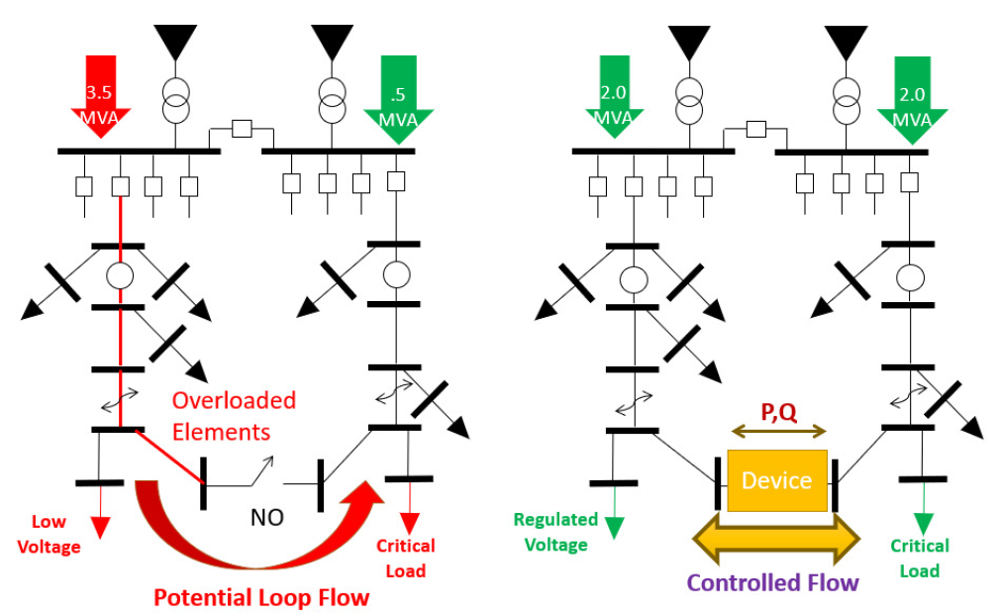
Figure 2. Existing system architecture with and without Tie Controller. (Left) Loop/Radial configuration; (Right) Networked with unified power flow controller
points of the PR are as similar as possible to existing utility equipment. Switched Source will use off the shelf switchgear as the interface point with the utility. These medium-voltage circuit breakers will “bookend” Switched Source’s power electronics and will be controlled through two methods: by the PR itself, and through an industry standard microprocessor relay. This configuration gives utilities a high level of confidence that the grid is protected from any faults that may occur in the power electronics or on an adjacent line. In the event of a fault, the PR has two modes of operation: it can contribute a limited amount of fault current (~450 A) or it can isolate itself as an open point, blocking the voltage with the power electronics and opening the switchgear. These modes are options for the utilities to select.

Key Objectives and Milestones
Specific aims/milestones for this project are as follows:
- Model Development: Develop system-level simulation models, including multiple PRs and multiple solar generation systems, for the purpose of studying the interaction between the two and developing optimal dispatch algorithms.
Milestone: In the chosen simulation environment, 1) a model of one PR, two substations and one representative solar system, or 2) a model of multiple PRs, multiple substations, and multiple solar systems, working as theoretically expected.
- Algorithm/Software Development: Develop dispatch algorithm that will maximize the benefits for multiple PRs, while taking into account measurements from substations, feeders, and solar systems.
Milestone: Working algorithm, implemented on the represented model, that can process measurement data and produce commands for the PRs to increase solar output (less solar energy curtailment) or hosting, reduce losses, and/or increase demand allowance.
- Algorithm Implementation and System Studies: Implement the algorithm “virtually” with multiple distribution systems and perform wide-scale system studies to demonstrate performance of the algorithm.
Milestone: The developed algorithm is implemented in large, realistic distribution systems and wide-scale studies are performed. The expected outcome is that the algorithm is (i) able to increase solar output/hosting significantly, (ii) reduce losses, and/or (iii) increase demand allowance.
The proposed R&D will confirm the feasibility of a distribution-level control system for power flow controllers and will result in the systematic generation of novel coordinating algorithms with potential applications in other areas. If shown to be successful in simulated and modeled environments, we will transition results of this proposed innovation R&D to field deployments. Successful accomplishment of this work is essential for the commercial viability of PR technology.

