Technical Assistance Request
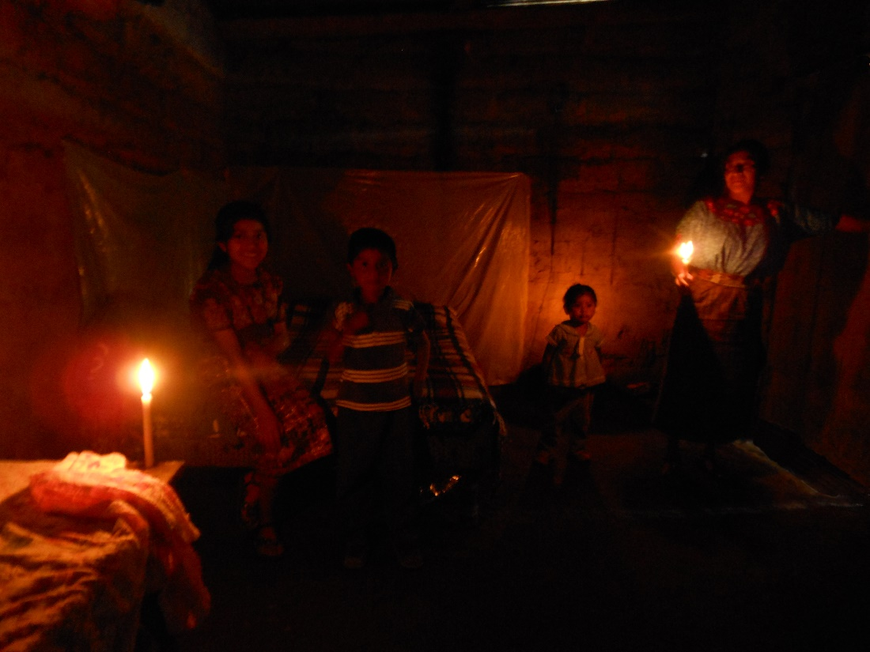
Life Without Electricity

The Solar-20 team requests technical assistance for:

- Rapid proof-of-concept and business model exploration. We have good data to start business plan models. We have access to Foundations, Nonprofits, Government Agencies who work in solar humanitarian development. We also know businesses who serve the existing market.

- Access to the innovation pipeline. Ann Arbor Michigan, where we are located, has a culture of tech. startups and business incubation. We intend to locate Solar-20 in Southeast Michigan.

- Research and development support. With our local American Made Connector, Next Energy, we will interface with National Labs.

- Access to commercialization funding. At the end of the Go phase of American Made Solar Challenge we will seek seed funding.

- Collaboration with regional thought leadership and promotional support.

- Connections to potential solar industry partners and investors.

- Access to hardware and development tools.

- Packaging and Printed Circuit Design – Battery and circuit housing design.

- Agency compliance consulting

- CAD assistance

- Graphics, feel and touch design

- Access to Universities

- Preparation for manufacturing

