Technical Assistance Request
Unique challenges and needs
A unique challenge in developing this innovation is to understand and estimate the cost of manufacture and installation of PV plants built by the new approach. Experience with today’s lowest cost solution at utility scale - PV modules on single axis trackers - shows that low cost only is achieved at very high volume, now 100 GW/year installed globally. In the Go! phase, once the technical approach has been validated, we need help from industry in obtaining estimates of what manufacturing and installed cost can be expected for the new technology at the same high rate. We also need to estimate the level of investment and Capex required to reach that rate. We will not have the previous luxury of years of energy prices higher than the present $0.025/kWh for PV installations in good sites.
The key elements to be costed are:
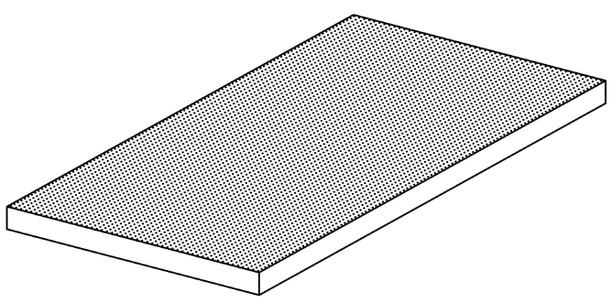
Manufacture of glass sheets imprinted with lens arrays:
Our innovative approach involves use of a modified glass entrance sheet that efficiently separates the direct sunlight and diffuse sky components of solar energy entering the hybrid module. The sheet should be the size of a standard PV module, 1 m x 2 m, and be molded on the lower side into a seamless array of 55 x 110 lenses. The challenge is to identify a process of manufacture with the potential for extension to manufacture at the very high volume currently produced for present PV modules, i.e. close to 250 km²/year globally, requiring around 15 standard float glass factories devoted to making lens array glass. At this volume, the added cost for the molding should be no more than a few $/m² ($0.01/W) to the base float glass cost of around $10/m².
Multijunction Cells
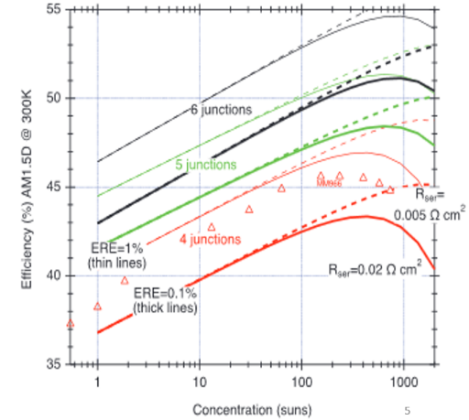
Multijunction cells are used to convert the sunlight brought to 500x concentration spot by each glass lens of the array. The cells will be about 0.8 mm x 0.8 mm square. Our target for conversion efficiency is 50% as is projected for 6J cells. The 2019 world record, held by NREL, is 47% with a 6J cell. The total cell area for 500x concentration is 1/500 that of the lens arrays and silicon modules, i.e. around 500,000 m² annually. We would welcome assistance from industry and NREL in estimating the cost that can be expected in such high volume. Our targeted cost for the multijunction cells in this very high volume is $10,000/m², as projected by the substrate reuse/lift-off approach of NREL. This translates to $0.05/W, one fifth silicon module cost per watt.
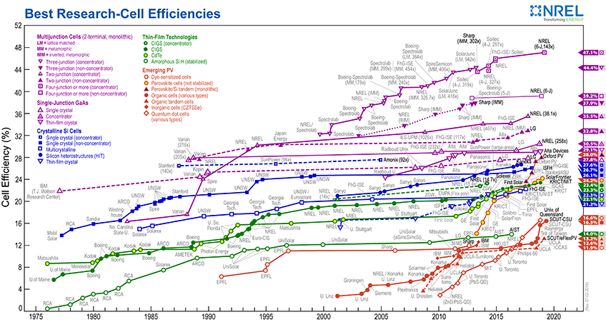

Cell connections and assembly
A critical requirement for low cost mass production of the hybrid cells to be investigated in the Go! phase will be an automated method for placement in an array of the many tiny MJ cells onto standard 6” silicon wafer. We plan to work with major US silicon cell manufacturers such as Sunpower to develop and cost the automated assembly concept.

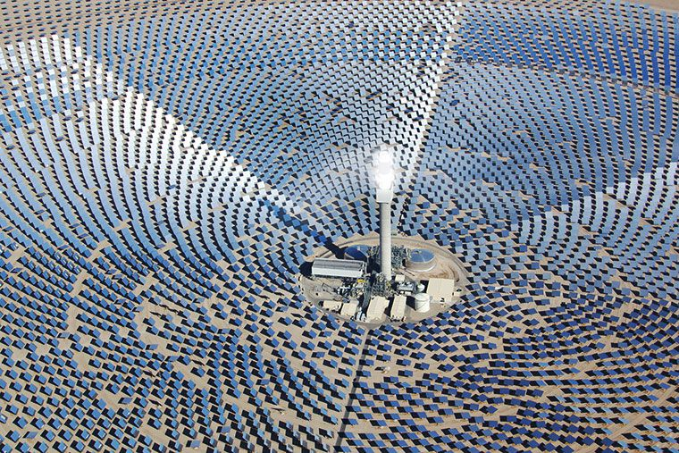
Dual axis trackers. Dual axis trackers are used widely in heliostats for power tower CSP, and there is current support from the DOE in reducing heliostat prices from the current installed cost of $140/m² to $50/m². For our hybrid modules with 40% efficiency, the lower rate corresponds to $0.125/watt, little more than standard mounting cost for single axis trackers. In the Ready! and Go! phases, we look forward to working with Sandia National Labs as well as US manufacturers of solar single axis trackers to understand the expected cost reduction from new approaches to reducing dual axis tracker cost. We note that the pointing tolerance we need of 0.2 degrees places less demand on accuracy than for heliostats.
Full system cost analysis.
Here we will also look to the NREL techno-economic analysis team to help develop an overall costing for the new hybrid approach, from component costs to installation to LCOE.

