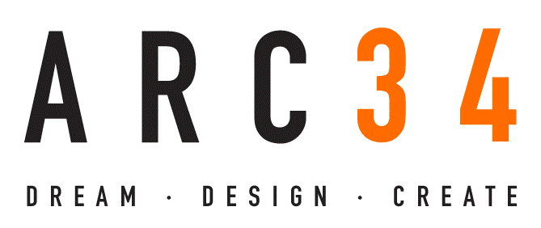

Technical Assistance Request

For our Solar Cooler proof-of-concept, our intent is to develop the custom controller hardware/software, and identify and integrate the solar array, thermoelectric device and batteries into a vacuum panel insulated enclosure. This will allow us to validate our assumptions regarding solar panel power production, total power consumption and battery longevity. Milestones to achieve this will include:
- Developing a solar array that can produce more than 55 watts with a surface area of 589 sq. in. or less (approximately 31” x 19”).
- Creating a power management solution which integrates a solar charging circuit, battery management system, thermal sensor and user interface.
- Validating that our solution can maintain refrigeration temperatures while drawing around 35 Wh in expected conditions.
- Sourcing Lithium batteries with energy densities of 200 Wh/kg or greater.
- Identify vacuum insulation panels and fabricate custom enclosure (cooler).
In order to achieve this, we will need assistance in the following areas:
Component Sourcing. Component sourcing will play a significant part in the proof of concept process. Parts sourced for this phase will be critical for developing future plans and analyzing the potential manufacturing supply chain. In preparation for this, we have already begun working with Callye Keen, President of the Red Blue Collective (RBC).
Creating a Power Management Board. One of the key aspects of solution development will be engineering a custom power management PCB board which integrates the charging circuit, battery management, thermal sensor and user interface. Key functionality will include:
- Regulating power input from the solar array and/or external power recharging.
- Managing power distribution between load and batteries.
- Battery Management System (BMS) to prevent over/under charging.
- Integrated thermal sensor to regulate thermoelectric device operation.
- Interface which allows user to power system on/off, set temperature control and read battery charge levels.
Testing and Validation. Once the proof of concept is validated, we will need to begin identifying test and validation facilities for future engagement. Our intent is to work with the National Labs or other testing and consumer certification facilities within the American Made Network.

