
James D’Albora, james@verifyenergy.com
Daniel Gerber, daniel.l.gerber@gmail.com

Powerfly: A Plug-And-Play Solar Monitoring Device
Technical Assistance Request

The Powerfly is a secure Sunspec-compliant cellular gateway for solar monitoring. It is self powered through current transformer (CT) energy harvesting, and features a backup battery and revenue-grade metering capability. The technology is currently in an early prototype stage, but we hope to transition to a product in one year. At this point, we have built a prototype, shown below, that demonstrates the CT harvesting to periodically power a cellular chip. We have also developed a cellular gateway that can transmit an ethernet protocol through a cellular chip. We would like to issue a request for assistance in the further technical and operations aspects of this project.

We request technical assistance from an embedded systems engineer, a software engineer, and a mechanical engineer. The embedded systems engineer would be responsible for the software on the secure cellular gateway that communicates between the inverter and cloud. Desired skills are in cellular communications, security, and modbus. Familiarity with IEEE 2030.5 and/or Sunspec is also highly desirable but not necessary. The software engineer would assist in the development of a web platform for the Powerfly. Desired skills include web and database management, particularly for IoT management platforms. The mechanical engineer would assist in the design of the external case, and possibly in designing custom CTs. Desired skills include familiarity with solidworks and connections with a manufacturing process.

We request operations assistance from the American-Made Network (AMN) and the national labs. We will require lab space to develop our prototypes, and hope our connectors can support us in this request. We may also need assistance and advice on the certification process for Sunspec and UL listing. In addition, we could use assistance in setting up the appropriate manufacturing channels in the later stages of development. To meet our marketing goals, we will need to make connections with solar installers and inverter companies. We believe these connections can be facilitated with existing contacts in the AMN and labs.

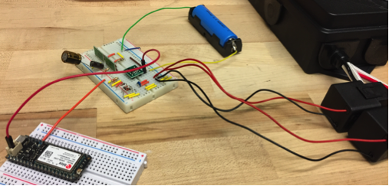

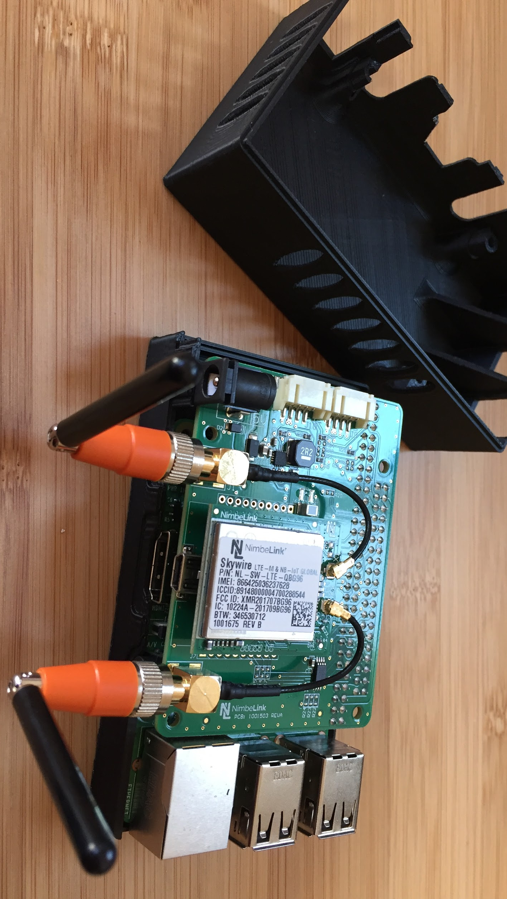
Proof of concept prototype for energy harvesting through CTs with a battery management system. The prototype has been demonstrated to periodically power a Ublox cellular chip.

Prototype of an ethernet cellular gateway on a Raspberry Pi with a 3D printed enclosure.

