SOLAR YACHT - technical assistance request (2 pages, including images, will be made public)

Provide a two-page description of the unique challenges and needs a national lab, private facility, and/or member of the American-Made Network could potentially help you resolve. The Prize Administrator will make this request broadly available so members of the American-Made Network can understand your needs and assist you through the voucher program or otherwise.

This project involves converting an 31’ Chris Craft motor yacht to an Solar Exoskeleton powered electric propulsion system that integrates and exploits the availability of solar energy to provide clean propulsion power. As such a project of this magnitude requires the support of a yacht services facility equipped to effect the conversion. The main engines will be removed and replaced with 10 kW permanent magnet AC motors coupled to the propulsion shafts in their place. With all the space and weight savings from the diesel engine removals we would then install 48 volt lithium battery banks. The hull and superstructure would then be embedded with a photovoltaic exoskeleton that would be integrated with charging the battery banks. Work of this nature would require a yacht yard with cranes, pipefitters, welders, machinists, electricians, fiberglass fitters, PV Cell fitters, blasters, painters ect. This is why we reached out to Mayer Yacht Services. Additionally we would require a yacht yard for the application of the PV exoskeleton. We would also require Solbian to assist with the application to ensure it is done to the manufacturer’s specification. However we would expect this service to be included with the purchase of their PV system. I would support the commissioning of the all electric propulsion system and the PV Cell exoskeleton. However the yacht services through the duration of the project would be needed at the daily estimated cost of $200 per day on average for approximately 30 days. This Yacht Services Cost would essentially be the bulk of our technical assistance request as this would allow us to work onboard with supporting services. The yacht would serve as our laboratory as we work together with the equipment manufacturers to commission and tune the systems. Note: Main engines would be removed freeing up considerable space and displacement weight.
We reached out to Electric Yacht for the possibility to repower a 31’ yacht from diesel to all electric and then incorporate an embedded PV exoskeleton. The ideal boat would have a full displacement or full planning boat with significant space to capture solar power.

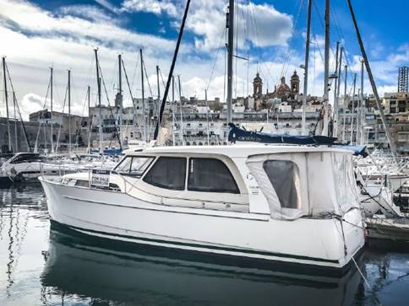

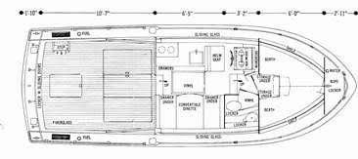

Chris Craft 31 Measurements
LOA 31 ft
LWL 27 ft (estimate)
Beam 11 ft 3 in
Max Draft 2 ft 4 in
Displacement 10582 lb (12000lbs used for calculations to address large battery pack)
Motor Dual Motor
Hull Deep V

Propulsion motors – 2 x QuietTorque 10.0 Sport air cooled 48v Single Powerhead PMAC Motor System

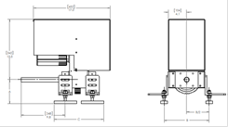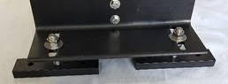

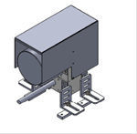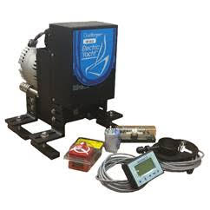

SPEED AND POWER

Speed & Power 2 X QuietTorque 10.0 air cooled motor systems
Kts Amps Watts (calm Waters)
2.2 10 480
2.7 20 960 This is the speed that a 2 kW solar array would provide
3.4 40 1920
3.9 60 2880
4.3 80 3840
4.7 100 4800
5.2 140 6720
5.5 160 7680
5.7 170 8160
5.9 190 9120
6.2 230 11040
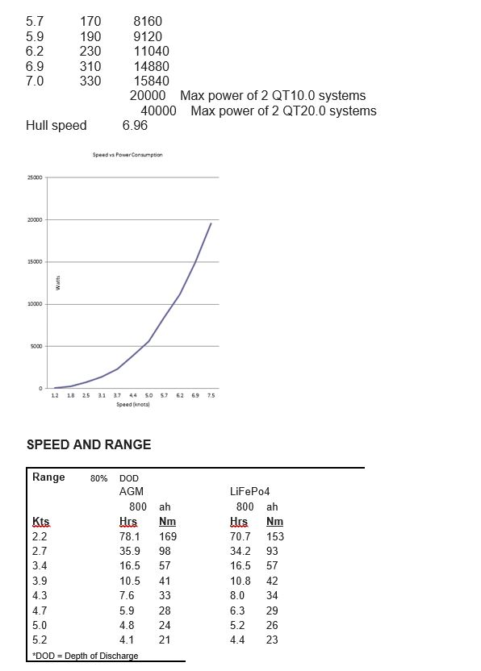

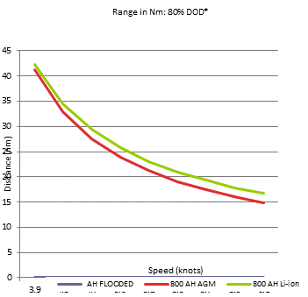

The Electric Yacht QuietTorque™ system is specifically built to marine standards and is more than a DIY kit adapted from another use. QuietTorque™ systems use marine grade wiring and are built to ABYC and Coast Guard approved standards. Built by marine propulsion engineers, each Electric Yacht QuietTorque™ system motor is power matched, mechanically engineered, and the controller programed for your boat.

The engineered aluminum and stainless-steel frame provide stability, heat management, and thrust management. The QuietTorque™ system is light weight and simple to install. Each system includes a flexible motor mounts and coupler.

A quality purpose built marine throttle provides precise control and is programmable with the helm monitor. Forward, reverse, and neutral lock out along with a key on switch.

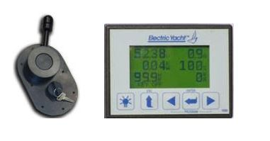

A programmable monitor displays the critical information to the helm and system set up:
1. Set up forward/reverse and throttle throw;
2. Set battery type and size;
3. Set regeneration level;
4. In real time know accurate battery state of charge (SOG), power draw, regeneration, % of charge, RPM, and range to discharge

System Overview

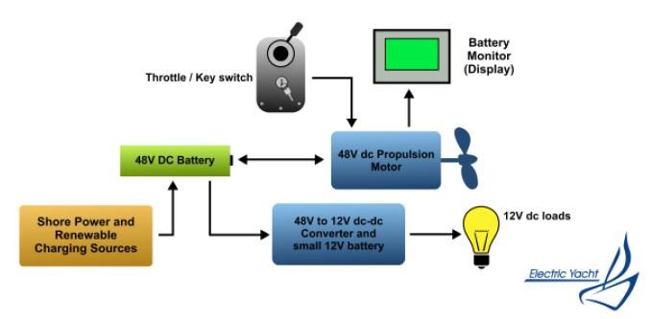

This electric propulsion system consists of a number of components. The system uses a 48Vdc battery bank serves as central energy storage. Size and type depend on budget, desired range and frequency of use. 48Vdc propulsion motor provides propulsion power and can regenerate electricity when sailing with propeller turning. The throttle control is used to control motor speed and direction. For safety, it locks in neutral, preventing accidental operation. Lift locking
ring and push ahead or astern to activate motor instantly. Turn key switch and remove to de-activate motor.
With kite drive deployed we would leave throttle in neutral with key switch on. Propeller will normally start turning between 4 and 5 knots. As sailing speed increases, regenerated power increases.
Battery monitor display shows battery state of charge (SOC) and battery voltage at a glance. When motoring, it shows motor speed, battery voltage/current, power consumption and time to discharge at current throttle setting. A battery charger plugged into shore power in a slip is
the most common means of charging batteries.
In our case the PV exoskeleton (solar panels) are the highlight however a wind generator, solar panels or a portable or fixed generator can also be used. An optional dc-dc converter can be used to provide 12Vdc power from the 48Vdc battery bank.

1 x Solbianflex PV Exoskeleton (approx. 2-4 kW)
This 31’ Chris Craft will have a SP Series Solbianflex panels embedded in her deck and structure. These mono-crystalline silicon-based modules which cells achieve a record conversion rate of 24% of sunlight into electricity. It is precisely for this high-performance technology that we have selected these panels. Given the 27m² of available deck space we expect to produce as much as 4 kW directly available to charge the battery bank. These flex panels will be fitted to the curvature of the hull with a structural adhesive and then protected by a fluorinated polymer that assures UV/scratch resistance and excellent light transmission.


